

Project Title: |  | VideoPoint 3.0
Organization: |  | Lenox Softworks, Inc.
Contact: |  | Karolina Khurshid
 | Email: | karolina@lsw.com
 | Phone: | (413) 637 0099

Background Information
Lenox Softworks (LSW), founded in 1995, is a Massachusetts based web and software development company serving a variety of educational and commercial clients nationwide.

The flagship product of LSW is VideoPoint - video analysis software that allows a user to collect position and time data from digital video. Developed in conjunction with the Workshop Physics curriculum at Dickinson College, VideoPoint has had extensive classroom testing and is one of the most popular physics educational software in the country. The team of original authors and key consultants include Priscilla Laws (Dickinson College), Pat Cooney (Millersville University) and Robert Teese (Rochester Institute of Technology). The product website can be viewed at www.lsw.com/videopoint. The value of video analysis in Physics instruction cannot be understated. As you’ll see in the attached article, educational technology of this sort can be very powerful.

LSW is now facing the challenge of bringing this software up-to-date in terms of a) compatibility with new operating systems (Windows XP and OS X) and b) more user-friendly and modern-looking user interface.

Project Description
The current version of VideoPoint (version 2.5) was developed in C++ in 2001 as a cross-platform application compatible with both Windows and Mac platforms. The VideoPoint 3.0 Project, as a redesign of version 2.5, needs to be undertaken for the following reasons (in order of importance):
- Compatibility with Mac OS X: since the introduction of OS X, Macintosh users are no longer able to use VideoPoint unless they are able/willing to switch to Classic mode.
- User interface changes: the current user interface is not only outdated in terms of its look and feel, but has also proven to be too complex for the average teacher or student to understand and use effectively (see Figure 1 below).
- Introduction of new features: through ongoing feedback from users over the years, we have collected a list of new features we would like implemented in the new version. In addition, we are looking for a fresh perspective and are open to new ideas from the Project Team.
Figure 1: Curent User Interface (version 2.5)
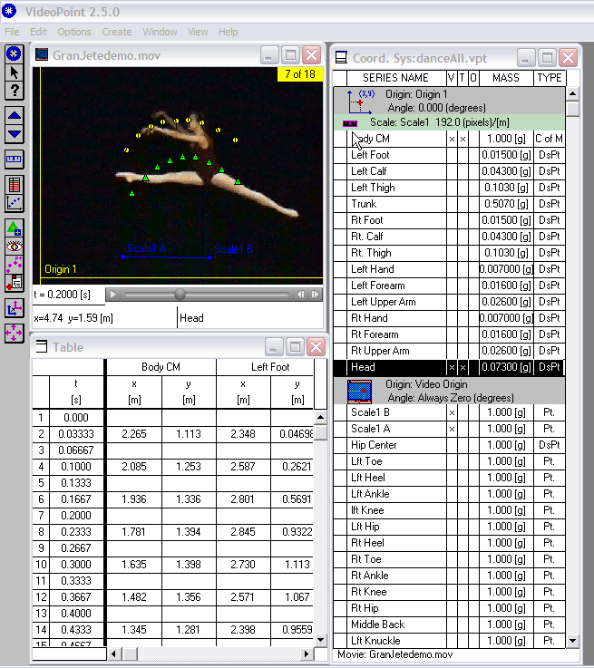
Although VideoPoint is an existing product in need of redesign, the VideoPoint 3.0 Project will be significant enough to require the team to go through the complete development cycle and treat this project as a new product development. The undertaking will be more complex than just making a few adjustments or recompiling existing code. We envision that while the existing code base could be reused for specific functions and calculations, the changes required in terms of cross-platform compatibility and user interface design will warrant the creation of new requirements and specifications documents, test plan, prototypes, etc.

This Project will require very close cooperation between the Project Team and LSW. Since this is an educational tool, it is important that prototypes are tested with end users on an ongoing basis and that their feedback be incorporated into the product design to assure that it is not only usable but also pedagogically sound. The LSW educational team would solicit this feedback from the end users and work with the Project Team on prioritizing and implementation. In addition, LSW graphic artists would work closely with the Project Team on creating an attractive design to match the rest of LSW educational products suite (see Figure 2).

VideoPoint is widely popular software in the science education circles and the VideoPoint 3.0 Project would be ideal for students with interest in physics and/or science education and educational technology (although it’s not a requirement). It would offer a unique challenge for the Project Team in that it would require students to be able to orient themselves in existing (and rather complex) code, decide what parts to reuse, and perhaps find better solutions. In addition, LSW would be open to including the names of the Project Team and the school on the product credits when it is commercially available.

Figure 2: Examples of interface design of new products from the suite
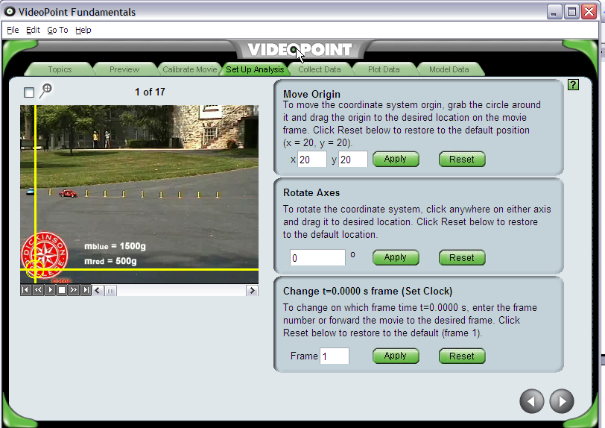
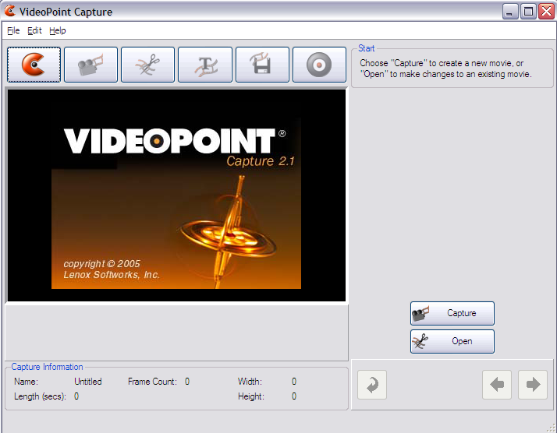

Technical Constraints & Assumptions
- Final product must be compatible with Windows 98, 2000, XP (Vista?) and OS X;
- Should not be developed separately for Windows and Mac OS; there needs to be only one code base to maintain;
- Although the original product was developed in C++, we are open to suggestions on changing the development platform;
- QuickTime format is the only acceptable video format for accurate video-based motion analysis.

Project Scope
- Requirement Solicitation: The Project Team should gather requirements based on existing software features, input from LSW team and potentially other parties, such as teachers and students (through the LSW education team);
- Analysis: During the analysis phase, the Project Team should create a high level requirements document and then a detailed Requirements and Specifications Document and Test Plan that the sponsor can use in the future for further development and updates;
- Design: In order to be able to solicit feedback from the end users, LSW will request a semi-functional prototype of the product or at least of the more complex features;
- Development: Due to the complexity and size of the project, we expect the Project Team to be able to carry the project at most to the Beta stage. A functional Beta version with a list of known issues would be a perfectly acceptable result.
- Testing: Thorough testing report and list of known issues would be desirable in order for the sponsor to be able to take over the project in the final stages.
Expected Deliverables
- High Level Requirements Document
- Software Requirements and Specifications Document
- Test Plan
- Prototype
- Beta Version
- Source Code
- Documentation
- Issues Review/ Test Report

