ECE 420
READINGS in ELECTRICAL and COMPUTER ENGINEERING

THESIS PROPOSAL

Efficient Voltage Regulator Designed for the PowerToad

Submitted by
James Itty Samuel
School of Engineering

In partial fulfillment of the requirements for
Master of Science in Electrical and Computer Engineering


Fairfield University
1073 North Benson Road
Fairfield, CT 06824

December 14, 2005
Abstract:
The paper discusses the design of a switching regulator to be used in the PowerToad. The PowerToad is a device developed by PowerToad Inc, a startup company. The power supply that is used in the PowerToad generates undesired excess amount of heat. A switching regulator should reduce the heat produced. The paper describes the PowerToad requirements, a design solution, and milestones that are necessary to reach the final goal of replacing the power supply. The particular topology used will be the buck regulator. The buck regulators can easily be designed if the constraints are known. Along with design of the buck regulator, to be placed in the PowerToad, I will also develop a software interface that will output a buck regulator design, depending on the constraints. The software tool interfaces with MultiSim, a simulation software for electronic circuits.
Table of Contents
1.0 Introduction 7
1.1 Problem Statement 7
1.1.1 PowerToad 8
1.1.2 Software Interface 10
1.2 Motivation 11
1.3 Approach 11
1.4 Societal Implications 12
1.4.1 Ethics 12
1.4.2 Safety 13
2.0 Historical Review 13
3.0 Designed Voltage Regulator 18
4.0 Validation 20
5.0 Milestones 20
6.0 Related Results 22
7.0 Conclusion 22
8.0 Literature Cited 23
9.0 Vita 26
10.0 Appendix 26
10.1 Figures 26

Introduction
Power supplies are constrained to provide power as efficiently as possible without generating too much heat. The main component of the power supply is the voltage regulator. The voltage regulator regulates the voltage from a power source to the device that requires the power. The regulator that this research presents will output varying voltages from 12 V to 18 V, with a peak power of 75 watts. We plan to make use of a programmable switching regulator that is optimized for efficiency.
Improperly designed regulators can dissipate excess heat. The best way to compensate for the excess heat is to account for thermal issues from the onset of design. This paper discusses a regulator designed for the PowerToad. PowerToad is a device that provides power to laptops and/or cell phones. Laptops typically require 12 – 18 V depending on the model. The present design of the PowerToad uses a linear regulator to regulate 24 V-DC input with an output range of 12 to 18 V-DC. Currently, the power supply used in the PowerToad dissipates excess heat since a linear regulator is used.

1.1 Problem Statement
The linear regulator used in the PowerToad is the LM2756 – ADJ. The ADJ means that the output voltage can be adjusted. The power supply’s constraints require 24 V-DC input and an output voltage range of 12 to 18 V-DC. The current flowing through the device will be capped at 5 Amperes, but 4 Amperes is required. Power generated in a linear regulator can be calculated using the following equation:
$P=(V_{\text{dc}}−V_{O})(I_{\text{.}O})$ (1)
Therefore, a linear regulator with these constraints can dissipate power from 48 to 90 Watts [8]. The heat from this power needs to be reduced. The device should not produce excess heat. For the time being, PowerToad has placed a heat sink on the voltage regulator to release the heat. A fan is also used to cool the heat sink. However, the fan produces noise which is not desired.
A regulator needs to be designed such that in regulating the voltage too much heat is not dissipated. The dissipated heat should be minimal and essentially cool to the touch. Further, the regulator should be small enough to be contained on the circuit board. The design should also follow basic electrical engineering standards. Given only these constraints a proper solution needs to be implemented. The process of regulating voltage from 24 V to a certain amount of voltage out will be optimized. The amount of heat generated will be the factor that determines whether the design is the most optimal

1.1.1 PowerToad
PowerToad is a startup company that is implementing a device that could be used by many people in different industries. The PowerToad is a tool that can be used in different settings to essentially provide power for laptops and/or cell phones. The pod (see Figure 1) is placed in a center location and is powered to a wall outlet. Users can connect their laptop and cell phones to the device. The PowerToad has generic power cords for different model laptops and cell phones. A USB cable is also provided and is used to create a local area network. Once the USB cable has been connected to the laptop, the PowerToad’s software determines how much voltage the laptop requires. Different model laptops require different amounts of voltage, but typically the voltage ranges from a minimum of 12 V to a maximum of 18 Volts.
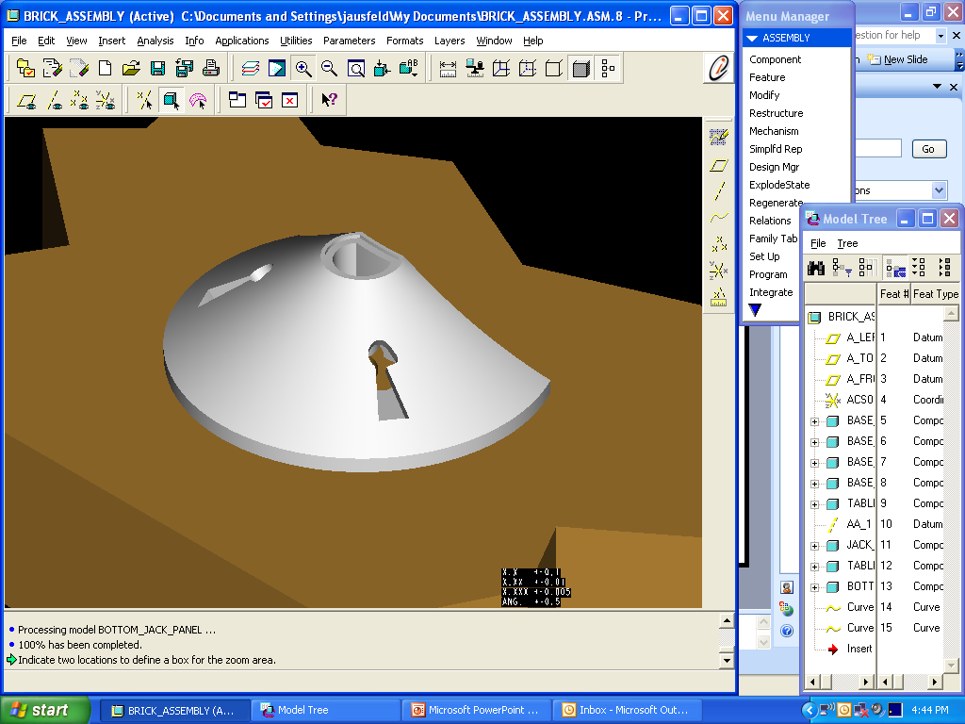
Laptop Computer with USB
DC Power
Variable DC Power
USB
Power Toad LP2
AC input

Pod
The Pod can be mounted on any side or surface of any furniture (including tables, chairs, desks and benches)
Figure 1 Schematic diagram of PowerToad use

The AC input is converted to 24 V DC. The PowerToad uses this voltage to provide a regulated DC output voltage to the laptop. The PowerToad has a microcontroller that determines how much voltage is required by the laptop. The microcontroller controls the amount of output voltage sent to the laptop. Figure 2 shows all the components of the PowerToad. All these components should fit into a fairly compact container. Figure 3 shows the linear regulator with a heat sink attached. The linear regulator is part of a circuit that receives 24 V DC input and provides 12 to 18 V to the laptop. This voltage is linearly regulated to provide the necessary output voltage to the laptop. The microcontroller uses a lookup table to determine how much voltage should be provided out to the laptop. The heat sink obviously makes the device even more bulky. The goal of this thesis is to reduce the heat generated in this particular component, so that a heat sink may not even be needed.

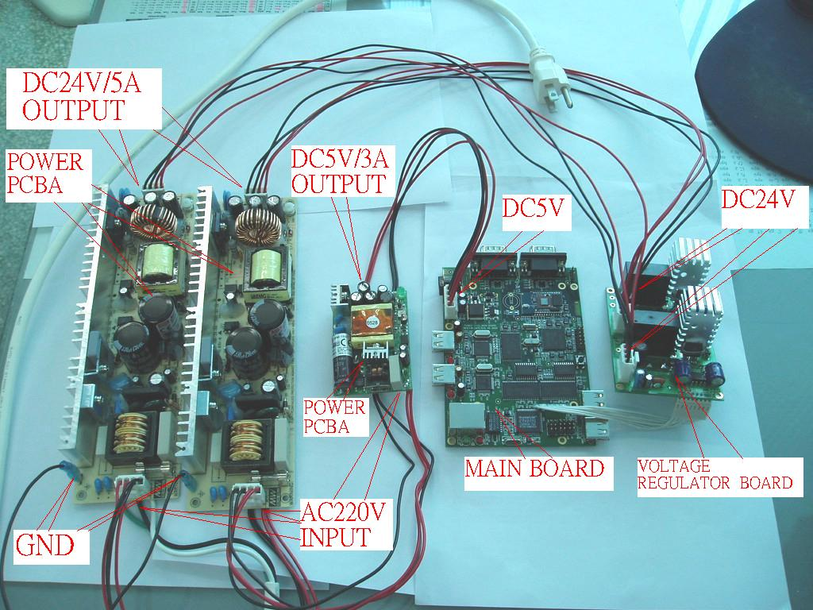
Figure 2 All the components together

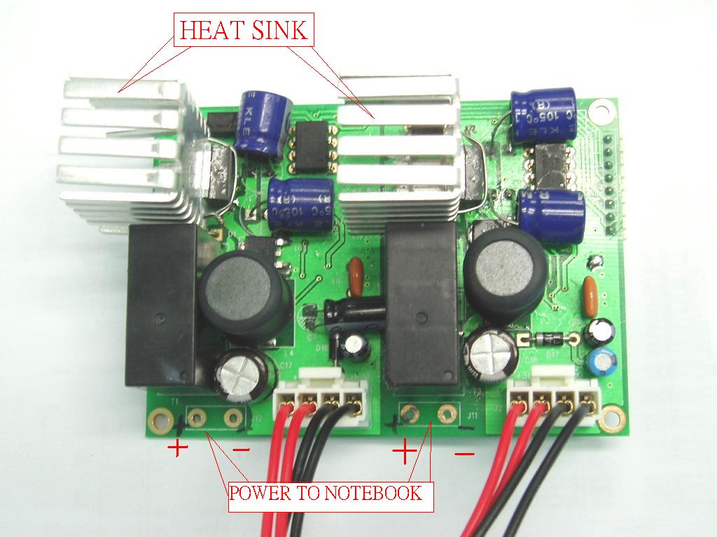
24 V DC input
Figure 3 Voltage regulator with 24 V input and output connections to the laptop

1.1.2 Software Interface
I will also be developing a software interface to Multisim. Multisim is a simulation tool used by electrical engineers to simulate circuits. A Java application can be developed that will record certain constraints. The application will produce a netlist, which can be imported into Multisim. Users can type in constraints of a regulator circuit (input voltage, output voltage, current, and/or reference voltage). These constraints will be used to specify values for an inductor, capacitor, and 2 resistors that are used in buck regulators (please refer to section 2.0 on page 8). Multisim can import the netlist with the calculated circuit specifications. The netlist is a simple text file with a “.cir” file extension. Currently an interface of this kind does not exist. Having such an interface will simplify the design of buck regulators, especially for those that are not too familiar with buck regulator designs.

1.2 Motivation
The PowerToad currently uses a linear regulator. The use of a linear regulator dissipates too much heat. The linear regulator can be outfitted with a heat sink and a fan. This way any heat that is produced is transferred to the heat sink and a fan can blow out the heat. However, this complexity adds two new problems. First, the addition of a heat sink makes the device bulky. PowerToad Inc. requires the device to be as small as possible and so heat sinks are undesirable. The other problem is that noise is produced if a fan is used. The PowerToad is to be used in office settings and therefore noise should be avoided. The conclusion is that a better regulator needs to be used to fit the constraints of the PowerToad device. Essentially, PowerToad needs an efficient power supply that is suitable to the corporate office setting; therefore the device should be compact and noise output should be minimal.

1.3 Approach
My approach has been to research different regulator topologies that are available in the market today. Also, I am researching different technologies that can be applied to make the regulator more efficient. These topologies will help me to better design the switching regulator that will be used in the PowerToad device.
There are different topologies that are commonly used. These include the “buck”, boost, polarity inverting, and the push-pull regulator. From my readings, I have resolved to use the buck regulator. The buck regulator is typically used in the power supplies of modern day PC’s and also in mobile devices. After I have done my research, I would like to design this regulator. The regulator must be efficient, duty cycle has to be high, and heat has to be minimal.
After the design has been finalized, I would like to experiment by replacing the linear regulator used in the PowerToad with the newly designed regulator. I will run tests to see how efficient is the switching regulator. The primary factor will be to check if the power dissipated has been reduced and if the generated heat is reduced.

1.4 Societal Implications
The PowerToad will be a commercially available device that can be deployed to hotels, universities, schools, hospitals, offices, etc. As a result, the PowerToad cannot cause serious damage. The power supply should regulate voltage as specified and there is no room for error. If this heat is not properly accounted, the regulator could inflame the device or potentially harm the user.

1.4.1 Ethics
A switching regulator is used so that the heat dissipated by the power supply will be minimal. The primary concern is that the solution does not fulfill its own purpose, which is to reduce the heat. If this is the case, the regulator can become overly heated and damage or ignite the circuitry. As a result, PowerToad can potentially burn a person or even start a fire. In order to prevent any serious damage, a thermocouple should be used in the device to sense temperature and turn off a device if the temperature rises above a certain threshold.
Another concern is that the new switching regulator solution should not damage the device in anyway while the device is running. The regulator must ensure that with 24 V DC input only 12 – 18 V DC can be output with a maximum current of 4A. If any of these constraints are not met, then the switching regulator could potentially damage other circuit components. This can only be prevented by testing and experimenting with the solution.
A third concern is that the new solution should not infringe upon any copyrighted ideas. The “buck” regulator topology is a commonly used topology and therefore this should not be a problem. Further, extensive reading will be done to see what solutions are publicly available.

1.4.2 Safety
Safety can be ensured by using a thermocouple. The thermocouple will shut off the power supply if the dissipated heat is in excess of a threshold. The threshold has not been determined but can be determined by experimenting. With every 10°C rise in temperature, the reliability of the circuit is decreased by approximately half [42].

Historical Review
There many topologies that can be used, such as the buck-converter, boost converter, or buck-boost converter. The two main classifications of regulators are linear and switching regulators. Linear regulators are useful when low output noise is required and also when a fast response to input and output disturbances is required. Switch regulators are useful when power efficiency is critical and to also reduce the amount of power dissipated [5].
“Buck” Regulator
The “buck” regulator is the earliest of all switching regulators and was developed in the early 1960’s. The regulator is referred to as a “buck” regulator since the regulator bucks or reduces the voltage, typically high to low voltage. Switching regulators use a fast-operating transistor switch in order to switch DC input voltage through to the output at an adjustable duty cycle. The average DC voltage delivered to the output can be controlled by varying the duty cycle. Further, by using a LC filters, square-wave modulation could be eliminated and could produced ripple free DC voltages equal to the DC input. A negative-feedback loop can be used to regulate the voltage against input and output load changes [21].
The transistor Q1 (see Figure 1) is in series with the input voltage V_{DC}. It is closed for the time out of the switching period T. When it is on, the voltage at V1 is V_{DC}. When the transistor turns off, the voltage at V1 falls very rapidly. The magnitude of the output voltage is
$V_{o}=V_{\text{dc}}({T_{\text{on}}}/T)$ (2)
The output voltage is sensed by the sampling resistors R1, R2 and compared to the reference voltage in the error amplifier (EA). The amplified voltage is fed to a pulse-width-modulater (PWM). The PWM controls the on time of the transistor. If the input voltage goes high, the Q1 on time is decreased bringing the output voltage back down. Similarly if the input voltage goes low, then Q1 time on is increased. This topology can be used in the PowerToad to maintain the appropriate voltage that would be required by a laptop. Once the voltage has been determined, the current amplifier can be used to maintain the necessary output voltage [21].
Figure 4 Buck regulator

Boost Regulator
Figure 5 Boost regulator
The boost regulator can produce a higher regulated voltage from a lower unregulated voltage. The inductor L1 is placed in series with the switching transistor Q1. The L1 feeds the output capacitor C_{o} and the load resistor through the diode D1. The output voltage is higher than the input voltage. This is because when Q1 is on for a time T_{on}, D1 is reversed-biased and current ramps up linearly to a peak value. During this T_{on} time, the output current is supplied entirely from C_{o}. When Q1 turns off, the current in L1 reverses in order to maintain a constant current. The no-dot end of the L1 is positive with respect to the dot end. The voltage at the dot end is at V_{DC} and the L1 delivers its stored energy to C_{o} and charges up the capacitor to a higher voltage than V_{DC} [21].
The buck regulator needs to have a high duty cycle. The duty cycle is the ratio between the pulse duration and the period of the pulse. Today, regulators used in notebooks have an extremely small duty cycle, since the output voltage is small (~1V). However, this small duty cycle affects the performance of the voltage regulator. Other designs have been proposed to increase duty cycle. However, these designs limit the switching frequency. Ren discusses the two-stage approach to overcome the bottle-neck. The first stage consists of a simple multiphase buck converter. A buck converter reduces input voltage in direct proportion to the duty cycle. The second stage requires ultra-high frequency to make the whole voltage regulator more efficient. A 30 V trench MOSFET is used to produce the high frequency [12].
Another way to increase the duty cycle is through the multiphase coupled-buck converter, which enables the use of a large duty cycle. Since the duty cycle is being reduced as the input voltage increases, the buck regulator might not be used efficiently. The multi-phased tapped-inductor buck converter is a simple topology that extends the duty cycle. Multi-winding coupled inductors are used to enlarge the duty cycle. However, the coupled inductor windings cause severe voltage spikes. The proposed design solves the voltage-spiking problem. The design also produces smoother input and output currents. A modification is made in order to allow the capacitor to have a constant voltage. The resulting topology, called the multiphase coupled-buck converter. A third winding is coupled with the output inductor of the neighbor channel and is placed in series with the existing top winding. The voltage induced in the third winding compensates the voltage of the existing top winding in the neighbor channel, and therefore, the capacitor appears as a constant voltage, which equals the input voltage minus output voltage [9].
The efficiency of regulators can be improved by using a technique called soft switching. Soft switching is when converter reduces switching loss by simply programming critical delays to switch when the voltage across the device is nearly zero. This process is called zero voltage switching (ZVS). Soft switching allows the device to achieve higher efficiencies at higher operating frequencies, since switch losses are reduced [18].
Yao presents a novel topology that modifies the buck converter to have coupled windings in the buck converter. The coupled windings improve the efficiency of the converter.
Figure 6 Conventional Buck with Two-Phase Interleave
The conventional buck converter is shown in the right block of Figure 1. The coupled windings are shown in the left block. In Figure 1, the L2a and L2c inductors together act as a transformer. The L1a and L1b inductors together act as an inductor. This addition reduces the switching current by (1+n) times, where n is the number of turns of the inductor. I believe this design can be applied to the new regulator for the PowerToad. The design is very similar to a push-pull converter with an isolated transformer. However, this design is much simpler. Another advantage of this design is that the turns ratio can be adjusted to extend the switching cycle [19].
Namgoong writes how linear voltage regulators are inefficient since their efficiency (Vout/Vin) has decreased as voltages have dropped. This is good to know since the PowerToad is currently using a linear regulator. This type of regulator can generate a profound amount of heat. The article also compared different topologies and their efficiency of use. Essentially the author argues that for portable devices the one-stage buck converter is the best overall topology compared to two-stage buck, resonant mode (differing frequencies), or forward converters. The article is good, however it is geared towards CPU use in portable devices, such as a laptop or other mobile devices [10].
Vasquez discusses using a single-switch voltage regulator rather than the typical two-stage voltage regulator. However, the design that the author presents is based on a flyback converter. The flyback converter cannot produce a negative voltage; therefore this regulator is only suitable for some applications. The advantage of this topology is that only one switch is required to control the output voltage. The reason only one switch is required is because the converter does not correct inherently the power factor. The converter demands the same amount of current and therefore the main converter tries to produce a constant output voltage [15].

Designed Voltage Regulator
In order to design the switching regulator, I need to design the individual components. These components are the inductor, capacitor, and resistor. The transistor that I will be using is the IRF540 transistor, a standard generic transistor. I also use a standard, generic diode the BAS20. Equations are used to compute the values of the capacitor (C1), inductor (L1), and resistors (R1, R2). The equations are given as follows:
(3)

(4)

(5)

The R_{o} value is approximately equal to R1 and R2. The constraints of the PowerToad are as follows:
V_{o} = V_{dcn} = 12 - 18 V
I _{o} = 4 - 5A
V _{i} = 24 V_{dc}
V _{REF} = 0.15 V
For my initial design, I am not using a feedback system (error amplifier and pulse width modulator) to control the switch. Instead I am using a function generator to control the transistor switch. My initial design is designed using initial constraints of input 15 V. Using these constraints, I calculate my component values to be:
L = 140.063 uH; C = 526.32 uF; R1 = R2 = 190 mOhm
Figure 7 First stage of the proposed design

I simulated the circuit with these components in Multisim 7 and found that the output voltage is approximately 15.023 V. The next step is to design and simulate the feedback system to control the switch. The feedback system will consist of an error amplifier and a pulse width modulator. By varying the pulse and length of T_{on}, the switch can be controlled which controls the output voltage.

Validation
Dynamic analysis and simulation will be used to validate the newly designed switching regulator circuit. Dynamic analysis includes analyzing the current linear regulator circuit. The analysis will include measuring the output voltage, current, and a thermal measurement of the amount of heat that is generated. After the switching regulator circuit replaces the linear regulator circuit, the same analysis will be done. This analysis should have the correct output voltage and current. Further, the heat that is generated should be significantly less than the linear model. The circuit should be cool to the touch, so that a thermal management solution is not needed.
Along with the dynamic analysis, I will use simulation to simulate the results I should have. Multisim 7 can be used to simulate the buck regulator design. The simulation software will display output voltage and current. Since this is a simulation tool, the measurements are based on ideal conditions, which may not be replicated in the real world.
The experiment will primarily consist of testing the switching regulator and ensuring that it works properly. This entails testing if the regulator produces undesired heat. Also, the circuit should produce the right voltage depending on the required voltage of the laptop. Adjusting a potentiometer and varying the resistance will model the required voltage. If the feedback system works properly, then the correct voltage should be seen consistently on the output. This may involve using a look-up table. In other words a certain amount of resistance on the potentiometer corresponds to the desired voltage on the output.

Milestones
The primary goal for this semester is to design an appropriate switching regulator that will meet all the constraints of the device. This design phase is also the first milestone of my thesis. Once I have a design, I will have a foundation for the implementation of the design. The second milestone would be to implement the switching regulator in simulation software and simulate the results. The simulation software I will be using is Multisim 7. The simulation should a working a switching regulator that is regulating a 24 input voltage to vary amounts of output voltage. The output voltage will be varied by a potentiometer. If the simulation produces a good amount of output voltage with the nominal current below 5 A, then the design is satisfactory. The next milestone would be to actually build the switching regulator, along with the needed circuitry. Building the regulator can be done at laboratories provided by Fairfield University, with the assistance of professors at the university. The final milestone would consist of switching the linear regulator with the switching regulator and running several experiments. The experiments would basically test if I can produce a regulated voltage that falls within the 12 to 18 V with a nominal current less than 5 Amperes. The experiments would obviously test how much heat is produced. If the heat is minimal but still more than expected then I would recommend to PowerToad few thermal management solutions.
Milestones:
- Design an efficient switching regulator
- Simulate the regulator in Multisim 7
- Design & Implement replacement circuit
- Replace Existing circuitry
- Experiment and note results
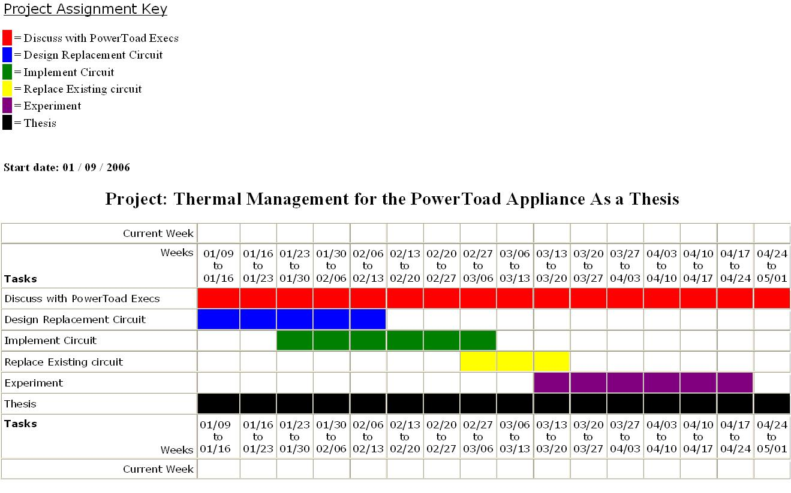
Figure 8 Milestones in a Gantt chart

Related Results
The results of the hardware implementation should essentially show that the switching regulator is working correctly according to specifications. A working solution will also show that the Multisim simulation is a good tool to use in order to model and analyze circuits. The interface tool that will be used determine the component values will also be tested by running the experiments. The interface displays what components should be used in the circuit (values for L, C, R).

Conclusion
This paper proposes a thesis project to design and implement a switching regulator that will be used in the PowerToad. The goal of the thesis would be to completely replace the linear regulator that is used in the current PowerToad device. The switching regulator would meet the requirements and constraints of the device and reduce the heat that is generated. The old linear regulator circuit will be replaced by the switching regulator circuit. By making this replacement, PowerToad would not have to use the bulk heat sinks.

Literature Cited
[1] B. Arbetter and D. Maksimovic, “DC-DC Converter with Fast Transient Response and High Efficiency for Low-Voltage Microprocessor Loads,” IEEE IEEE Applied Power Electronics Conference, 1998.

[2] A. Bhattacharya, “Finned Metal Foam Heat Sinks for Electronics Cooling in Forced Convection,” Journal of Electronic Packaging, September 2002, p.155-163, ASME. Boston, MA, USA

[3] D. Brooks, M. Martonosi, "Dynamic Thermal Management for High-Performance Microprocessors," Proceedings of the 7th International Symposium on High-Performance Computer Architecture, January 2001, Monterrey, Mexico.
[4] T. Costlow, “Cooling off hot spots,” Design News, October 6, 2003, p.44-45. Washington, DC, USA

[5] S. Das, "Timing, Energy, and Thermal Performance of Three Dimensional Integrated Circuits", Great Lakes Symposium on VLSI 2004, April 26–28, p.338-343, ACM. Boston, MA, USA

[6] A. Godil, “Higher Voltage from a Buck Regulator,” EDN, May 29, 2003, p.80-81. Waltham, MA

[7] S. Heo, "Reducing Power Density through Activity Migration", International Symposium on Low Power Electronics and Design 2003 , August 25–27, p.217-222, ACM. Seoul, Korea

[8] V. Mehrota, J. Sun, S. Chandrasekaran, “Ultra compact DC to DC Converters for the digital Age,” 2002, IEEE, NY

[9] T. Morimoto, K. Saitoh, M. Nakamura, “A Novel Switching Regulator with Active Commutation PWM Rectifier”, Power Electronics and Motion Control Conference, 2000, IEEE, NY.

[10] W. Namgoong, “Buck Regulator as a Solution to Portable Thermal Challenges,” Experimental Heat Transfer, September 1, 1998, vol. 17, p.227-241. Taylor&Francis.

[11] Y. Panvo and M. M. Jovanovic, “Design Consideration for 12-V/1.5-V, 50-A Voltage Regulator Modules,” 2000, IEEE IEEE Applied Power Electronics Conference.

[12] Y. Ren, M. Xu, K. Yao, Y. Meng, and F. C. Lee, “Two-Stage Approach for 12-V VR”, IEEE TRANSACTIONS ON POWER ELECTRONICS, 2004, IEEE, NY.

[13] A. Rozman and K. Fellhoelter, “ Circuit Considerations for Fast Sensitive, Low-Voltage Loads in a Distributed Power System,” IEEE IEEE Applied Power Electronics Conference, 1995, pp. 33-42.

[14] J. SebastiBn, P. Villegas, F. NuAo and M.M' Hernando, “VERY EFFICIENT TWO-INPUT DC-TO-DC SWITCHING POST-REGULATORS,” 1996, IEEE, NY

[15] N. Vazquez, “An efficient single-switch voltage regulator,” IEEE 31st Power Electronics Specialists Conference, May 2000, p.811-816, IEEE, NY.

[16] J. Wei and F. C. Lee, “Two Novel Soft-Switched, High Frequency, High-Efficiency, Non-Isolated Voltage Regulators—The Phase-Shift Buck Converter and the Matrix-Transformer Phase-Buck Converter” IEEE TRANSACTIONS ON POWER ELECTRONICS, MARCH 2005, VOL. 20, NO. 2, IEEE, NY

[17] P. Wong, X. Zhou, J. Chen, H. Wu, F.C. Lee and D. Y. Chen, “VRM Transient Study and Output Filter Design for Future Processors,” VPEC Annual Seminar, 1997.

[18] P. Xu, J. Wei, F. C. Lee, “Multiphase Coupled-Buck Converter—A Novel High Efficient 12 V Voltage Regulator Module”, IEEE TRANSACTIONS ON POWER ELECTRONICS, 2003, IEEE, NY.

[19] K. Yao et.al. “A Novel Winding-Coupled Buck Converter for High Frequency, High-Step-Down DC-DC Conversion,” IEEE Transactions on Power Electronics, September 2005, p.1017-1024, IEEE, NY.

[20] X. Zhou, P. Wong, P. Xu, F. C. Lee and A. Q. Huang, “Investigation of Candidate VRM Topologies for Future Microprocessors,” IEEE Transaction on Power Electronics, Nov. 2000, pp. 1172-1182.

[21] A. Pressman, Switching Power Supply Design. McGraw-Hill Professional. November 1, 1997, pp. 20-50.

[22] H. J. Shin, S. K. Reynolds, K. R. Wrenner, T. Rajeevakumar, S. Gowda, and D. J. Pearson "Low-Dropout On-Chip Voltage Regulator for Low-Power Circuits," IEEE Symposium on Low Power Electronics, 1994, p. 76-77, IEEE, NY.

[23] P. Alou, P. Pirez-Bedmar, J.A. Cobos, J. Uceda and M. Rascon, "A High Efficiency Voltage Regulator Module with Single Winding Self-Driven Synchronous Rectification," 2000, p. 1510 - 1515, IEEE, NY.

[24] C. G. Keeney, M. McWhorter, "A Highly Efficient Inductorless Voltage Regulator," IEEE Journal of Solid State Circuits, August 1969, Vol. SC-4, No. 4, IEEE, NY.

[25] B. Zhai, D. Blaauw, D. Sylvester, K. Flautner, "Theoretical and Practical Limits of Dynamic Voltage Scaling," IEEE Design Automation Conference, June 2004, IEEE, NY.

[26] E. Wirth, "Thermal Management in Embedded Systems," Thesis, March 2004, University of Virginia, Virginia.

[27] D. E. Lackey, P. S. Zuchowski, T. R. Bednar, D. W. Stout, S. W. Gould, J. M. Cohn "Managing Power and Performance for System-on-Chip Designs using Voltage Islands,"IEEE, 2002, IEEE, NY.

[28] K. Naik, D. S. L. Wei, "Software Implementation Strategies for Power-Conscious Systems," Mobile Networks and Applications, 2001, Vol. 6, p. 291-305, Kluwer Academic Publishers, Netherlands.

[29] P. L. Wong, "Performance Improvements of Multi-Channel Interleaving Voltage Regulator Modules with Integrated Coupling Inductors," March 2001, Virginia.

[30] M. V. Zelkowitz, D. R. Wallace, "Experimental Models for Validating Technology," IEEE, May 1998, IEEE, NY.

[31] T. Saito, S. Tasaki, H. Torikai, "Interleaved Buck Converters Based on Winner-Take-All Switching," IEEE Transactions on Circuits and Systems, August 2005, Vol. 52, No. 8, p. 1666-1672, IEEE, NY.

[32] J. A. Cobos, P. Alou, Q. Garcia and J. Uceda, “Several Alternatives for Low Output Voltage On-Board Converters,” IEEE APEC, 1998, pp. 163-169, IEEE, NY.

[33] X. Zhou, P. Xu and F. C. Lee, “A High Power Density, High Frequency and Fast Transient Voltage Regulator Module with a Novel Current Sharing and Current Sharing Technique,” IEEE Applied Power Electronics Conference, 1999, IEEE, NY.

[34] L. Spaziani, “A Study of MOSFET Performance in Processor-Targeted Buck and Synchronous-Rectifier Buck Converters,” HFPC, 1996, pp. 123-137.

[35] C. S. Mitter, “Device Consideration for High Current, Low Voltage Synchronous Buck Regulator(SBR),” IEEE Conference: Wescon’97, Santa Clara, CA, pp. 281-288, IEEE, NY.

[36] M. Dubey, P. Gupta, "Design of Genetic-Algorithm Based Robust Power System Stabilizer," International Academy of Sciences, 2005, Vol. 2, No.1, p.48-52.

[37] S.Hamada and M.Nakaoka, “Saturable reactor-assisted soft-switching asymmetrical PWM DC-DC converter with high-frequency transformer link”, IEEE Proceedings of Electrical Power Appliances, Vo1.145,No.2., IEEE, NY.

[38] R. Lenk, “Introduction to the tapped buck converter,” in Proceedings of High Frequency Power Converter Conference, 2000, pp. 155–166.

[39] P.-L.Wong, F. C. Lee, P. Xu, and K. Yao, “Critical inductance in voltage regulator modules,” in Proc. IEEE Applied Power Electronics Conf. Expo, 2002, pp. 485–492.

[40] A. Elbanhawy, “Effect of MOSFET parasitic inductance on switching performance of synchronous buck converters,” in Proc. Intel Technology Symp., 2003.
[41] J.Wei, P. Xu, and F. C. Lee, “A high efficiency topology for 12 V VRMpush-pull buck and its integrated magnetics implementations,” in Proc. IEEE Applied Power Electronics Conf. Expo, 2002, pp. 679–685.
[42] J. Sergent, A. Krum, Thermal Management Handbook for Electronic Assemblies. McGraw-Hill Professional. May 31, 1998

Vita
James Itty Samuel is pursuing a Master of Science in Electrical and Computer Engineering at Fairfield University. He received a Bachelor of Science in Electrical Engineer and Computer Science from Massachusetts Institute of Technology in June 2004. Currently he is working as a software engineer at Survey Sampling International

Appendix
List of figures.

10.1 Figures
Figure 1 Schematic diagram of PowerToad use 9
Figure 2 All the components together 10
Figure 3 Voltage regulator with 24 V input and output connections to the laptop 10
Figure 4 Buck regulator 15
Figure 5 Boost regulator 15
Figure 6 Conventional Buck with Two-Phase Interleave 17
Figure 7 First stage of the proposed design 19
Figure 8 Milestones in a Gantt chart 22

