IMPROVED 3D DIFFRACTION SCANNER DESIGN

By

Gino Lopes

Submitted to Graduate Faculty of Fairfield University in partial fulfillment of the requirements for the degree of A Master of Science in the Electrical and Computer Engineering program.

Advisor: Professor Douglas A. Lyon, Ph.D.

August 8, 2008

Introduction
This paper deals with the improved design for a 3D Scanner based on diffraction. The previous design consisted of a diffraction grating, red laser line generator, network web camera for the image acquisition and pc for image processing and control. A turntable with a motor and controller was used for positioning of the objects to be scanned. An enclosure was constructed to house the hardware and reduce the effects of the surrounding environment. A Macbook Pro with a 2.2-GHz processor and 4-Gb of ram was used for hardware control and image processing.
The previous design had areas for improvement, and a review and redesign of the 3D Diffraction Scanner was undertaken.

Design Improvements
The previous design used a Lego motor and controller that proved unable to control the rotation of the turntable with any precision. To fix the rotation issue a stepper motor and microcontroller was used in place of the Lego motor and controller. The stepper motor had a step angle of 7.5°, which allowed for 48 steps per revolution. To increase the number of steps per revolution a ten-tooth gear was mounted to the motor shaft. A thirty-tooth gear was mounted to the turntable platen using a one-quarter inch steel shaft. The combination of the thirty-tooth and ten-tooth increased the number steps per revolution from to144, a 3-to-1 improvement. The two gears were coupled together using a timing belt.

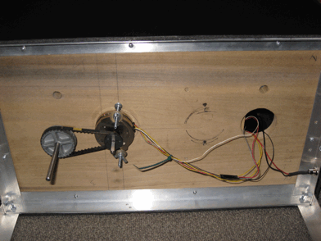
Figure 1, Bottom view of Scanner.

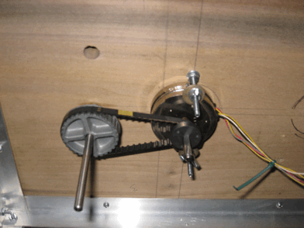
Figure 2, Close up view of the stepper motor and gear assembly.

The microcontroller used was the Arduino Diecimila. A ULN2003 was used to provide the current to the stepper motor windings. The microcontroller was used to control the stepper motor trough the ULN2003 and provide power to the red laser line generator.

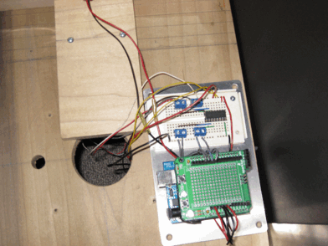
Figure 3, Top view of Arduino Microcontroller and ULN2003 Chip mounted on a breadboard.

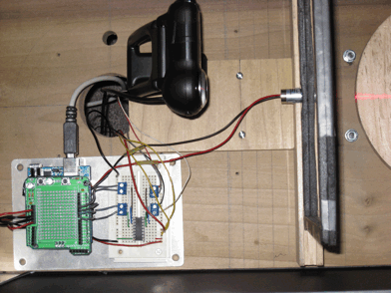
Figure 4, Another top view showing the control electronics and camera.
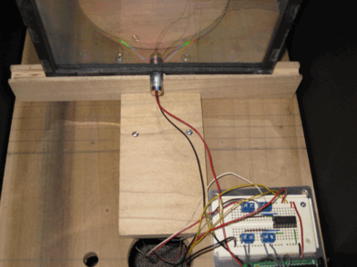
Figure 5, Another top view showing ULN2003 chip on breadboard, red laser, and diffraction grating.

The automatic gain on the network web camera had proved to be a problem because it could not be turned off. An additional camera problem discovered was that a significant amount of signal noise was present in the network web camera that proved difficult to process out of the acquired images. A Logitech Pro 5000 USB web camera was chosen to replace the network camera. The Logitech camera had a 1024x960 CCD Array.
No Mac drivers were available for the Logitech camera. The lack of Mac drivers limited the features that could be controlled on the camera. The Logitech camera did work with Macbook Pro but the max resolution obtain was 640x480.

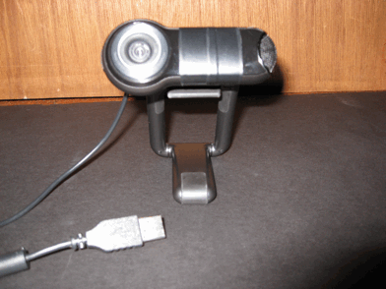
Figure 6, Front view of the Logitech Pro 5000 Web Camera.

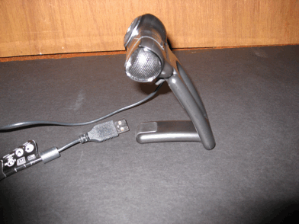
Figure 7, Side view of the Logitech Pro 5000 Web Camera.
The original enclosure consisted of a wood base with black foamboard walls and top and measured approximately 11.5” x 32” long. The new enclosure has an aluminum frame with a wooden platform to mount the hardware to and black foamboard attached to the aluminum frame. The new enclosure measures approximately 11.5” x 20” long. The aluminum frame substantially increased the strength and stability of the enclosure when compared to the previous design while also reducing the weight. The redesign of enclosure also made it more portable then the previous scanner.

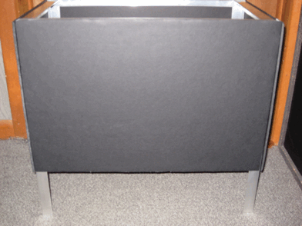
Figure 8, Side view of the redesigned enclosure.
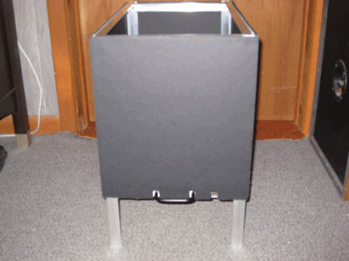
Figure 9, Another view of the new scanner enclosure.

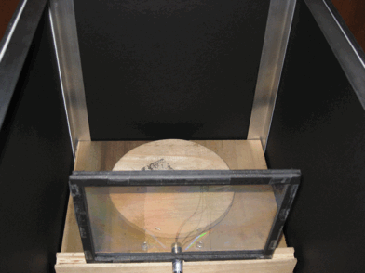
Figure 10, View of the new scanner looking from the top.

A brighter red laser was used to provide the source illumination for the scanner.

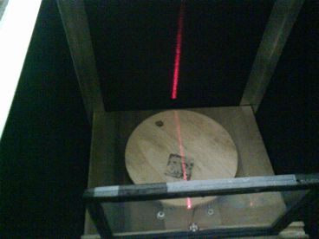
Figure 11, Top view of scanner with laser turned on.

A small toy was placed on the turntable for reference and illuminated with the laser.

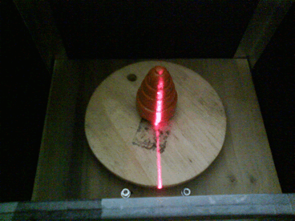
Figure 12, Another view of the scanner with the laser illuminating small toy.

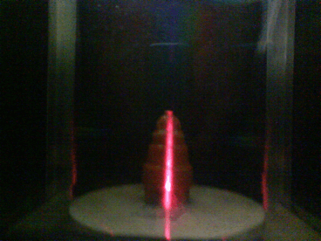
Figure 13. Another view looking through the diffraction grating.

A test of the scanners functionality was done using a target (kids small toy, approximately 3” tall) placed on the turntable. The target was then illuminated with the red laser. The stepper motor was then commanded to take 144 steps (one full revolution of the turntable) and images acquired for each step using the Logitech camera. The images were taken with the camera looking through the grating at the illuminated target.
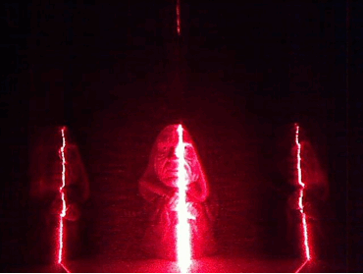
Figure 14, Image of the target taken by the Logitech camera looking through the diffraction grating.

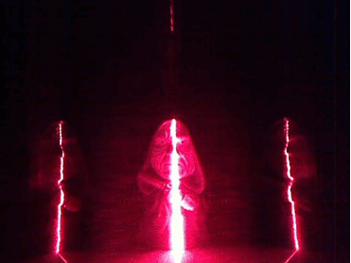
Figure 15, Another image of the target after taking a step.

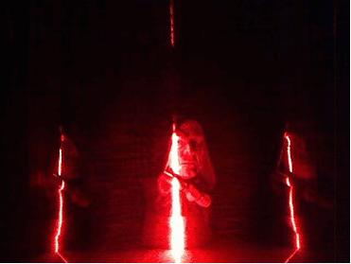
Figure 16, Another image of the target after a few steps. The picture shows that the target has moved.

Source Code

The Arduino firmware source code for stepper motor control is as follows:

/*
- Motor_Control
*
- A stepper motor moves the number of steps read
- from serial port.
*
*/

#include <Stepper.h>
// change this to the number of steps on your motor
#define STEPS 144
// create an instance of the stepper class, specifying
// the number of steps of the motor and the pins it’s
// attached to.
Stepper stepper(STEPS, 8, 9, 10, 11);
int previous = 0;
//int numSteps = 0;

void setup()
{
// set the speed of the motor to 30 RPMs
stepper.setSpeed(30);
Serial.begin(9600); // Start serial communication at 9600 bps
}

void loop()
{
if(serialAvailable()){
// get the number of steps to move from serial port int numSteps = serialRead();
Serial.print(numSteps);
// move a number of steps.
stepper.step(numSteps - previous);
//numSteps = 0;
//Serial.print(previous);

previous = numSteps;
//stepper.step(0);
}
}
The source code for the image acquisition and stepper motor control is as follows:

import processing.video.*;
import processing.serial.*;

Serial arduino;
PImage nolaser;
PImage laser;
int delayTime = 500;
int count = 0;
int numOfSteps = 145;

Capture video;
void setup() {
size(640, 480); //Window size to display video in.
video = new Capture(this, 640, 480, 30); //Camera image size in pixels: horizontal, vertical, framerate.
arduino = new Serial(this, “/dev/tty.usbserial-A70064De”, 9600); // Start the arduino
arduino.write(‘A’); //Initialize communication
println(“setup done”);
}

void draw()
{

if( video.available() )
{
video.read();
image(video, 0, 0); //display image: image to display, start point x, start point y
if(count < numOfSteps && arduino.available() > 0){ println(“Arduino available!”);
//save(“image” + count + “.jpg”);
// Saves each frame as line-0000.tif, line-0001.tif, etc. delay(delayTime); saveFrame(“line-####.jpg”); arduino.write(count); println(“Reading Arduino: “ + arduino.read()); count++;
}
else if(count == numOfSteps){
println(“Complete”);
}
else {
println(“Video Available!”);
arduino.write(0);
}
}
}

