On the Design, Construction and Operation
of a Diffraction Rangefinder
By
Gino Lopes

A Thesis submitted to the Graduate Faculty of Fairfield University in partial fulfillment of the requirements for the degree of A Master of Science in the Electrical and Computer Engineering program

Advisor: Professor Douglas A. Lyon, Ph.D.

Electrical and Computer Engineering Department
Fairfield University, Fairfield CT 06824
TABLE OF CONTENTS
List of Equations ii
List of Figures ii
List of Graphs ii
List of Tables ii
1 Introduction 1
1.1 Problem Statement 1
1.2 Approach 1
1.3 Motivation 2
2 Rangefinding 3
2.1 Types of Rangefinding 3
2.2 Diffraction Rangefinding 3
2.3 Resolution and Accuracy 4
3 Grating 5
3.1 Diffraction Grating 5
3.2 Grating Equation 5
3.3 Diffraction Orders Dispersion Angle 6
3.4 Summary 7
4 3D Scanner 9
4.1 3D Scanner Overview 9
4.2 Camera Selection 10
4.3 Laser Source 10
4.4 Grating Selection 11
4.5 Design Criteria and optical pose 11
4.6 Scanner Layout 12
4.7 Software 13
5 Testing the 3D Scanner 14
5.1 Testing using the Calibration Wedge 14
6 Experimental Data 18
7 Performance Characteristics 24
7.1 Resolution 24
8 Scanner Comparison 25
9 Conclusion 25
10 Discovered Problems 25
11 Future Work 26
12 Appendix 27
12.1 Hardware Specifications 27
12.2 Initial Work Using Java Media Framework 27
12.3 Literature Cited 29
12.4 Footnotes 29

List of Equations
Equation 3-1, Grating Equation 5
Equation 3-2, Common form of the Grating Equation with Incident light normal to grating surface. 6
Equation 3-3, Finding the dispersion angle using Grating Equation. 6
Equation 3-4, Trigonometric equation for the angle of diffraction. 7

List of Figures
Figure 3-1, Light source being diffracted as it passes through a diffraction grating. 5
Figure 3-2, Angles formed by light reflecting off a target and viewed by a camera or eye. 7
Figure 4-1, Original 3D Scanner 9
Figure 4-2, Modified 3D Scanner 10
Figure 4-3, Top view of 3D Scanner. 12
Figure 4-4, Profile view of 3D Scanner 12
Figure 5-1, Profile of 3D Scanner Layout with Calibration Wedge. 14
Figure 5-2, Front edge of calibration wedge, 92mm from diffraction grating. 15
Figure 5-3, Right side first order of fringe, of the calibration wedge, 92mm from diffraction grating after processing. 15
Figure 5-4, Front edge of calibration wedge, 49mm from diffraction grating. 16
Figure 5-5, Right side first order of fringe, of the calibration wedge, 49mm from diffraction grating after processing. 16
Figure 5-6, Front edge of calibration wedge, 135mm from diffraction grating. 17
Figure 5-7, Right side first order of fringe, of the calibration wedge, 135mm from diffraction grating after processing. 17

List of Graphs
Graph 6-1, Calibration Wedge 49mm From Grating. 19
Graph 6-2, Calibration Wedge 92mm From Grating. 21
Graph 6-3, Calibration Wedge 135mm From Grating. 23

List of Tables
Table 6-1: Calibration Wedge Positioned 49mm From Diffraction Grating. 18
Table 6-2: Calibration Wedge Positioned 92mm From Diffraction Grating. 20
Table 6-3: Calibration Wedge Positioned 135mm From Diffraction Grating. 22
Table 7-1: Average Number of Pixels. 24
Table 7-2: Using Grating equation to calculate dispersion angle of 1000 line per mm grating. 24
Table 7-3: Using trigonometry to calculate mm per pixels from acquired data. 24
Table 7-4: Pixels per mm. 24
Table 7-5: Average distance resolvable. 25
Table 8-1, Comparison of the 3D Scanner with other scanners on the market. 25
Table 12-1: Grating Specifications from Vendor Catalog. 27
Table 12-2: Camera Specifications 27
Table 12-3: Laser Specifications 27
Table 12-4: Wedge Specifications 27

Abstract
This thesis describes the design, construction and operation of a diffraction rangefinder prototype, as well as characterizes its performance. We characterize accuracy, error performance and resolution. We also characterize sources of error in the prototype and to identify a means for improving performance.
The prototype uses a computer to control a turntable and to digitize images from a camera. Software and optical sub-systems enable the image processing and control of the system. A Real-time manipulation facility, based in Java3D, provides a means for displaying the resulting boundary representation of the target.
This proof-of-concept prototype works in the 5 to 86 mm range with an accuracy of better than 0.4 mm in depth and with an angular resolution of 1 degree of rotation. Further, it is able to range deeply into holes, unlike triangulation rangefinders, as it does not suffer from occlusion characteristic in triangulation rangefinders.

Introduction
There are different types of methods used in acquiring range images: radar, triangulation, moiré, holographic interferometry, lens focus, and Fresnel diffraction. In this paper we will concentrate on a novel method that utilizes a laser, camera, and diffraction grating. By utilizing a diffraction grating, laser, camera, and computer, range images of 3D objects can be acquired and analyzed. The resulting 3D data is visualized using Java3D, in real time.
An advantage of using diffraction over triangulation is reduced susceptibility to occlusion and shadows. This is due to the design of the optical system so that the transmitter and receiver are coaxial with respect to one-another.
We present the design and construction of the Diffraction rangefinder for use in digitizing 3D objects. We characterize accuracy, error performance and resolution. We also characterize sources of error in the prototype and to identify a means for improving performance.

Problem Statement
Our goal is to design a diffraction rangefinder, subject to the constraint that it be able to:
- Fit on a desktop,
- Digitize and display objects,
- Be affordable,
- Be easy to use,
- Not suffer from occlusion issues, characteristic of triangulation rangefinders,
- Characterize the performance of the rangefinder

Performance is characterized by measuring the accuracy of the diffraction rangefinder. This is compared with published performance with other rangefinders in production.

Approach
The design of the range finder involved several quick prototypes. Each embodied refinements over the last. Refinements included a decrease in size optical mounting stabilization and diffraction grating improvement. Further, we redesigned the mechanics of turntable to make use of commercial off-the shelf products and to improve precision. The primary sensor (a USB camera) was replaced with a network-ready camera, to solve driver issues. Further, a light-tight box was created, to enable operations in non-laboratory lighting conditions.
The new camera, modified turntable, and a motor control system based on LEGO Mindstorm were integrated into a light-tight box.
Rangefinder performance was assessed via a series of test scans.

- Characteristics of the diffraction rangefinder were documented.
- We compared our performance with that of published triangulation rangefinder performance.
- Our comparison led to an assessment of the weakness and strength of triangulation relative to diffraction rangefinders.

Motivation
Diffraction rangefinders represent a new class of rangefinder for digitizing objects. The diffraction rangefinder has a small footprint, does not need disparity between the illumination and the sensor (to improve accuracy) and does not suffer from occlusions that occur with triangulation rangefinders.
Past attempts were made to characterize the accuracy of the Diffraction Rangefinder [Lyon2] but limited experimental data was available to validate the predictions [Lyon 1996]. The mathematical equations [Lyon 1996] were developed for an off-axis camera and laser setup. The current Diffraction Rangefinder uses a coaxial camera and laser setup. Three-dimensional objects are scanned using the Diffraction Rangefinder; the resulting data is used to construct a 3D boundary representation. This enables the characterization of performance.
We are motivated to characterize the diffraction rangefinder so that we can validate the models governing its performance. Our theoretical model shows that the performance of the diffraction rangefinder should be superior to that of a triangulation rangefinder, under certain circumstances. We are motivated to explore these circumstances so that we can better assess the market for diffraction rangefinders.

Rangefinding

Types of Rangefinding
There are several different types of rangefinding available to the mythologist. Triangulation is, by far, the most common. Other methods exist, such as shape from shading [Prados and Faugeras], but are more complicated to implement.
Shape to shading is a process of computing the shape of a three-dimensional surface by looking at the brightness of one image of the surface.
Triangulation can be used to find the range-to-target by using two different views (angles) of the target, or by making use of off-access illumination [Dewitt2]. A disadvantage of triangulation is that the transmitter and receiver must be separate in order to view the angle. Another disadvantage is that triangulation is subject to shadows and image occlusion
A LIDAR system works by using time-of-flight to compute distance. Some advantage’s of a laser over triangulation is that the receiver and transmitter can be co-axial and shadows and occlusion limitation are minimized. LIDAR system typically use laser pulses to the measure distance to target by calculating the time delay between the laser pulse and detection of a reflected signal from the target. To use LIDAR for surface scanning either the laser source or target would need to be moved in both the x-axis and y-axis so that enough data points can be collected to reproduce the surface detail. The National Oceanic and Atmospheric Administration (NOAA) and NASA scientists use aircraft mounted LIDAR based system to document topographic changes along shorelines.
Diffraction rangefinding measures the distance to a target by reading the curvature of the wave front. A diffraction rangefinder can work with (active illumination) or without (passive illumination) coherent radiation. Some advantages of a diffraction rangefinder are less susceptibility to occlusion and the receiver and transmitter can be co-axial. A disadvantage is a limitation in range of measurement due to size of the grating; you would need a larger grating to measure long distance.

Diffraction Rangefinding
Initial work utilizing a diffraction grating with a laser and camera to image a 3D objects profile [Dewitt] had already been undertaken. The camera was not placed perpendicular to the object but at an angle. The use of the diffraction grating allows only the wave fronts that are in phase with the grating to be detected. The diffraction grating can magnify the objects dimension if properly designed. Monochromatic light (i.e. laser) or bandpass filter is required due to the gratings sensitivity to wavelength. Depending on the wavelength of the illumination source and grating pitch microscopic or long distances can be viewed. Short wavelength illumination and pitch works for microscopic detail while long wavelength and large scale gratings works for long distance. There is accuracy lose over long distances dependent on grating design.
The 3D Scanner takes the original diffraction rangefinder design and modifies it for use as a standalone automated testbed. Modification of the original proposed design is that the camera, laser and diffraction grating are coaxial to one another and affixed to a tabletop design instead of a handheld device. By placing the components coaxial to one another the variables that would need to be accounted for are reduced, such as the camera angle and angle of illumination, which will help in the final distance to target calculations.

Resolution and Accuracy
In order to verify the resolution and accuracy of the 3D Scanner some basic concepts would need to be defined first. Both the software and hardware would need to be tested for accuracy in reproduction of the 3D object.
A paper written by Paul J. Besl gives some incite into some basic methodology that can be used to verify the capabilities of the 3D scanner [Besl]. A measuring device is characterized by its resolution, repeatability, and accuracy. Range resolution is the smallest change that a sensor can measure. Range repeatability is the statistical variations in repeated measurement of the same distance. Range accuracy is the statistical variations in repeated measurement of a known true value. Based on these definitions the groundwork for defining the accuracy of a diffraction rangefinder can be found.
Though we have only talked so far about profiling the 3D Scanners mechanical capabilities there is one other area that would also need to be looked at and that is the image processing software used. Gerald Dalley and Patrick Flynn [Dalley & Flynn] proposed that once a test-bed is implemented, data would need to be gathered to verify that the algorithms used in the image processing software are appropriate for the application. The software designed to test the test-bed should be reusable in larger applications. Any data points that fall outside a set range around the section of the image being processed should be able to be removed by the software. Being able to discern unusable data points from usable data points will allow the processing software to more accurately stitch together all the imaged sections of the 3D model under analysis. A sampling of the test data can be used to verify trends and provide for a statistical analysis of the resulting data. The resulting processed imaged would need to be analyzed for accuracy of reproduction of original 3D model. Any errors would need to be evaluated to resolve the cause. Over time with enough data, computer simulation, and analysis of the data the accuracy and resolution of the test-bed can be compiled.

Grating

Diffraction Grating
A diffraction grating is composed of adjacent slits or holes, which can number in the thousands and form a symmetrical pattern. All the slits or holes have the same dimensions and the centers are equally spaced to one another. The diffraction grating has the properties that if a light source, held perpendicular to the grating, and transmitted through the pattern would be spread into an equally spaced diffraction pattern composed of fringes.
The center fringe is called the zero-order fringe. Successive fringes on either side of the zero-order fringe are called first-order, second-order, third-order, etc. The fringes begin to lose their intensity, as they get further away from the center fringe.
A representation of a light source passing through a diffraction grating and the resulting spread of the light or fringes is depicted in the following diagram. The location of the brightest fringes can be located by using the grating equation.

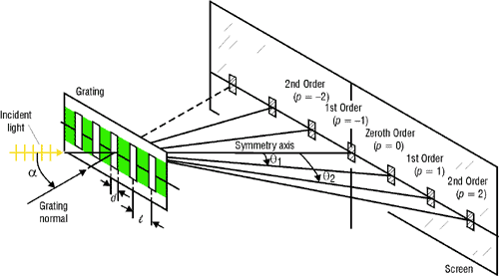
Figure 3-1, Light source being diffracted as it passes through a diffraction grating.

Grating Equation

The derivation of the grating equation is not a consideration of this paper and no attempt will be made to show how the equation was derived. If one wishes to understand how the equation was derived there is a wealth of information on the web as well as in many books. Instead we will be using the grating equation and variations of the grating equation to analyze the data acquired.

$$\text{Sin}(α)+\text{Sin}(q)={nλ}/l$$
Equation 3-1, Grating Equation

α = Angle of incidence of light with respect to the normal of the grating.
θ = Angle of the n^{th} order fringe.
l = Distance between the adjacent centers of the slits on the grating.
n = the fringe order (integers 1,2,3 etc.).
λ = Wavelength of the light source.

If the incident light is normal to the grating (α = 0) then the grating equation can be reduced to the more common form.

$$\text{Sin}(q)={nλ}/l$$
Equation 3-2, Common form of the Grating Equation with Incident light normal to grating surface.

Diffraction Orders Dispersion Angle
The dispersion (diffraction) angle of the light source can be calculated using the grating equation and solving for θ. The dispersion angle is the angle formed by the fringes after the light source passes through the diffraction grating.

$$\text{Sin}(q)=(n∗λ)/l$$
Equation 3-3, Finding the dispersion angle using Grating Equation.

For example if the following values are known:

λ = 0.640um
l = 1.0um
n = 1

Calculate the dispersion angle (θ) of the fringes, when using a 1000-line/mm grating:

Sin (θ) = (1 * 0.640um) / 1.0um
θ = Sin⁻¹(0.640 / 1.0)
θ = 39.79° degrees

The dispersion angle of diffraction can also be found by using trigonometry and equations for finding the angles of triangles. The grating is represented by line d and the distance from the zero-order fringe and the first-order fringe is Δd. The distance from the grating to the camera or eye is given by line D. The distance from the grating to the target is given by line D’. The distance between fringes and the distance to the camera or eye form a right triangle that can used to calculate the angle of diffraction between the fringes using trigonometry.

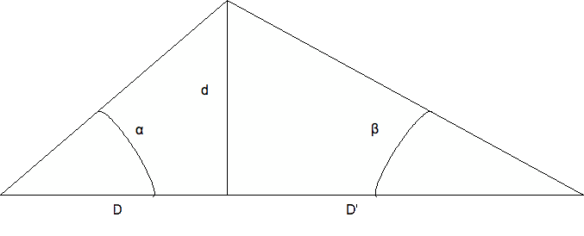
Figure 3-2, Angles formed by light reflecting off a target and viewed by a camera or eye.

D = Distance to viewing object, such as a camera or eye.
D’ = Distance to the target.
Δd = Distance from the zero-order fringe and first-order fringe.
α = The viewing angle of the first-order fringe as seen by the camera or eye.
β = Angle of diffraction of the reflected light from the target as seen through the grating.

If the incident light is normal to the grating surface (α = 0) then the diffraction angle (β) of the fringes can be found by using the following equation. The angle for α can also be found using the same technique.

$$\begin{aligned}\text{Tan}(β)=d/D' \\ β={\text{Tan}}^{−1}(d/D')\end{aligned}$$
Equation 3-4, Trigonometric equation for the angle of diffraction.

For example:

If d = 112.44mm, D = 135mm, solve for β.
β = Tan⁻¹(d/D),
β =Tan⁻¹(112.44mm / 135mm)
β = 39.79°

Summary
The dispersion angle, distance between diffraction orders (fringes), and distance to target can be calculated using a combination of the grating equation and trigonometry. The correct method to use would depend on the design parameters, design limitations, or information one is trying to find.
If the grating specifications and light source wavelength are known then the grating equation can readily be used to calculate the dispersion angle of the diffraction orders. Knowing the dispersion angle of the grating and distance between diffraction orders then the distance to target can be calculated.

3D Scanner

3D Scanner Overview
After an examination of existing prototype 3D scanners I decided that several design refinements were in order. The mounting structure that held the optics was modified, as well as a new support for improved alignment and a fixed height placement of camera and laser. The base for the 3D Scanner was also modified to allow for easier transport and placement.
A new system for securing the diffraction grating was also constructed. While the new diffraction grating holder can be further refined, the improvements over the original holder keeps the grating in a more secure and stable position.
To rotate the turntable a Lego Mindstorm RXTX controller was used. More robust systems are available such as stepper motors and controllers, but are a more expensive solution.

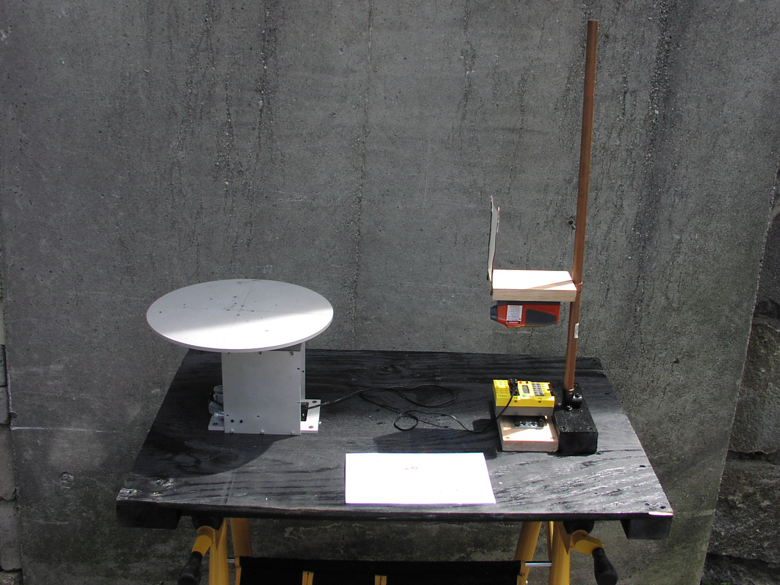
Figure 4-3, Original 3D Scanner

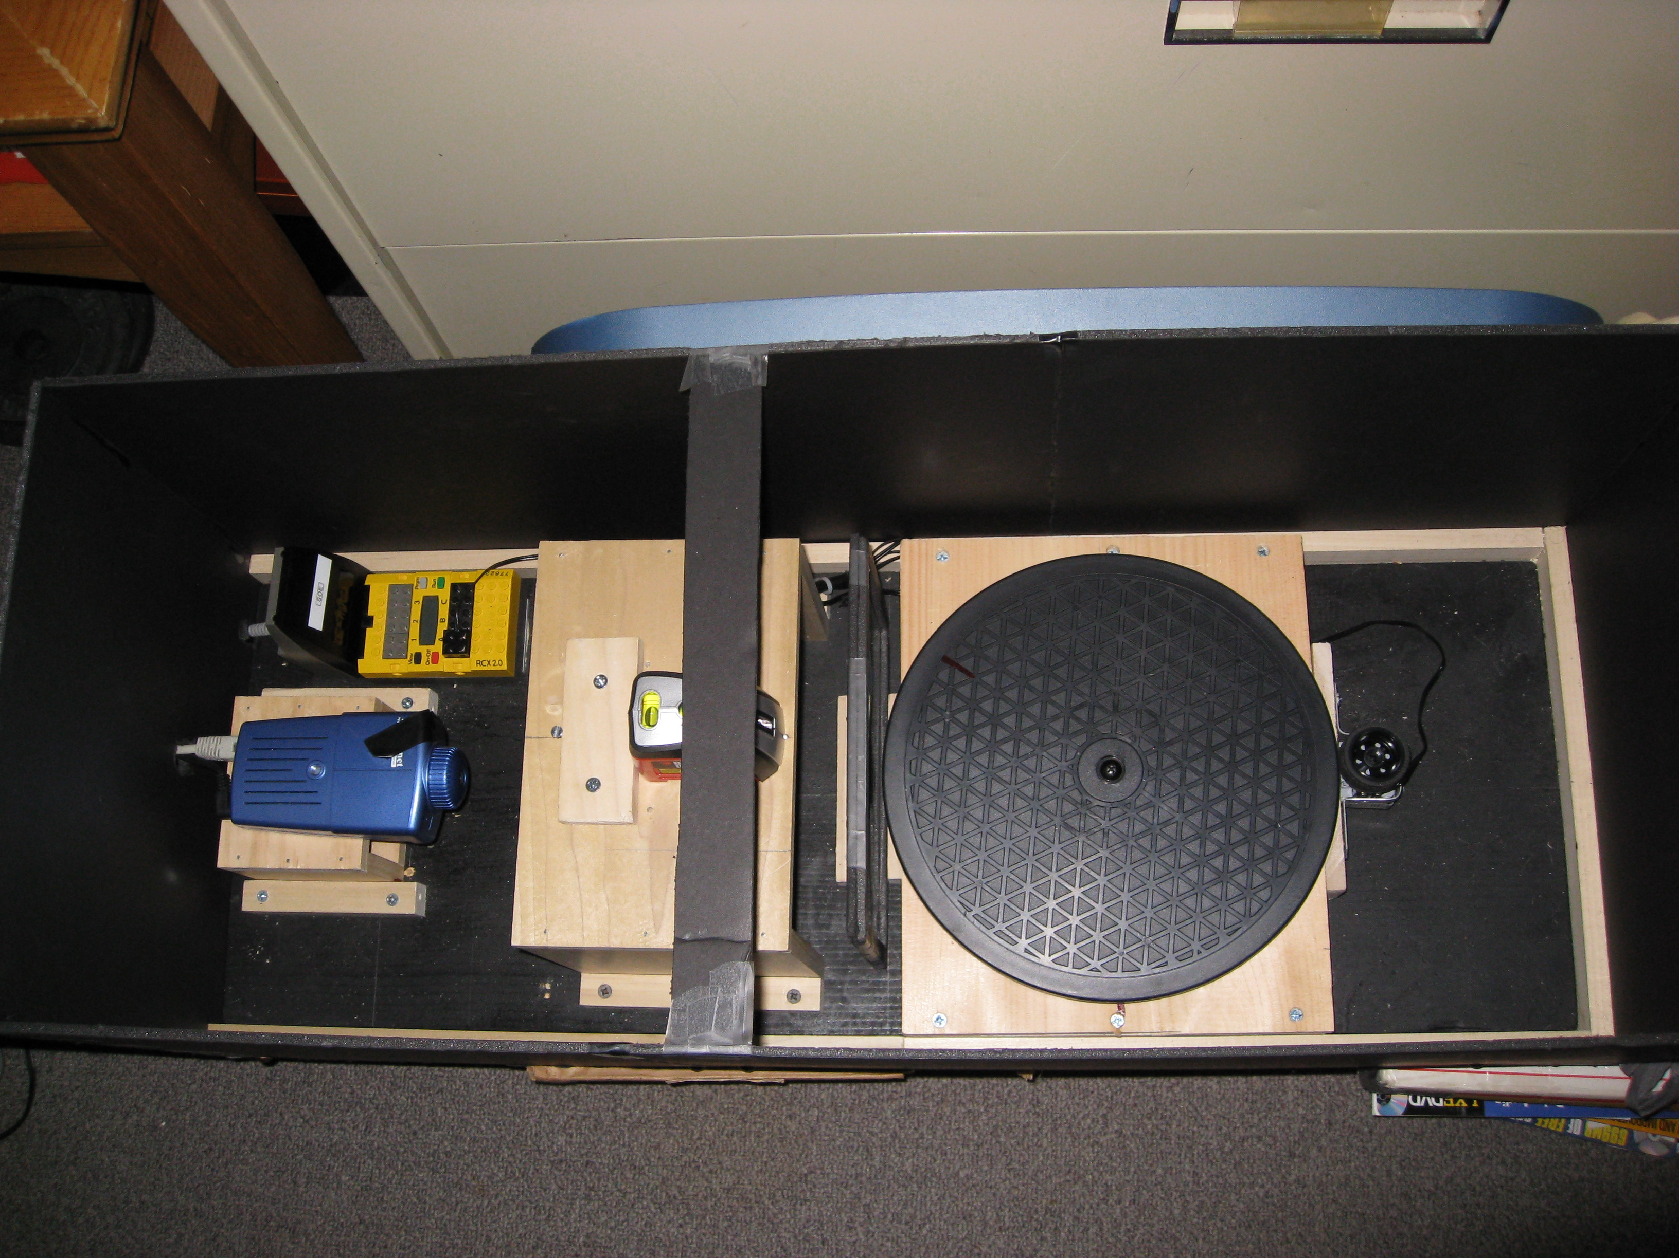
Figure 4-4, Modified 3D Scanner

Camera Selection
A USB camera and Java Media Framework (JMF) was first used but proved to be difficult to properly integrate. An alternative approach utilizing a network camera was found to be work better with the JAVA software environment. The USB camera and JMF concept was discarded in favor of the network camera.
Thanks to the work done by Dr. Douglas Lyon, drivers for using a network camera were already available in the software. The network camera selected had a built in web server which greatly improved the ease of integration into the image acquisition system by simply connecting the camera to the pc using an RJ45 crossover cable or regular network cable connected to a network router. Once the network camera was connected to the pc either directly using a crossover cable or through a network router the camera could then be accessed using its Internet Protocol (IP) address.

Laser Source
To illuminate the target a coherent light source was used. The coherent light source is a diode laser line generator projecting a visible red line with a wavelength of approximately 628nm at <5mW of power. The main requirements were that it be a red visible laser source with a 60°-fan angle. The fan angle of the laser allows for staging the laser closer to the turntable to help reduce the overall footprint of the 3D Scanner. An inexpensive laser, obtained at a local home improvement store proved adequate for the task of illuminating the target.

Grating Selection
Two different gratings were tested for quality of image resolution. A diffraction grating with a 500-line/mm pitch was first used then and a second diffraction grating with a 1000-line/mm pitch was used. Both gratings produced acceptable images with well-defined profiles. A visual check of the resulting images showed that the second grating, with 1000-line/mm, had better defined line then the first grating.
The decision was made to use a 1000-line/mm-pitch diffraction grating in the 3D Scanners optical path. The tradeoff using the 1000-line/mm grating resulted in a wider dispersion angle of the diffraction orders. The dispersion angle of the diffraction grating defined where the camera, target, and laser source had to be positioned for the zero-order and first-order fringes to be viewable. Only the zero-order and first-order of diffraction will be utilized for image processing

Design Criteria and optical pose
The diffraction angle and distance to target constrained the minimum width of the diffraction grating. The width of the grating had to allow for viewing of the zero-order and first-order fringes. For processing of the acquired images the zero-order and first-order provided the best image resolution. Viewing orders beyond the first diffraction order would have greatly increased the width of the grating with no gain in image resolution. The ability of the laser to illuminate the target was limited by the height of the grating and how far away the laser had to be positioned from the target. The camera then had to be positioned so that its field of view (FOV) was able to capture the zero-order and first-order fringes.
Based on the components selected the following design criteria for the 3D Scanner was used:

- Distance from diffraction grating to the center of turntable is 135mm.
- Diameter of the target should not exceed 86mm.
- Height of the target, at closest point to diffraction grating, should not exceed 85mm.

Scanner Layout

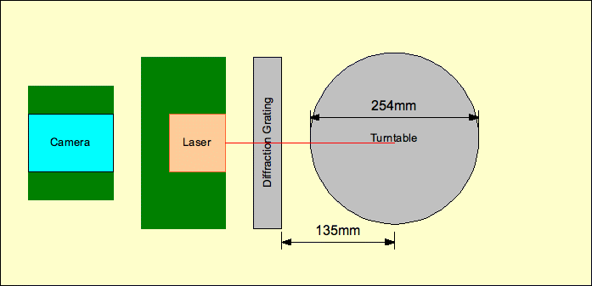
Figure 4-5, Top view of 3D Scanner.

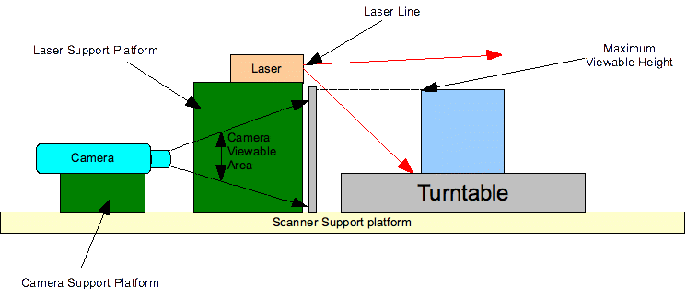
Figure 4-6, Profile view of 3D Scanner

Software
Java was chosen as the software platform to use for development of the image acquisition and hardware integration environment. There are advantages to using Java over other common software platforms such as C or C++. The major advantage is that Java is platform independent and the software application written can be used on different computer environments such as Mac, Linux, and Windows.

Testing the 3D Scanner
A calibration wedge was used as a resolution target for scanner performance characterization. Using the calibration wedge with known dimensions allows for verification of the scanners operation and characteristics.
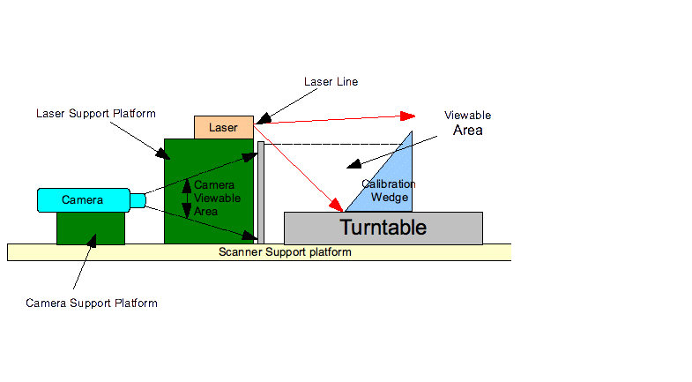

Figure 5-7, Profile of 3D Scanner Layout with Calibration Wedge.

Testing using the Calibration Wedge
The calibration wedge was positioned at 49mm, 92mm, and 135mm. At each position images were acquired using the JAVA Image Acquisition And Processing Software application developed. Images of the calibration wedge at the different positions have been included for viewing. The data from the acquired images was then analyzed.

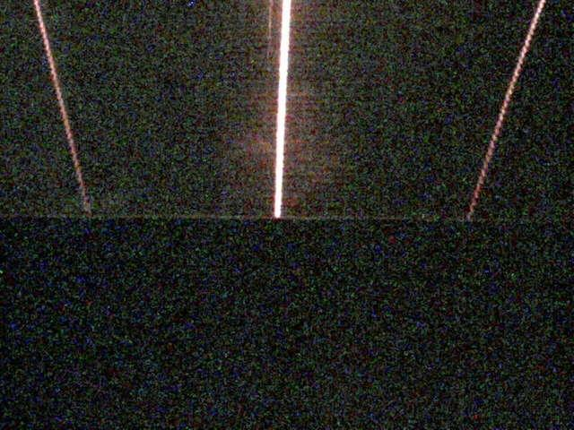
Figure 5-8, Front edge of calibration wedge, 92mm from diffraction grating.

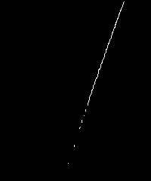
Figure 5-9, Right side first order of fringe, of the calibration wedge, 92mm from diffraction grating after processing.

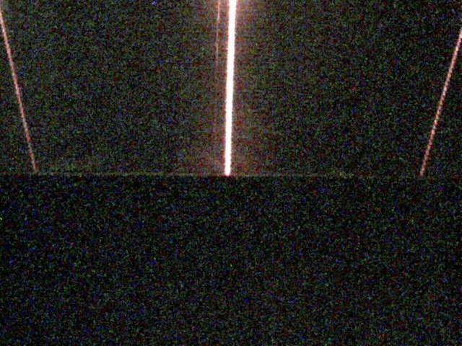
Figure 5-10, Front edge of calibration wedge, 49mm from diffraction grating.

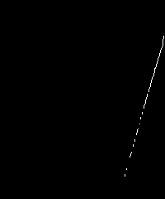
Figure 5-11, Right side first order of fringe, of the calibration wedge, 49mm from diffraction grating after processing.
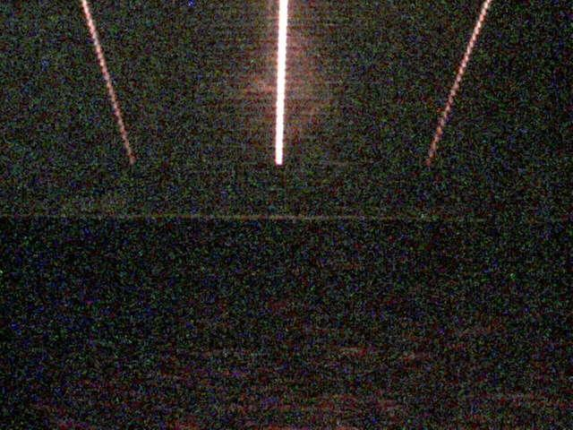
Figure 5-12, Front edge of calibration wedge, 135mm from diffraction grating.

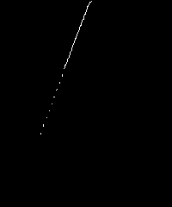
Figure 5-13, Right side first order of fringe, of the calibration wedge, 135mm from diffraction grating after processing.

Experimental Data

Table 6-1: Calibration Wedge Positioned 49mm From Diffraction Grating.
Y-Axis | 49mmL | 49mmC | 49mmR | Number of pixels between Zero Order and First Order on Left Side | Number of pixels between Zero Order and First Order on Right Side
46 | 6 | 301 | 638 | 295 | 337
47 | 6 | 301 | 637 | 295 | 336
48 | 6 | 301 | 637 | 295 | 336
49 | 6 | 301 | 637 | 295 | 336
50 | 7 | 320 | 637 | 313 | 317
51 | 7 | 320 | 637 | 313 | 317
52 | 7 | 320 | 637 | 313 | 317
53 | 7 | 320 | 637 | 313 | 317
54 | 8 | 320 | 637 | 312 | 317
55 | 8 | 320 | 637 | 312 | 317
56 | 8 | 320 | 636 | 312 | 316
57 | 8 | 320 | 636 | 312 | 316
58 | 8 | 320 | 635 | 312 | 315
59 | 8 | 320 | 635 | 312 | 315
60 | 8 | 320 | 634 | 312 | 314
61 | 9 | 300 | 634 | 291 | 334
62 | 10 | 300 | 634 | 290 | 334
63 | 10 | 300 | 634 | 290 | 334
64 | 10 | 300 | 633 | 290 | 333
65 | 10 | 300 | 633 | 290 | 333
66 | 10 | 300 | 633 | 290 | 333
67 | 11 | 300 | 633 | 289 | 333
68 | 11 | 300 | 632 | 289 | 332
69 | 11 | 300 | 632 | 289 | 332
70 | 11 | 300 | 631 | 289 | 331
71 | 12 | 300 | 631 | 288 | 331
72 | 12 | 300 | 631 | 288 | 331
73 | 12 | 319 | 631 | 307 | 312
74 | 12 | 319 | 630 | 307 | 311
75 | 12 | 319 | 630 | 307 | 311
76 | 12 | 319 | 630 | 307 | 311
77 | 13 | 319 | 629 | 306 | 310
78 | 13 | 319 | 629 | 306 | 310
79 | 13 | 319 | 629 | 306 | 310

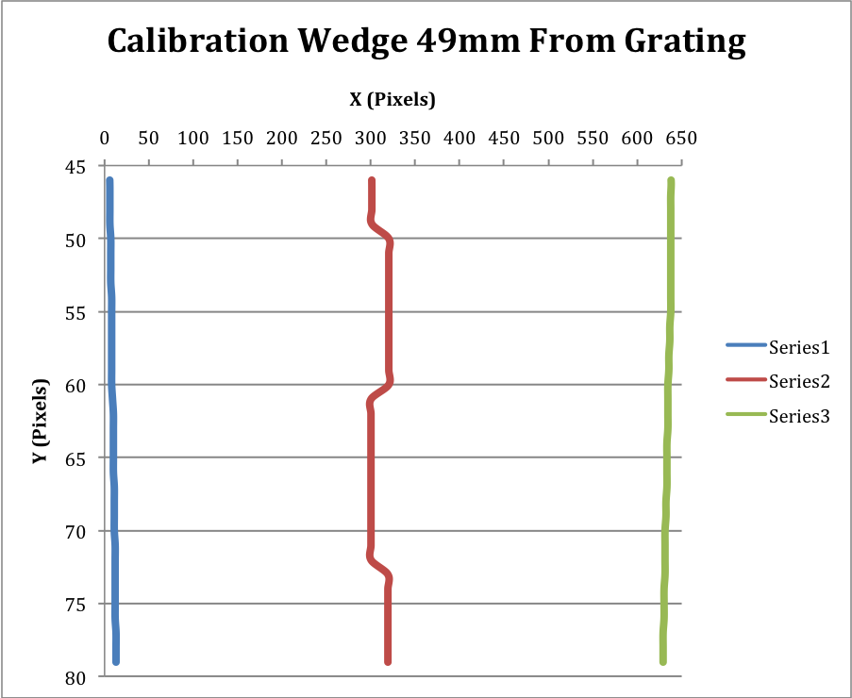
Graph 6-1, Calibration Wedge 49mm From Grating.
Table 6-2: Calibration Wedge Positioned 92mm From Diffraction Grating.
Y-Axis | 92mmL | 92mmC | 92mmR | Number of pixels between Zero Order and First Order on Left Side | Number of pixels between Zero Order and First Order on Right Side
46 | 50 | 317 | 588 | 267 | 271
47 | 51 | 317 | 587 | 266 | 270
48 | 52 | 316 | 587 | 264 | 271
49 | 52 | 316 | 587 | 264 | 271
50 | 52 | 316 | 587 | 264 | 271
51 | 52 | 316 | 586 | 264 | 270
52 | 52 | 316 | 585 | 264 | 269
53 | 52 | 316 | 585 | 264 | 269
54 | 53 | 316 | 585 | 263 | 269
55 | 53 | 316 | 584 | 263 | 268
56 | 54 | 316 | 584 | 262 | 268
57 | 54 | 316 | 583 | 262 | 267
58 | 54 | 316 | 583 | 262 | 267
59 | 54 | 316 | 583 | 262 | 267
60 | 54 | 316 | 582 | 262 | 266
61 | 55 | 316 | 582 | 261 | 266
62 | 55 | 316 | 582 | 261 | 266
63 | 55 | 316 | 582 | 261 | 266
64 | 56 | 316 | 581 | 260 | 265
65 | 56 | 316 | 580 | 260 | 264
66 | 56 | 315 | 580 | 259 | 265
67 | 56 | 315 | 580 | 259 | 265
68 | 57 | 315 | 580 | 258 | 265
69 | 57 | 315 | 580 | 258 | 265
70 | 57 | 315 | 579 | 258 | 264
71 | 57 | 315 | 578 | 258 | 263
72 | 57 | 315 | 578 | 258 | 263
73 | 58 | 315 | 578 | 257 | 263
74 | 58 | 315 | 578 | 257 | 263
75 | 58 | 315 | 578 | 257 | 263
76 | 59 | 315 | 577 | 256 | 262
77 | 59 | 315 | 577 | 256 | 262
78 | 59 | 315 | 576 | 256 | 261
79 | 59 | 315 | 576 | 256 | 261

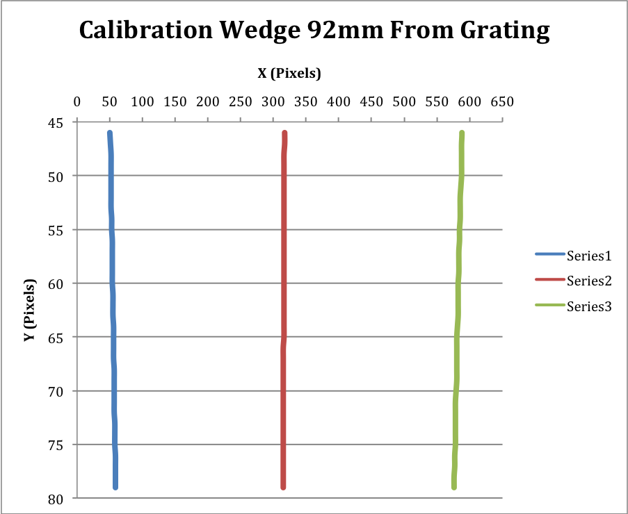
Graph 6-2, Calibration Wedge 92mm From Grating.
Table 6-3: Calibration Wedge Positioned 135mm From Diffraction Grating.
Y-Axis | 135mmL | 135mmC | 135mmR | Number of pixels between Zero Order and First Order on Left Side | Number of pixels between Zero Order and First Order on Right Side
46 | 107 | 315 | 527 | 208 | 212
47 | 107 | 315 | 526 | 208 | 211
48 | 108 | 315 | 526 | 207 | 211
49 | 108 | 315 | 526 | 207 | 211
50 | 108 | 315 | 525 | 207 | 210
51 | 109 | 315 | 525 | 206 | 210
52 | 109 | 315 | 524 | 206 | 209
53 | 109 | 315 | 524 | 206 | 209
54 | 109 | 315 | 524 | 206 | 209
55 | 109 | 315 | 523 | 206 | 208
56 | 110 | 315 | 523 | 205 | 208
57 | 111 | 315 | 523 | 204 | 208
58 | 111 | 315 | 523 | 204 | 208
59 | 111 | 315 | 522 | 204 | 207
60 | 111 | 314 | 521 | 203 | 207
61 | 111 | 314 | 521 | 203 | 207
62 | 111 | 314 | 521 | 203 | 207
63 | 112 | 311 | 521 | 199 | 210
64 | 112 | 310 | 520 | 198 | 210
65 | 113 | 304 | 520 | 191 | 216
66 | 113 | 313 | 520 | 200 | 207
67 | 113 | 313 | 519 | 200 | 206
68 | 113 | 313 | 518 | 200 | 205
69 | 113 | 313 | 518 | 200 | 205
70 | 113 | 313 | 518 | 200 | 205
71 | 114 | 313 | 518 | 199 | 205
72 | 115 | 313 | 517 | 198 | 204
73 | 115 | 313 | 517 | 198 | 204
74 | 115 | 313 | 516 | 198 | 203
75 | 115 | 313 | 515 | 198 | 202
76 | 116 | 313 | 515 | 197 | 202
77 | 116 | 313 | 515 | 197 | 202
78 | 116 | 313 | 515 | 197 | 202
79 | 117 | 313 | 514 | 196 | 201

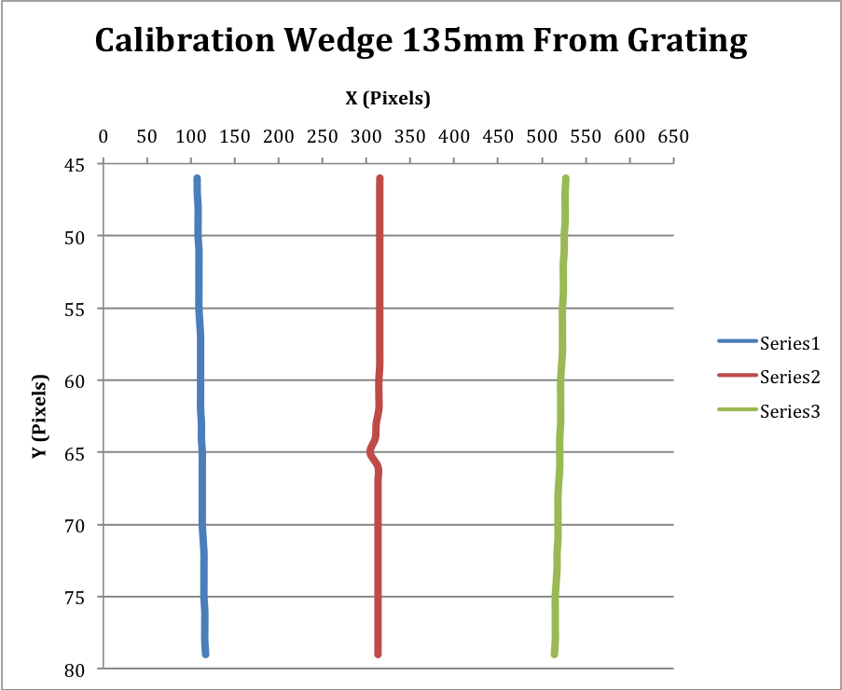
Graph 6-3, Calibration Wedge 135mm From Grating.

Performance Characteristics

Resolution
The acquired data was analyzed and the resolution of the scanner documented in the following tables.

Table 7-4: Average Number of Pixels.
Distance to Target | Between Zero Order and First Order on Right Side | Between Zero Order and First Order on Left Side
49mm | 301.029 | 323.206
92mm | 260.559 | 266.059
135mm | 201.735 | 207.088

The grating equation can be used to calculate the true dispersion angle of the diffraction grating using the grating pitch and wavelength of the actual laser light source used.

Table 7-5: Using Grating equation to calculate dispersion angle of 1000 line per mm grating.
Number of slits per mm (q): | 1000
One mm in meters: | 0.001
Center to center distance between slits (p) in meters (1mm/q): | 0.000001
Wavelength of light source (lambda) in meters: | 0.000000629
Diffraction Order (n): | 1
Dispersion Angle (sin(a)=(n*lambda)p) in degrees: | 39°

Using trigonometry, the true distance between the zero-order and first-order fringes can be calculated.

Table 7-6: Using trigonometry to calculate mm per pixels from acquired data.
Calculated dispersion Angle of grating: | 39
Distance from grating to target (D) in mm: | 135
Tan(b): | 0.806
Distance between zero-order and first-order fringes in mm: | 108.865

The pixels per mm can be calculated by divide the number of pixels between the zero-order and first-order fringes by the distance between the fringes.

Table 7-7: Pixels per mm.
Distance to Target | Between Zero Order and First Order on Right Side (pixels/mm) | Between Zero Order and First Order on Left Side (pixels/mm)
49mm | 2.765 | 2.969
92mm | 2.393 | 2.444
135mm | 1.853 | 1.902

The minimum resolvable distance can be found by taking the reciprocal of pixels per mm to obtain the resolvable distance in mm.

Table 7-8: Average distance resolvable.
Distance to Target | Between Zero Order and First Order on Right Side (mm) | Between Zero Order and First Order on Left Side (mm)
49mm | 0.36 | 0.34
92mm | 0.42 | 0.41
135mm | 0.54 | 0.53
Average | 0.44 | 0.43
Standard Deviation | 0.091 | 0.096

Based on the analysis of the experimental data, the resolution of the scanner was found to range from 0.34mm at 49mm from the grating to 0.54mm at 135mm from the grating.

Scanner Comparison
The resolution and dimensions of the 3d Scanners was compared against two other scanners, one from VXTechnologies and one from Cyberware. The results were documented in the following table

Table 8-9, Comparison of the 3D Scanner with other scanners on the market.
 | 3D Scanner | VXTechnologies  StarCam | Cyberware
Field of View | 12" X 7" (310mmX178mm) | 21" X 16" (533mmX406mm) | 14" X 17" (350mmX440mm)
Resolution | 0.017" (0.44mm) | 0.019" (0.48mm) | 0.015" (0.38mm)
Width | 11.5" | 16.375” (416mm) | 188.2 cm (74.1")
Height | 14" | 11.000” (280mm) | 205.3 cm (80.8")
Length | 30" | 9.250” (235mm) | Not Given

Conclusion
Using JMF and a USB camera was problematic and had to be scrapped in favor of a different hardware and software configuration. The network camera was found to be an easier configuration and was used in place of the USB camera. The additional benefit of using a network camera is that it can be connected to a network router for remote viewing and control of the image acquisition system.
The average resolution of the 3D Scanner was found be between 0.43mm and 0.44mm, comparable to other rangefinders on the market. Considering that the 3D Scanner was constructed mostly of wood and still able to achieve a very good resolution in comparison to more expensive models is a remarkable achievement. Overall the design of the scanner can be further improved for performance and marketability.
The software application used to acquire and process the data from the scanned objects still needs to be worked on to improve its user interface and ease of use.

Discovered Problems
The automatic gain of the network camera could not be turned off. The inability to turn off the automatic gain introduced additional noise and blooming of the fringes as viewed through the camera. The additional noise and blooming of the area around the fringes caused the image processing algorithms to remove excess data points during processing.
The turntable was difficult to rotate with accuracy due to warping of the mounting platform used to support the turntable. The Lego motor also proved inadequate to rotate the turntable in even steps.

Future Work
Future work that would enhance the scanners usability and marketability includes replacing the turntable with a robust model; replacing the Lego motor and RXTX controller with a stepper motor and controller for improved step resolution. Once the problems controlling the turntable are resolved the repeatability of the 3D Scanner can then be characterized. Increasing the laser fan angle from 60° would allow the laser to be positioned closer to the target, further reducing the scanners footprint. Replace the current camera with one that allowed turning off the automatic gain. The ability to turn off the automatic gain of the camera would reduce the noise and blooming that the automatic gain introduced into the images.

Appendix

Hardware Specifications

Table 12-10: Grating Specifications from Vendor Catalog.
Vendor: | Edmund Scientific
Description: | Holographic Diffraction Grating Film
Product Number: | A40-267
Material: | Clear Polyester Film
Dispersion Angle: | 36°
Thickness: | 0.003”
Groove Orientation: | Linear, parallel to the shortest dimension.

Table 12-11: Camera Specifications
Vendor: | Trendnet
Mode Number: | TV-IP100
Focal Length: | 6mm
F Number: | 1.8
Sensor Type: | ¼ inch CMOS
Pixel Array Size: | 640x480

Table 12-12: Laser Specifications
Vendor: | Black & Decker
Model Number: | BDL220S
Wavelength: | 629nm

Table 12-13: Wedge Specifications
Height: | 142mm
Width: | 50mm
Depth: | 86mm
Step Size: | 2mm

Initial Work Using Java Media Framework
Dr. Douglas A. Lyon, a Professor at Fairfield University in Fairfield Connecticut, explored the use of Java for embedded vision applications [Lyon]. Java Media Framework was utilized to allow for the use of USB cameras with java.
In order to reproduce and utilize the same software written I undertook to utilize Java Media Framework (jmf). There was some difficulty in getting jmf version 2.1.1e to work with IntelliJ 4.5. The image acquisition software that was designed for use with the 3D Scanner and a USB camera requires jmf in order for the USB camera to be usable. After installation of the jmf software a USB camera was successfully tested and found to work. When the java program used to take the images was run in IntelliJ no image could be taken due to the fact that the software did not recognize the USB camera. I reinstalled jmf a number of times and came to the conclusion the problem was with the configuration of IntelliJ. A lack of sufficient information regarding how to configure IntelliJ to work with jmf made this difficult. After a number of attempts at configuring IntelliJ I was finally able to use the java image acquisition program with the USB camera. In order for jmf to work with IntelliJ 4.5 the following steps are necessary:

- Download jmf2.1.1e from http://java.sun.com/products/java-media/jmf/2.1.1/download.html.
- Install jmf2.1.1e by running the executable (the software will make any necessary modification to CLASSPATH and PATH so any directory location should be usable).
- Start IntelliJ and open up the settings window.
- Under the IDE Settings click on JDK & Global Libraries.
- With the Classpath Tab selected click on ADD.
- Go to the location were the jmf2.1.1e\lib directory is located.
- Select the jar files by holding the ctrl key down and left mouse clicking on each jar file.
- Click OK when done selecting the jar files.
- The path to the jar files should now be listed under the Classpath Tab.
- Click OK to exit out of the window
- Close the Settings window.

The jmf libraries should now be accessible from within IntelliJ.
Using Java Media Framework for control of the image acquisition hardware was not straightforward and in the end proved difficult to implement.

Literature Cited
[Lyon] “Diffraction Rangefinding in Java”, Douglas Lyon, November 17, 2004
[Lyon2] “A Resolution Characterization of a Diffraction Rangefinder”. Douglas Lyon, August 25, 1996
[Prados and Faugeras] Emmanuel Prados, Olivier Faugeras “Shape From Shading”,
[Dewitt]Tom Dewitt, “3D Image Acquisition By Diffraction Profilometry”, Paper Summaries of SPSE’s 42nd Annual Conference, May ’89, pp. 51-54
[Dewitt2]Tom Dewitt, “Range Finding by the Diffraction Method”,
[Besl]Paul J. Besl, “Active, Optical Range Imaging Sensors”, Machine Vision and Applications (1988) 1:127-152
[Dalley & Flynn]Gerald Dalley, Patrick Flynn, “Range Image Registration: A Software Platform and Empirical Evaluation”, IEEE: 246-253, 2001

Footnotes

LEGO MINDSTORM and RXTX Controller are products of the LEGO Corporation Robotics Invention Systems.
www.csc.noaa.gov/products/sccoasts/html/tutlid.htm
Java Media Framework is a product of SUN Corporation.
Internet protocol the standard that controls the routing and structure of data transmitted over the Internet Encarta® World English Dictionary © 1999 Microsoft Corporation. All rights reserved. Developed for Microsoft by Bloomsbury Publishing Plc.
Java is a product of SUN Corporation.
www.vxtechnologies.com
www.cyberware.com
Java IDE from Jetbrains, used to run the development software. www.jetbrains.com

