ECE420 – Readings in ECE
Thesis Proposal

Pantomation5- Wireless Mouse for disabled individuals

Submitted by: Daron Egerton Bucknor

In partial fulfillment of the requirements for
Master of Science in Electrical and Computer Engineering

Fairfield University

Fairfield, Connecticut

Abstract

This thesis presents a next generation Pantomation5 tool that will aid quadriplegics, brain-damaged individuals and individuals suffering from carpal tunnel syndrome to communicate by way of a vision system that does gesture interpretation. The goal is to enable the tracking of a cooperative target affixed to the user’s hat so that a reliable means of controlling the mouse is available to those who are unable to effect mouse movement. The system uses a tracking a chroma-key to obtain relative mouse position information. Distinctive speech recognition technology is used to enable the interpretation of mouse clicks. The Real Virtual Networking Computing (VNC) project is used as a means of remotely controlling a computer, over a network. Several different types of cameras will be available for the system, but our primary focus is on low-cost off-the-shelf hardware to act as a means of providing the vision input. Thus, the primary focus of this work is on real-time image processing with high-end desktop computers and commercial off-the-shelf cameras (i.e., inexpensive web-cameras).
The pantomation5 system, unlike its predecessors, will accomplish mouse movement by employing a non-biological cooperative target. This is essential because previous releases that use biological cooperative targets such as cornea tracking produce inconsistent results because of variation in individuals’ genetic makeup.

Table of contents

  - Introduction ……………………………………………………………….. 4
1.1 Problem Statement …………………………………………………. 5
1.2 Motivation …………………………………………………………… 6
1.3 Approach …………………………………………………………….. 7
1.4 Alternative approach ……………………………………………. 8
1.5 Desired Result …………………………………………………… 9-
1.6 Societal Implication ………………………………………………….. 10
1.6.1 Safety Issues ………………………………………………….. 11
1.6.1 Ethical Ramification …………………………………………... 12
1.6.3 Contribution ……………………………………………….. 16
1.6.2 Milestone Chart ………………………………………………... 17
2.0 Historical Review ……..………………………………………………….. 18
3.0 Validation ………………………………………………………………..... 19
4.0 Conclusion ………………………………………………………………. 20
5.0 Bibliography ……………………………………………………………… 21

1.0 Introduction
The pantomation5 system is designed for people who are paralyzed from the neck down or individuals suffering from carpal tunnel syndrome. Their condition may have been as a result of illness such as cerebral palsy or congenital brain disorders or as a result of an accident or painful progressive condition caused by compression of a key nerve in their wrists. Pantomation5 enables control over a pick device, such as a mouse. After installation of the VNC server software on the target platform, no other modification of hardware or software will be required on the target machine. Another computer on the local-area-network (LAN) will perform the image processing and control the target machine. By keeping the target machine different from the machine running the pantomation5 system, we hope to have better control over configuration and processing latency, which allows appropriate human-computer interfaces [Paul]. This device allows the individual to control the mouse in a computer system using head movement. The cooperative target is placed on the brim of a hat that is used to effect mouse pointer movement. The target is a colored tag that is easily recognized by the pantomation5 software [26]. The mouse click is effected by making use of distinctive speech recognition done by digital signal processing. Whereby, command by the user will denote right mouse click, the left mouse click and double mouse click. Because the intended users of the pantomation5 system are severely disabled, VNC is a perfect choice since it provides mobile computing without requiring the user to carry any device whatsoever.

  - Problem Statement
Developing a system to help individuals with no voluntary muscle control below their neck is nothing new. Predecessors to the pantomation5 system limited the user to control the device in that location in which the machines are located. I wanted to develop a way to allow the user to have access to his or her communication machine from virtually anywhere he or she chooses with robust response time from all components within the system. The pantomation5 system solves that problem by allowing the individual to have access to his or her device at will, wherever he or she wishes [3]. The pantomation5 system has a distinct advantage in that instead of allowing the user access to resources anywhere in the world from the home computing environment. The VNC application provides access to the home computing environment from anywhere in the world including any web browsing terminals such at airports and coffee houses that offer wireless internet access.
The decision to apply VNC is easily made because of the portability of the system and the relative size of the components. VNC system is a thin client and solves the problem of cost. Since it is thin client, it gets its software and data from network servers, the centrally stored data and application collection and distribution dramatically reduces expense. Gesture interpretation is achieved by capturing images with off-the-shelf camera and computer setup that is programmed to track chroma-key attached to the users’ hat [Yeasin].

1.2 Motivation
The motivation behind the pantomation5 system is to get the user to communicate his or her thoughts independently and not be confined to the room where the server and computing hardware are stored. Therefore, the user should be able to have access to the device and at will and be able to communicate whatever experience he or she is enjoying with anyone [13].
The pantomation5 system is designed to meet wireless engineering and computing standards that puts the system on the cutting edge of today’s technology. The components are meant to be versatile yet practical. The system, while unique, is meant to interface with some of the more popular technology such that the applications and computer interfaces become an open cross-platform standard through the thin-client-computing. The thin client provides versatility in that it can run PC applications without PC management, therefore the user can access the server and run the pantomation5 application remotely without having the application itself running on different machines.
A popular predecessor to the pantomation5 system is Eye-gaze Response Interface Computer Aid (ERICA). This system measures ocular point of focus based on the ‘bright eye’ occurrence. This system, while effective to a certain extent, has drawbacks that I will expand upon later [Hutchinson].

Fig. 1
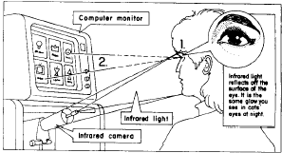
Model of Eye-gaze Response Interface Computer Aid (ERICA).

1.3 Approach
Image processing will be done locally through a tracking chroma-key placed on, for example, brim of the user’s hat [Bal]. An inexpensive camera will be able to send mouse position back to the server. Mouse clicks will be generated by distinctive speech commands that will be captured by digital signal processing. The system will accomplish its task by applying statistical modeling to a set of movements through image processing in conjunction with spoken commands issued by the user through speech recognition. The approach for mouse clicks has been agreed upon. This will be accomplished by speech recognition whereby the user will speak commands in English to effect all possible mouse click functions. Therefore, the user will say “Right-click”, “Left-click”, “Mouse-down”, “Mouse-release” and “Double-click” and the mouse will carry out the stated functions after the commands have been received and processed by the system. Speech recognition for the pantomation5 system should make use of the typical parameters used to characterize the capability of speech recognition systems outlined in the table in figure 2 below [12].

Fig. 2
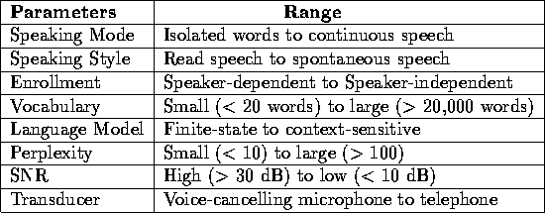
Table: Typical parameters used to characterize the capability of speech recognition systems

The information received from the user will then be passed to the server running the pantomation5 application and stored data. The pantomation5 system, based on advanced algorithm, will be designed robustly with error tolerance based on probabilistic methods. For example, performance of speech recognition systems is typically described in terms word error rate where, E, defined as:

Where S, I and D are the total number of substitutions, insertions, and deletions, respectively; essentially, we would want to make E as small as possible to reflect low error rate [9].
Error tolerance is essential because of intermittent unpredictable behavior that the user may display. This method is designed to cope with some degree of uncertainty and more accurately predict the likelihood that the behavior carried out is the intended gesture, or spoken command intended, barring such challenges created externally such as lighting and background noise.
VNC allows the user to operate the system through thin client architecture. This approach gives the user mobility and the framework provides quick response time even if the user is not in the same geographic location as the dedicated server. A model of the System is outlined in figure 3 below [3].
Fig. 3

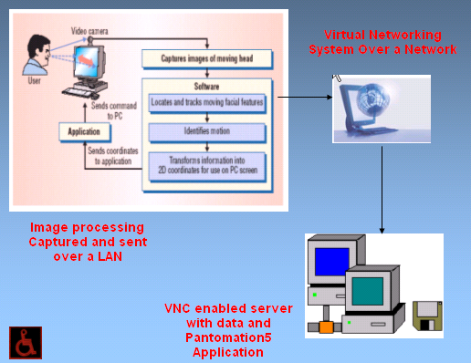

1.4 Alternative Approach
The competing approach to the pantomation5 system that uses a centralized server as the work-horse running the application is to have a system that has and all its components in a static physical location. The system would consist of three components, namely a cooperative target designed with extremely unique colorization attached to the individual’s chin, a camera with dedicated function to determine mouse position based on tracking this cooperative target and a PIC18 circuit board programmed to get information from the camera shooting different frames [6]. The framing determines next cursor position, by comparing the current frame to the previous frame. This system poses a challenge, however. The pantomation5 system was designed with mobility in mind. Using the competing architecture would limit the user to one physical location. The issue of immobility rids the pantomation5 system of its uniqueness.
Another drawback to this approach is the response time of the PIC18. It would be too taxing on the system. This system of approach would also pose interfacing issues since; based on the pantomation5 concept, there might be limited software application for PIC18 development.

Fig.2 Competing approach

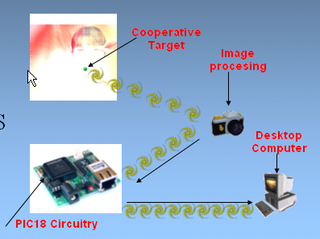
Gesture recognition using PIC18 programming

1.5 Desired Result
The dedicated VNC server should be running the application continuously when initiated. Meaning, the Virtual Networking Communication should maintain a state of seamless connection. The user should be able to control the contents on the server as he or she would while accessing the physical components of a standard desktop PC without experiencing latency. It is the desire to tap into the full advantage of the VNC itself by tapping into the multi-platform implementation characteristic since users may be using different operating systems to run the pantomation5 application [2].
It is also desired that I will accomplish a small error rate in speech recognition and when error does occur I will be able to adjust the parameters of the model to produce optimal performance.

  - Societal Ramification
It is my responsibility to assess the effects of this technology whether good or bad, and make the findings public. Failure to do due diligence and appraise the device before deploying it to the market is construed to be negligence my part. Negligence is often used to mean blameworthy behavior by individuals of professional groups. Engineers are not excluded form this list of professional [Johnson]. At the present time I can only envision positive effects as a result of the pantomation5 system. This device will help all individuals who would like to use the computer to surf the web and invoke mouse commands and who would otherwise be unable to do so if the pantomation5 is not developed. Since the device is not a weapon or a device that will aid negative actions, it can only be viewed as a helpful tool.

    - Safety Issues
As I work on the device, there is one safety issues that come to my mind. Because I am still learning the concept of the VNC, I am yet to determine how all the components will interface with one another. It is possible that if the components do not interact favorably with each other, then the system may fail. Failure of the system may or may not cause harm.

1.6.2 Ethical Ramification
Because I shall adhere to the engineering code of ethics, I must design, test, and disclose any flaws that I encounter in throughout the stages of development. Because I may not be doing the actual configuration of the system, it is likely that employees who are involved in the actual assembly may try to cut corners in assembly and testing. I will make all employees aware that we should avoid conflict of interest and build the units with strict ethical standards. Humans do make mistakes, it is important, however, to build the pantomation5 device around the code that build from the engineering code of ethics and make it a required training while individuals are employed to build the device. Any actions otherwise constitute a violation of the code of ethics and cold result in ethical ramifications [Johnson].

1.6.3 Contribution
With no hard evidence to support with certainty the impact that the device will have, it is hard to determine true contribution. Judging from the mechanisms that are currently being used, the pantomation5 system is expected make a big contribution for individuals who can speak but having limited movements below the neck. There is the ERICA system that is designed to track the cornea of the eyes; however, the system is sometimes ineffective for individuals with ‘bright-eye’ variation based on genetics. Also, mouse control is an automatic process based on continued stare by the user on a particular object on screen for a predetermined length of time [11]. This results in frequent calibration and erroneous mouse behavior because users oftentimes select objects on screen which he or she had not intended to select. The pantomation5 system solves these problems first by using color tracking instead of genetic cornea tracking and secondly by allowing the user to use speech recognition to manually invoke mouse functions.

1.6.4 Milestone
The primary goal for this semester is to design a wireless mouse for individuals who cannot physically operate a computer with conventional mouse. This design phase is also the first milestone for my thesis. The second phase would be to implement the device and conduct tests to validate favorable system performance.

Fig. 5
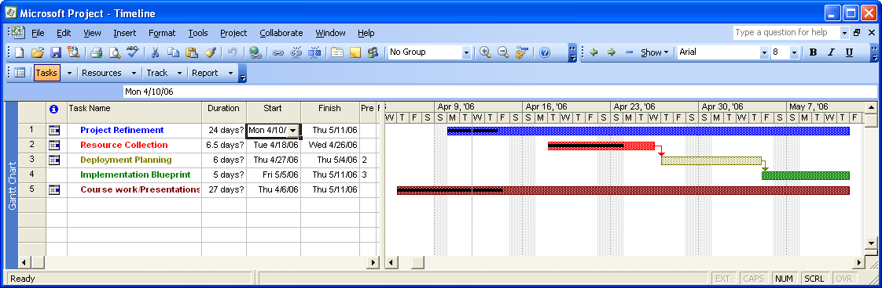

- Historical Review
VNC was developed by Olivetti Research Ltd / AT&T Labs Cambridge which made it available to the public in 1998. In 2002 they've founded a company called Real VCN which is doing further work on it. As the protocol itself is open, there are other designs and implementations around now: TightVNC, Ultr@VNC. Typically, VNC uses TCP as its transport protocol. The are some well known TCP ports for VNC traffic: 580x and 590x, the x must be replaced by the number of the virtual desktop[32].
Spoken language interfaces to the computer is a topic that has facinated engineers and speech scientists alike for over five decades. For many, the ability to converse freely with a machine signals the ultimate challenge to our understanding of the production and performance process in human speech communication. Advances in human language technology are needed for the average citizen to communicate with networks through natural communication skills using devices, such as telephones and computers. When one thinks about speaking to computers, the first image is usually speech recognition, the conversion of an acoustic signal to a flow of words [10]. After many years of research, speech recognition technology is beginning to become the standard in many systems. Over the years there has been dramatic improvement in speech recognition technology, to the extent that high performance algorithms and systems are becoming more abundant in everyday life. It is this emerging technology that I will incorporate in the advanced pantomation5 system to make it effortless for disabled users to effect mouse functions.

- Validation
It is imperative that the pantomation5 system is tested with the highest standards in mind. Validation will include stand alone testing of all components separately to judge life-span of individual components as well as flaws that may arise as result of continuous use. If the components are found to be inconsistent or fails intermittently, then we will need to find replacements that will satisfy the same function.
When components are considered satisfactory, it will be necessary to execute integration testing to judge how all components will function as one logical unit. At this point it will be necessary to observe effects of one component on another to validate system consistency.
If component integration is validated, then we need to do acceptance testing on different population. The subjects that we intend to test the system shall not be limited to those members for whom the system was intended; meaning that acceptance testing should include disabled as well as able bodied individuals. If these three testing phases deliver acceptable results, this should give us an indication about the soundness of the system. Please bear in mind that the validation stages are very high level and should meet engineering standards based on its precepts. Please see the validation in figure 4.

Fig. 4
Validation chart

4.0 Conclusion
Computer and information technology, especially the Internet offer great rewards for the future. As engineers we must be vigilant in shaping and steering the technology available to us. The pantomation5 device seeks to utilize that which is available to construct a tool that will be of great help to individuals who need it. Sharing information seems to be important for binding individuals together. With that much said the pantomation5 will contribute to the dissemination of information and in turn bring us that much closer to those who will use the device.

5.0 Bibliography

[1] http://www.vecmar.com/thin_client/thin-client-explained.htm
[2] http://www.13thmonkey.org/documentation/misc/VNC-paper-98.1.pdf
[3] http://www.tightvnc.org/intro.html
[4] http://www.networkcomputing.com/showArticle.jhtml?articleID=23900509&pgno=2
[5] http://www.ph.tn.tudelft.nl/Courses/FIP/noframes/fip-.html
[6] http://www.bc.edu/schools/csom/eagleeyes/cameramouse/about/
[7] http://www.ninds.nih.gov/disorders/carpal_tunnel/carpal_tunnel.htm
[8] http://www.canesta.com/assets/pdf/news/2004/Canesta_IEEE_Computer_10_04.pdf
[9] http://cslu.cse.ogi.edu/HLTsurvey/ch1node4.html
[10] http://www.eee.strath.ac.uk/r.w.stewart/digital/6
[11] Hutchinson, Thomas E. Eye-gaze computer interfaces, UVA
[12] http://cslu.cse.ogi.edu/HLTsurvey/ch1node3.html#11
[13] Paul, George V. et al. A real-time Object Tracking System using a Color
Camera
[14] Bunyarit Uyyanonvara et al. Novel fast color reduction algorithm for
time-constrained applications
[15] Yeasin, Mohammed et al. A Multiobject Tracking Framework for Interactive
Multimedia Applications
[16] Pantic, Maja et al. Facial Action Recognition in face profile image
sequences
[17] Semenov, M. A fast algorithm for choosing the proper palette in real-image
representation
[18] Sato, Yoichi et al. Video-based tracking of user’s motion for augmented
desk interface
[19] Shimoide, Alan Automated Behavioral phenotype detection and analysis
using color-based motion tracking
[20] Afzulpurkar, Nitin V. et al. Real Time, Dynamic Target Tracking using
Image Motion
[21] Bal, A. et al. Automatic Target Tracking in FLIR Image Sequences using
intensity variation Function and template modeling

[22] Thornton, AL Colour object location using complex coding in the frequency
domain
[23] Worthy, Martin N. Human-Computer Interaction Using Eye Gaze Input
[24] Borko, Fuhrt. Video and image processing in multimedia systems
[25] S. Intill, et al. Real time closed-world tracking
[26] G.R Bradski Computer vision face tracking for vision-based human
computer interaction
[27] Y. B Shalom et al. Tracking and data association
[28] I. J. Cox A review of statistical data association techniques for motion
correspondence
[29] E. Huber Real-time gesture recognition using proximity space
[30] S. Blackman et al. Design and Analysis of Modern Tracking Systems
[31] Johnson, Deborah G. Computer ethics
[32] http://wiki.ethereal.com/VNC

