MAGNETIC PULSE WELDER (MPW)

Andrew Gust

ECE 420 Readings

Final

May 4, 2006

ABSTRACT

A cold weld process is provided that allows for the joining of tubing, in particular, copper tubing, such as in plumbing circuits. The cold weld process uses magnetic pulse welding which is welding via a magnetic field applied to an outer workpiece in order to collapse the outer workpiece onto an inner workpiece at a high enough velocity to achieve a full metallurgical bond. The magnetic field is created via a coil while the impulse current is created via a capacitor bank. The coil is separable to allow for manipulation of the device with respect to the tubing being welded. The MPW device advantageously provides a faster and simpler method as compared to soldering, which is typically used in residential, commercial and industrial settings. Testing should establish that the MPW joints are as good, if not better, than the joints created via soldering.

TABLE OF CONTENTS

Problem Statement…………………………………………………….4

II. Motivation……………………………………………………………….4

Approach………………………………………………………………..5

Expected Data and Validation……………………………………….10

- Societal Implications………………………………………………….12

- Historical Review………………………………………………………13

Literature Cited……………………………………………………..…21

I. Problem Statement:

In residential, commercial and industrial settings, workpieces, such as tubes or conduits, require attachment to form a circuit in a fashion that provides strong joints that are typically waterproof and air-tight. A new process is proposed for attaching the tubes that is both fast and simple to use. Minimizing the cost of joining the tubes, such as reducing energy usage and material requirements, is also a constraint upon the process. The goal is to create a low-cost, fast process that is easy to use, readily available, and results in a complete metallurgical bond between the tubes.

II. Motivation:
In creating a plumbing circuit, the sweating of copper piping via solder is both time consuming, and difficult for a novice. Incomplete soldered joints can result in damage over time, e.g., a leak springs after the wall is completed. The present MPW device is primarily focused on plumbing in residential, commercial and industrial settings where time and ease of process can be valuable savings. However, the process can also be applied to gas lines and other conduits where strong connections and/or leak-proof connections are important. Repair of existing circuits, e.g., piping in a wall with limited access, could greatly benefit from the ease of use of this process. There also exists a cost savings based upon the elimination of materials, such as soldering.

III. Approach:
This section describes three approaches that have been considered:

OPTION I: Build a coil and circuit based upon the data and specifications published for welding of an aluminum alloy tube with a steel end fitting. This is the least effective approach. It provides much more power than is needed, which results in wasted energy. It also requires more electrical components to manage the power (e.g., capacitors) than are needed, which results in a waste of money. It may also result in applying too great of a force on the outer workpiece. If the velocity of the outer workpiece is too high then the inner workpiece will be crushed under the resulting impact. This would render the workpiece useless for purposes of delivering water.

OPTION II: Calculate the energy required for welding a copper tube with another copper tube and then build the coil and circuit. This approach eliminates the waste of energy and money from delivering too much power, and it also prevents too large of a force being applied to the inner workpiece. However, individual components, (e.g., capacitors) can be protected by simulating the power delivery to ensure effective operation.

OPTION III: Calculate the energy required for welding a copper tube with another copper tube, simulate the circuit, and then build the coil and circuit. This approach solves the problems of delivering too much power and too much force, as well as evaluating individual components for the ability to function effectively in the circuit. While more time consuming, there is a large amount of power being used and this approach is the best at accomplishing the goal of creating a strong weld between the copper pipes.

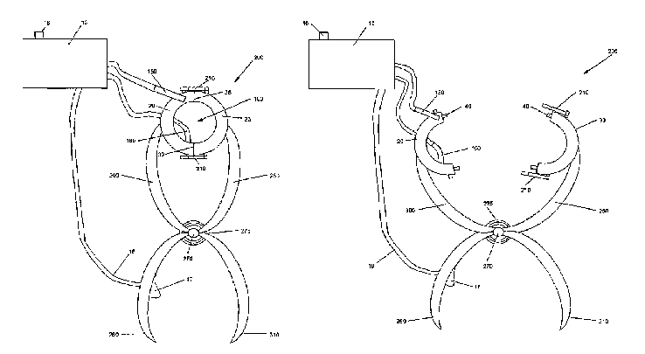
Figure 1 shows a first exemplary embodiment of an MPW device that has a separable coil to facilitate positioning of the coil with respect to the piping:

FIGURE 1

Figure 2 shows a first exemplary embodiment of an MPW device that has a separable coil to facilitate positioning of the coil with respect to the piping:

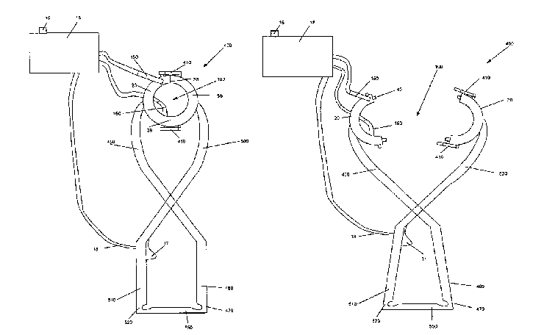

FIGURE 2

The above examples allow the user to easily and quickly wrap the coil about the outer workpiece, e.g., the coupler, and then generate a magnetic field through the coil to cause the weld.

To prevent the coil portions from separating during the welding process, locks are provided as shown in Figure 3:

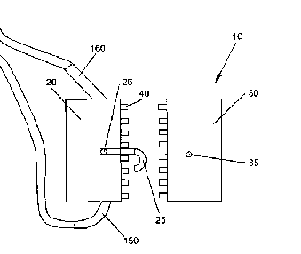

FIGURE 3

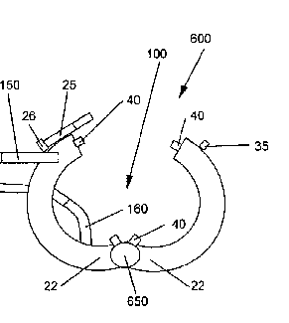
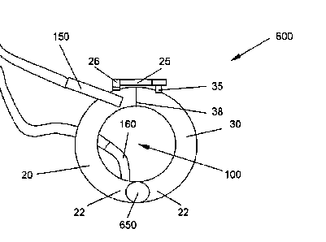
Preferably, these are quick connect and/or quick release locking mechanisms so that repeated welds can be quickly and easily generated by the user over an entire circuit of piping. The particular type of locking mechanism can be varied. Another example of a locking mechanism is shown with a pivoting coil in Figures 4 and 5:

FIGURE 4 FIGURE 5
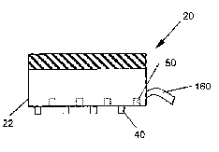
The contacts between the coil portions should also be made to withstand repeated connecting and disconnecting over the life of the device. If a physical contact is being used, then an example is shown in Figure 6 of the partial cross section of one of the coil portions:
FIGURE 6

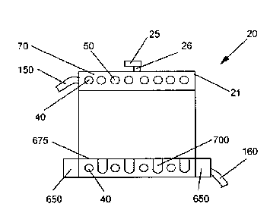
For a pivoting coil, the contacts can be as follows in Figure 7:

FIGURE 7

IV. Expected Data and Validation:
A controlled method of replicated experimentation will validate the MPW device. This can be accomplished by forming welds in multiple workpieces, while individually varying the power, the gap between workpieces and the impulse current duration. The welds will be stress tested using the materials lab. This can be done for different diameter copper pipes (e.g., ½ or ¾ inch) using the same coil and an adjustable power source. The adjustable power source will allow varying of the amount of power and also varying of the impulse current duration. To vary the gap between the workpieces, couplers (outer workpieces) having varying diameters can be used.

Data can then be gathered by applying force to the workpieces to determine the strength of the weld. The workpiece can be cantilevered with weight placed at its end. The workpiece can be subjected to a torsional force through weight placed on a rod passing through an unfixed end of the workpiece. The workpiece can be subjected to an axial force by fixing an upper end of the workpiece and placing weight at its lower end. A definition of yield of the weld needs to be defined and then can be observed and/or memorialized through video imaging. The position of any cracking/yielding should also be recorded.

The resulting data for yield strength can be compared to the factors of power, tube gap and impulse current duration in order to evaluate their effect on the process. The design of the power electronics and/or the coil can be adjusted based upon the evaluated data. This data gathering process can also be applied to workpieces of a different material, e.g., steel, as well as dissimilar workpieces, e.g., an aluminum coupler with copper piping.

The strength testing described above is important for establishing a process that provides a conduit with improved characteristics over circuits with currently used soldering techniques. Additional testing can also be done to establish that the resulting welds are waterproof and/or air-tight. Such testing includes pressurizing the welded workpieces with water and/or air to establish that there are no leaks.

The pipe positioning and resulting weld is shown in the cross-sectional views of Figures 8 and 9 for a coupler with a pipe end and separating rings:

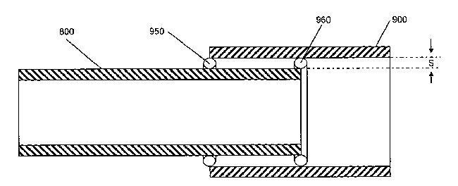
FIGURE 8

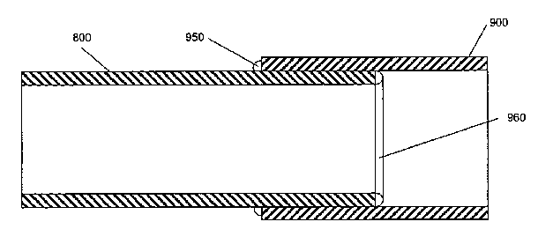
FIGURE 9

V. Societal Implications:
From an ethical standpoint, IEEE rules of conduct apply to this project since the design issues substantially fall under principles of electrical engineering. If an improvement over existing processes and devices is being claimed then there is a need to substantiate that improvement by gathering data comparing MPW to alternative types of joining, e.g., soldering. A new product is being created for which there is a market. There is a potential for selling many of the MPW devices that, due to their efficiency over contemporary soldering practices, could reduce the need for workers in this field. It is not clear that any other ethical issues exist with this project. A determination of foreseeable destructive uses can be done due to the large power capabilities that could be used for destructive purposes. Such destructive purposes could be reasonably avoidable through safety design features.

From a safety standpoint, due to the power usage, proper insulation for the user may be required. The resulting magnetic field needs to be evaluated and controlled and/or warnings provided. Any pipe/coupler acceleration needs to be evaluated for movement outside of the coil. Prevention of ejection of the workpiece needs to be accomplished. The stress testing and resulting strength data needs to be confirmed as providing joints that will not cause gas leaks that may result in an explosion.

VI. Historical Review:
MPW processes have been applied to tubing in order to attach the tube to a fitting of another component. [Dudko et al. 2003]. The resulting integral workpiece formed a load bearing structural joint, described as having improved strength to weight ratio, and prolonged fatigue life. [Dudko et al. 2003]. The energy required in Dudko was an impulse current of approximately 500kA based on a total charge of 16.8kV at the 144μF capacitor bank. [Dudko et al. 2003]. However, Dudko was working with an aluminum alloy tube (OD 88.9 mm and wall thickness 2.2 mm) and a steel end fitting (OD of 84.5 mm), as opposed to the copper piping used in plumbing. [Dudko et al. 2003].

Similarly, this amount of energy was utilized to magnetically pulse weld a mild steel end fitting (driveshaft yoke) with an aluminum tube grade Al6061, T-6 (driveshaft tube). [Kistersky et al. 2003]. The resulting impulse current lasted approximately 20μsec. [Kistersky et al. 2003]. The impulse current was also approximately 500kA and was generated via a capacitor bank. [Kistersky et al. 2003]. Important factors for creating a strong weld are the velocity and the collapsing angle in order to ensure that the metal of the outer component penetrates the metal of the inner component thus creating a full metallurgical bond at the molecular level. [Kistersky et al. 2003].

Another important factor in achieving a successful weld is the gap formed between the inner and outer tubes [Yablochnikov, B. 2003]. In using a MPW process to weld the neck of an aluminum end fitting into the open end of a vehicle’s aluminum driveshaft tube, the applicant determined that a substantially uniform gap between the two workpieces of about 0.5 to about 5 mm was desired. [Yablochnikov, B. 2003]. Additionally, the applicant determined that a preferred range of from about 1 to about 3 mm should be used. [Yablochnikov, B. 2003].

In applying the above principles to copper piping, the plastic deformation of the material is a critical factor. [Gabbianelli et al. 2002]. Additionally, the MPW process is not limited to collapsing outer workpieces down around inner workpieces. The MPW process can be used to rapidly expand an inner workpiece wall via plastic deformation, and force the inner workpiece wall into welded engagement upon impact with an overlapping outer workpiece wall. [Gabbianelli et al. 2002]. Such a process requires positioning of the coil within the inner workpiece. [Gabbianelli et al. 2002]. The coil of the MPW device can be slid into the inner workpiece where the magnetic field is created via the impulse current, resulting in a rapid outward expansion of the inner workpiece onto the outer workpiece. [Kichline et al. 2001]

For materials having high yield strength and ductility, MPW requires large amounts of energy to join the components. [Benoit et al. Sept. 2002]. Energy requirements could be reduced by temporarily diminishing the high yield strength prior to the joining process. [Benoit et al. Sept. 2002]. The material can later be restored to its higher temper and strength, such as by work hardening and subsequent heat or aging processes. [Benoit et al. Sept. 2002]. An example of such a strength reducing process is regressive heat treatment (RHT). [Benoit et al. July 2002]. RHT was successfully used by the applicants to facilitate the MPW welding of an aluminum tube with either an aluminum or steel fitting. [Benoit et al. July 2002].

The MPW process utilizes a cold welding technique that can be easily used on existing designs of tubing such as ½ inch or ¾ inch copper pipes for plumbing. Other cold-welding techniques have the drawback of requiring high pressure/force devices and uniquely designed workpieces to enable the tube attachment. [Lemelson 1972]. Tubes can be attached end to end by providing end flanges that are abutted against each other. [Lemelson 1972]. If a large enough force is applied to the flanges then a cold pressure weld will result. [Lemelson 1972]. To achieve such a large force, hydraulic or pneumatic device would be needed. [Lemelson 1972]. Such a cold pressure weld system would be cumbersome, costly and time-consuming.

The present MPW device also has the added advantage of removing heat from the welding process. Induction devices have been used for joining of pipes. However, such devices generate heat through induction heating which then melts the solder. [Barber et al. 2005]. Such a device merely trades the blow-torch for a magnetically generated heat source. Moreover, these systems still require the use of additional material, i.e., solder. [Barber et al. 2005]. Such devices also require accurate manipulation of the device to direct the magnetic field for properly locating the heat on the workpiece to melt the bonding material. [Riess et al. 2003].

The present MPW device is currently designed for welding of tubular workpieces. However, the MPW process or even a magnetic pulse forming (MPF) process can be utilized for non-tubular shapes. [Gafri et al.]. The forming process, unlike welding, does not provide a full metallurgical bond between the workpieces. [Gafri et al.]. For purposes of the current project, welding appears preferable on copper pipes that are being used for plumbing, but this may change.

The present MPW device has the advantage of being mobile and easily manipulatable with respect to the plumbing circuit that is being created in the residential, commercial or industrial setting. Contemporary magnetic pulse devices, e.g., MPF devices, require heavy and expensive equipment. [Snaper 1995]. The advantage of the automated contemporary processes was that they were able to rapidly produce nearly identical formations with very little hand labor being involved. [Snaper 1995].

Additionally, the coil used by the MPW device can be varied in order to improve the process. [Kojima et al. 1989]. Variations in the length and diameter of the coil, as well as the positioning of the coil around the outer and inner workpieces, have an effect on the weld that is produced. [Kojima et al. 1989].

A coupler that is of a different material than the copper piping (or other material such as steel) can also be utilized. [Stern et al. 2000]. The MPW process allows for welding of dissimilar metals. [Stern et al. 2000]. The use of a dissimilar metal as a coupler (i.e., an outer workpiece) may be advantageous for improving strength, reducing energy or being more cost effective.

The use of MPW on high strength materials is recognized as an effective way for forming strong welds that accurately position and attach the workpieces. [Yablochnikov et al. 1983]; [Karpouhin et al. 1991]; [Hardwick et al. 1986]; [Noland et al. 1967]; [Pismenny et al 2004]; [Shribman et al 2002]; [Livshitz et al. 1999]; [Kochan et al. 2000]. Such high strength materials include aluminum and steel, and the MPW process has been used with these materials in such industries as automotive, nuclear power, and oil drilling. Id. As shown in Figure 10, there are many ways of attaching workpieces. However, the MPW process has distinct advantages in time-savings, cost-effectiveness and ease of use in certain applications.

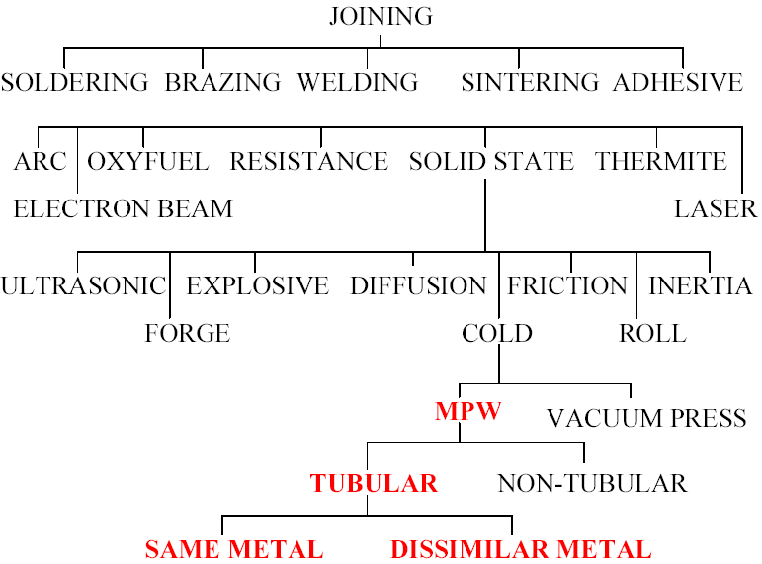

FIGURE 10

The determination of the size and strength of the magnetic field can be made based upon Maxwell’s equations. [Zeisberger et al., 2005]. The number of turns of the coil can be a single turn or for a more uniform magnetic field a large number of turns [Castoldi et al., 2000]. Control of the magnetic field can be achieved through the particular design of the coil or coils. [Vieira et al., 2003].

Adhesives may be used to facilitate the procedure. Such adhesives can be magnetically permeable so as to allow the eddy currents to be generated along the surface of the workpiece. [DeBonte et al., 1977].The coupler can be made from super-conducting material to facilitate the weld, although this would be an expensive weld. [Harnois, 2004].

Testing of the weld properties, e.g., strength, can be done by finite element analysis. [Sablik et al., 1998]. This testing can also determine the Creep damage at the weld. [Sablik et al., 1996]. The particular microstructure of the metal being welded will have a large influence on the resulting weld properties. [Thompson et al., 1990].

The amount of energy required can be calculated directly through complex mathematics, including inverse problem solvers, and monitoring of the current distribution along the workpiece surface when the magnetic field is generated. [Granados et al., 2005].

Other types of welding become too expensive such as electron beam welding which require expensive equipment such as special lenses or laser welding. [Kurilov et al., 2002]; [Hubbard et al., IEEE 1A8]; [Itoh et al., 1998].
The device can be used in conjunction with inspection via internal pipeline images. [O’Brien et al., 2003]. Robots and the like can be used to obtain the internal pipe images. [Kawaguchi et al., IEEE 0-7803]; [Kawaguchi et al., 1995].

Other welding techniques also require additional steps such as the need for deperming in order to utilize DC Arc welding on a pipe.[Kildishev et al., 1999].
Various electronics can be used to control and/or generate the necessary energy for the magnetic pulse weld. Such electronics can include fault current tolerable contactors. [Zhou, 2005]. The welding current can be controlled via an inverter and a transformer. [Takasaki et al., 2005].

There is also a potential use of the MPW to generate uniform welds in order to avoid problems such as electrical resistance across the weld. [Tong, 1997].

VII. LITERATURE CITED
1. Dudko et al., “Method of Fabricating Structural Joints”, U.S. Patent No. 6,561,722, March 2003.

2. Kistersky et al., “Energy storage apparatus and inductor tools for magnetic pulse welding and forming”, U.S. Patent No. 6,548,791, April 2003.

3. Yablochnikov, B., "Method of magnetic pulse welding an end fitting to a driveshaft tube of a vehicular driveshaft", U.S. Patent No. 6,531,688, March 2003.

4. Gabbianelli et al., " Hydroforming a tubular structure of varying diameter from a tubular blank made using electromagnetic pulse welding ", U.S. Patent No. 6,474,534, November 2002.

5. Benoit et al., “Method of joining metal components", U.S. Patent No. 6,452,139, September 2002.

6. Benoit et al., “Apparatus for joining metal components", U.S. Patent No. 6,420,686, July 2002.

7. Kichline et al., “Apparatus and method for joining vehicle frame components", U.S. Patent No. 6,255,631, July 2001.

8. Lemelson, “Tube Welding Apparatus", U.S. Patent No. 3,684,150, August 1972.

9. Barber et al., “Portable induction heating tool for soldering pipes ", U.S. Patent No. 6,875,966, April 2005.

10. Riess et al., "Hand Held Induction Tool", U.S. Patent No. 6,509,555, January 2003.

11. Gafri et al., "Apparatus and method for pulsed magnetic forming of a dish from a planar plate ", U.S. Patent No. 6,564,605, May 2003.

12. Snaper, " Procedure and apparatus for cold joining of metallic pipes", U.S. Patent No. 5,442,846, August 1995.

13. Kojima et al., "Effect of Collision Angle on the Result of Electromagnetic Welding of Aluminum", Transactions of the Japan Welding Society, vol. 20, No. 2, Oct., 1989.

14. Stern, A., Aizenshtein, M., Shribman, V., and Gafri, O. “A Study of the Interface in Magnetic Pulse Welding of Dissimilar Metals”, Proceedings of Welding and Joining 2000: New Materials and New Perspectives. Tel-Aviv, Israel.

15. Yablochnikov, B., "Apparatus for Magnetic Pulse Welding Large Diameter Thin-Walled Pipes", AVT. Svarka, No. 4, 1983.

16. Karpouhin et al., "Magnetic Pulse Welding", International Conference on the Joining of Materials, Helsingor, Denmark, May, 1991.

17. Hardwick et al., "Some More Recent Advances in Cladding Technology", Ninth Annual Conference on High Energy Reaction on Materials, Novosibirsk, Russia, Aug., 1986.
18. Noland et al., "High-Velocity Metal Working", Office of Technology Utilization, NASA, Washington, D.C., 1967.

19. Pismenny A.S., Pentegov I.V., Stemkovsky E.P., Shejkovsky D.A. and Kislitsyn V.M. “Calculation of modes of magnetic-pulse welding”, Paton Welding Journal, No. 11, 2004.

20. Shribman V., Stern A., Livshitz Y, And Gafri O., “Magnetic Pulse Welding Produces High-Strength Aluminum Welds”, Welding Journal April 2002 Volume 81 Number 4.

21. Livshitz, Y., and Gafri, O. “Technology and Equipment for Industrial Use of Pulse Magnetic Fields.” U.S.A.: IEEE 99-322978.

22. Kochan A., “Magnetic pulse welding shows potential for automotive applications”, Assembly Automation, June 2000, Vol. 20, Issue 2.

23. Zeisberger et al., "Magnetic Characterization of Welded YbaCuO-Bulk Samples", IEEE 1051-8223, 2005.

24. Castoldi et al., "Possible Fabrication Techniques and Welding Specifications for the External Cylinder of the CMS Coil", IEEE 1051-8223, 2000.

25. Harnois, "Study of CeO2 + SnO2 + Ag Doped YbCO as a Candidate for Welding Composition", IEEE 1051-8223, 2004.

26. Sablik et al., "Finite Element Modeling of Creep Damage Effects on a Magnetic Detector Signal for a Seam Weld/HAZ-Region in a Steel Pipe", IEEE 0018-9464, 1998.

27. Granados et al., "Critical Current Determination of Artificially Welded HTS Samples by In-field Hall Mapping Technique", IEEE 1051-8223, 2005.

28. Kurilov et al., "Welding Device with Single Coil Lenses", IEEE 0-7803-7373-1, 2002.

29. O’Brien et al., "Analysis and Classification of Internal Pipeline Images", IEEE 0-7803-7750-8, 2003.

30. DeBonte et al., "Magnetically Permeable Adhesives and Adhesive-Joined Shield Structures", IEEE Transactions on Magnetics, 1977.

31. Thompson et al., "Magnetic Properties of Welds in High-Strength Pearlitic Steels", IEEE 0018-9464/90/0900-1984, 1990.

32. Tong, "Welded Splice Design in a Mid-Size Superconducting Magnetic Energy Storage System", IEEE 1051-8223, 1997.

33. Alexeff, "A Plasma Loudspeaker Using a D.C., Carbon Arc in a Modulated Magnetic Field", IEEE P4A11.

34. Hubbard et al., "Beam Propagation Options For Intense Electron Beams In Welding And Materials Processing Applications", IEEE 1A8.

35. Itoh et al., "Development of Bore Tools for Blanket Cooling Pipe Connection in ITER", IEEE 0-7803-4226-7, 1998.

36. Sablik et al., "Finite Element Simulation of Magnetic Detection of Creep Damage at Seam Welds", IEEE 0018-9464/96, 1996.

37. Kawaguchi et al., "Sensors and Crabbing for an In-pipe Magnetic-wheeled Robot", IEEE 0-7803.

38. Kawaguchi et al., "Internal Pipe Inspection Robot", IEEE 0-7803-1965-6/95, 1995.

39. Kildishev et al., "Deperming Technology in Large Ferromagnetic Pipes", IEEE 0018-9464/99, 1999.

40. Zhou, "A Novel Concept for Fault Current Tolerable Contactors", IEEE 1521-3331, 2005.

41. Takasaki et al., "Current Controllability of the Low-Voltage 10kA Inverter Power Source", IEEE 0018-9464, 2005.

42. Vieira et al., "Alcator C-Mod non-axisymmetric control coils Design and Fabrication", IEEE 0-7803-7908-X/03, 2003.

