departmentS of Electrical/Computer/Software/mechanical engineering
Fairfield University

wrap-up sessions

Spring 2009

Course: EG32 Course name: Fundamentals of Engineering 2
Instructor: Jeffrey N. Denenberg (with periodic guest speakers)

High points of the course (“successes”):

Pedagogy: Lectures and problem solving sessions. All class materials available for download via a course web site on http://doctord.webhop.net. Eidos used for Homework/Lab uploads, “Reflections” and freshman project related submissions.

Homework: Graded assignments, Project and “Reflections”

Exams and Projects: Exam results were mixed, some good, some poorer than desired;

Student Attendance and Performance: Classes were well attended. Student interest stayed high throughout the semester.

Other:

Problems encountered:

Assignments:
Students were better about doing the assigned homework this semester. Reflections and Homework uploads were generally done in a timely manner. The reflection on the importance of doing assignments last semester had its desired effect. I will continue to put a reflection question on the second exam in EG31 next semester.

Instruction method:
_____________________________________________________________________________

Course prerequisites:

None

Student feedback:
Generally positive

Student Performance: Reasonable, but this group seemed less motivated on average from prior years. They were enthusiastic about the Freshman Projects and these turned out quite well.
_____________________________________________________________________________

_____________________________________________________________________________

Grade distribution:
Reasonable distribution A-C-, average B+

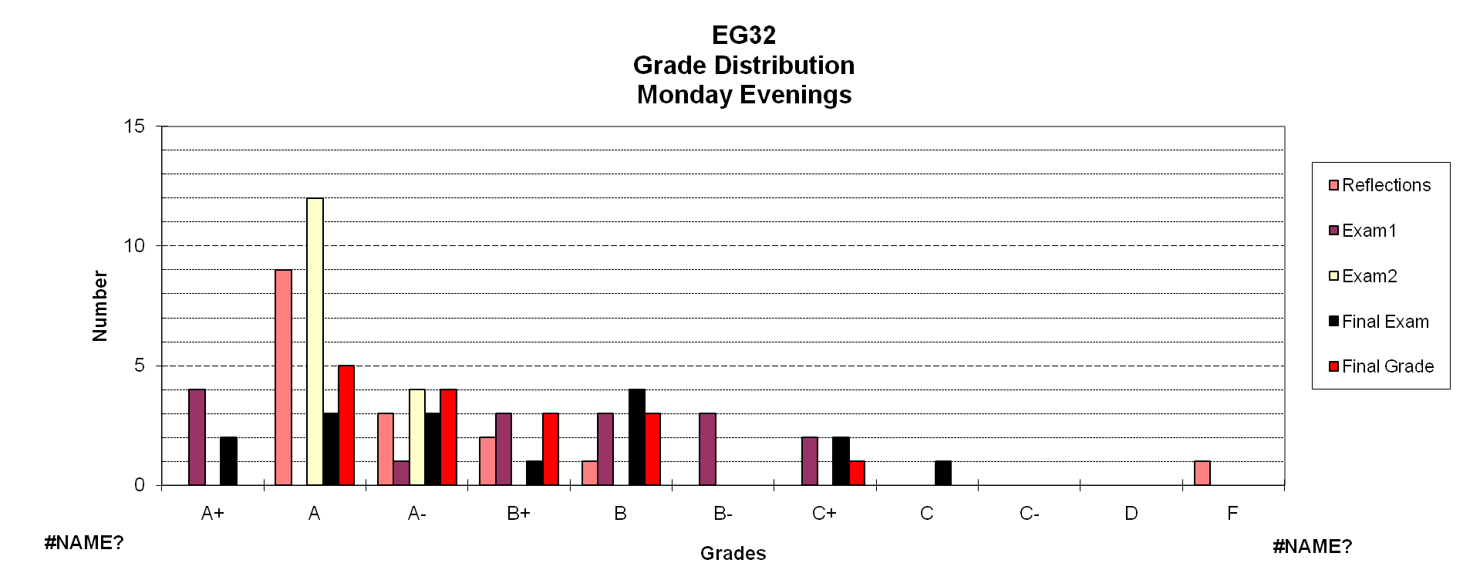

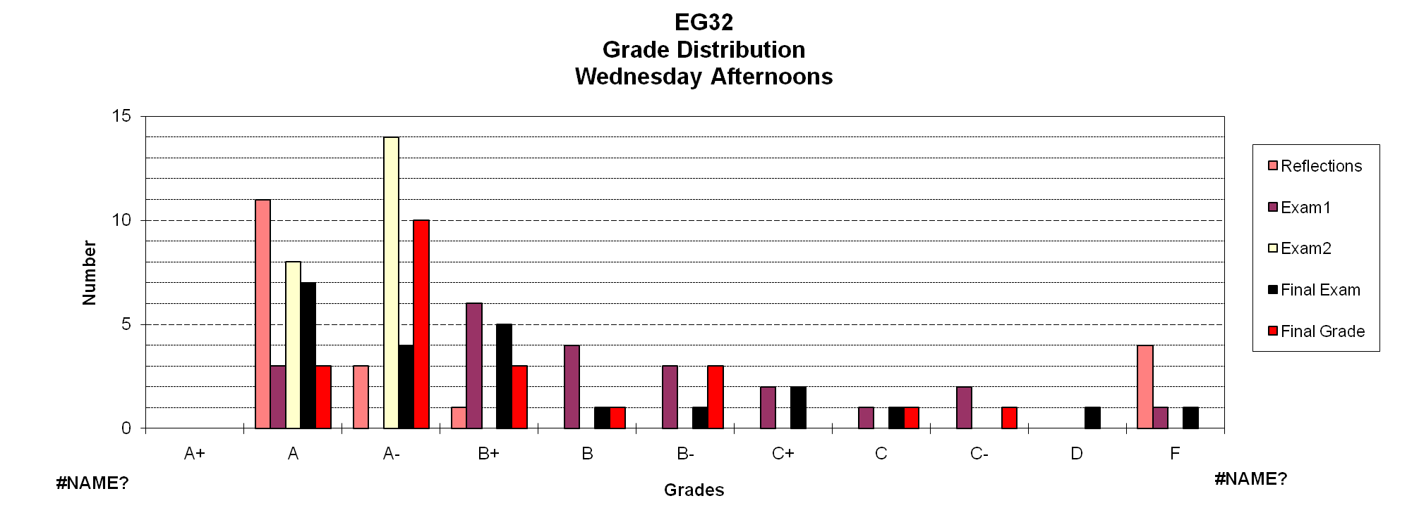

Action steps

Course Portfolio: Competency Forms done and student work filed.

Change course prerequisites? no

Change course content? Continuous process, add some Instrumentation content to EG31 next Fall

Change course objectives and/or outcomes? Minor updates

Recommendations for further improvement*
Continue to emphasize the relationship of Calculus and Physics to Engineering as well as the fact that the course knowledge is cumulative. This means that the process of cramming for exams and then forgetting the material doesn’t work in engineering.

instructional environment

Please comment on any problems that were encountered because of inadequacies in the classroom environment, lack of supplies, and inadequate service from staff:

We need to establish standard software environments for the SOE computers. Many applications are needed every semester and should be loaded as na default package. These should include:
- MS Office – Full install
- Matlab – with all licensed toolboxes (missing this semester)
- MathCAD
- Working Model
- AutoCAD (or other CAD package in use at the SOE)
- Software development environments

Other packages as defined by current instructors.

A problem with “Groups Submissions” in Eidos occurred at the end of the semester. We can resolve it over the summer.

Were the problems brought to the attention of the Dean’s office?

Yes

Were the problems corrected in a timely fashion? ___Not Yet___________________________

* use an additional sheet if necessary.

