On Line Registration for Graduate Students

On-line registration for all Graduate schools is now available. The following table is how each school should proceed with registering on-line.

Graduate School of Arts & Sciences | No pin required
Graduate School of Business | Register after meeting with advisor who removes an academic hold
Graduate School of Education | Requires a pin number that will be given by advisor
Graduate School of Engineering | No pin required
Graduate School of Nursing | Requires a pin number that will be given by advisor

On-line registration is for students that want to pay their tuition and fees in full—just like telephone, fax and mail in registration. Any students that want to do a payment plan, company reimbursement, employee tuition remission or financial aid must come to the Registrar’s Office in person and complete the necessary paperwork.

To begin on-line registration, you go into your StagWeb account at stagweb.fairfield.edu. If you have never used your StagWeb account or it has been inactivated due to lack of activity, please call the Administrative Computing Help Desk at ext. 4357. You can use the reset password feature on the login page if you have simply forgotten your password. Your Fairfield ID number is used to login. If you need assistance once you login to StagWeb, please call the Registrar’s Office at 203-254-4288 or just ext. 4288 on campus. Remember, anyone with a financial or other type of hold will not be allowed to register.

- Click on the Academics tab
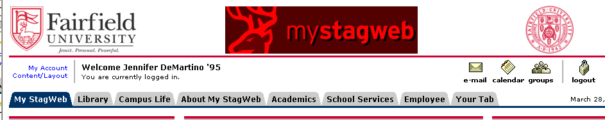
Student Name and Year

- Locate the Registration Channel

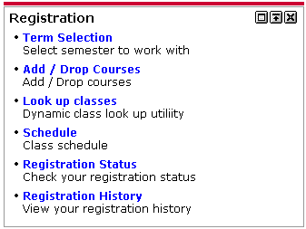

- Click on Add/Drop Courses

- Select Term (i.e. Spring 2007) and click Submit

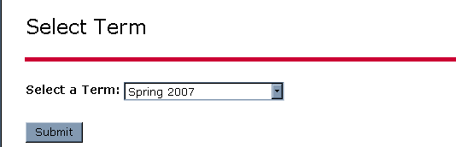

Add or Drop Classes

Top of Form
FOR GRADUATE AND CONTINUING STUDIES STUDENTS:
On-line registration for graduate and continuing studies students requires payment in full by Credit Card (MasterCard, Visa, or AMEX) or e-Check at the time of your on-line registration.
Any registration involving a payment plan, a promissory note, student loans, company billing or tuition remission must be done in person at the University Registrar's office.
To complete your registration, you must scroll to the bottom of this page and click on the "Finalize Registration" link.
If payment is not made in full at the time of on-line registration, the registration will be deleted.
FOR FULL-TIME UNDERGRADUATE DAY STUDENTS:
For the Fall and Spring semesters, a billing statement will be sent to your home or billing address for your tuition and fees.
For Summer, Winter Intersession and Spring Break Session payment must be made in full at the time of on-line registration by following the payment directions above.

To add a class, enter the Course Reference Number in the Add Classes section. To drop a class, use the options available in the Action pull-down list.

Add Classes Worksheet
CRNs

To Drop a Class: (Check availability of a course before you drop something, because if the course you are dropping is over the maximum you will not be able to get it back.) Go to the Action Column under Current Schedule and scroll to Drop/Web. Then click on Submit Changes at the bottom of the screen and the course will be dropped.

To Add a Class if you know the CRN: Go to Add Classes Worksheet, and type in the CRN (a five digit number) and click on Submit Changes at the bottom of screen. If you enter an incorrect CRN or change your mind, click on the Reset button at the bottom of the screen and the screen will clear. You can enter more than one CRN at a time (one per box). Remember, you cannot register for more than 18 credits at any time. The course will either appear in your list of registered courses or you will receive an error message if you were not able to register for the class.

Note: Remember to add labs when necessary.

If You Don’t Know the CRN: Click on Class Search at the bottom of the screen. This will allow you to choose a course, time and days of the week. Then click on Class Search and the options will show up. Note: If you are searching for a specific course number, the number must be entered as a “4 digit” number. For example, to enter AC 11, scroll to Accounting and then type in “0011”. To enter Accounting 203 enter “0203”. Click on Class Search. Note: You can also use the Class Search option to look for courses with certain attribute. For example, History-US will bring up a list of all History courses that are coded as counting as United States history.

The classes that come up show the total capacity – “Cap”, the actual enrollment – “Act” and the number of remaining spaces “Rem”.

Class Schedule Search

Top of Form
Subject:
Course Number:
Title:
Credit Range: | hours to hours
Part of Term:
Non-date based classes only
Attribute Type:
Start Time: | Hour |  | Minute |  | am/pm
End Time: | Hour |  | Minute |  | am/pm
Days: | Mon | Tue | Wed | Thur | Fri | Sat | Sun

Note: You can register for a course directly from the search screen. Simply check the Select box next to the desired course and click Register at the bottom of the screen (you can also choose to Add To Worksheet and register for it later).

You must click on FINALIZE REGISTRATION when you have registered for/dropped all of your courses.

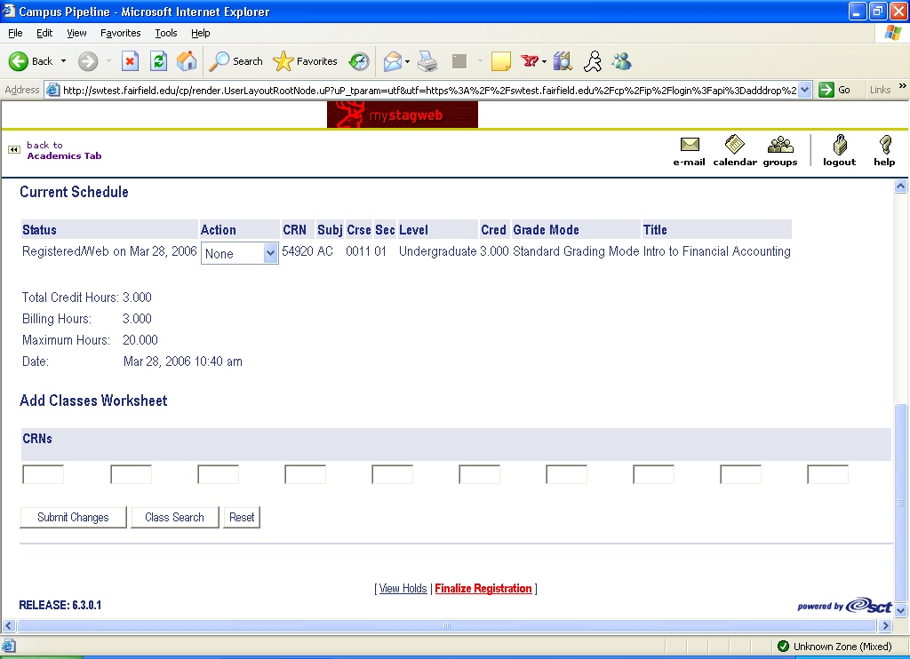

Now, you must select a payment type—Credit Card or eCheck.

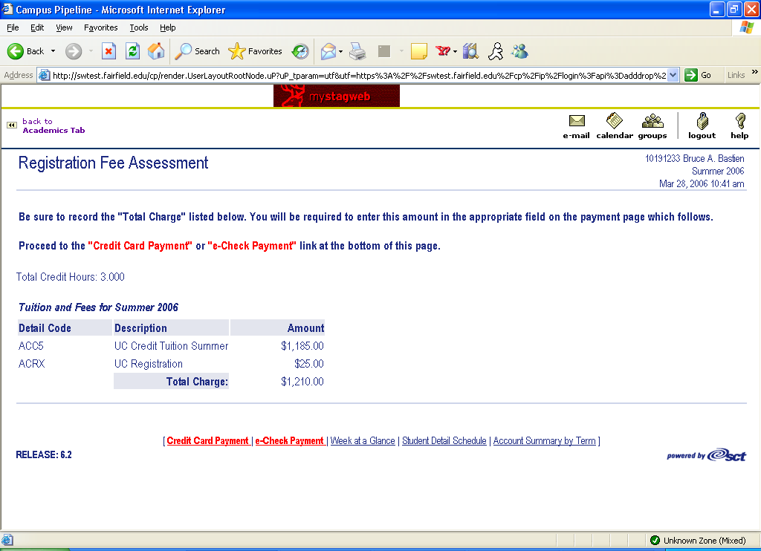

Credit Card Payment

Please enter the requested credit card information. Select Submit Payment to request authorization when it is complete.
Top of Form
Credit Card Information
Credit Card:
Card Number: | Note: When entering the payment amount, please DO NOT enter $ or commas. For example, the proper format is 1210.00
Expiration Date: | /
Payment Amount:
Credit Card Billing Address
Street Address:
City:
State or Province:
Zip or Postal Code:
Nation:


Welcome to Fairfield University's Pay by Check option.
• Enter your banking information and an amount to pay.
Please refer to the sample check below to assist in identifying
your bank's routing number and your bank account number.
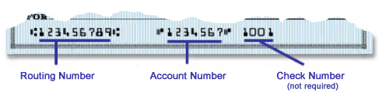
Banking Information:
Top of Form

Account type:
Routing number:
Account number:
Re-enter account number to confirm:
Your name as on the account:
Your address as on the account:  Note: When entering the payment amount, please DO NOT enter $ or commas. For example, the proper format is 1210.00 |  | Street Address
  City | State | Postal Code
Amount Paying: | $

Bottom of Form


