Environment Details 2
Create a New Weblogic Domain in Weblogic 2
Create a Project in MyEclipse 9
Web.xml file 11
Java Source file 12
Configuring Weblogic to start from with in MyEclipse 13
Deploy the application from within MyEclipse 14
Start Weblogic from within MyEclipse 16
Test Application 17

Environment Details
Operating System: Windows XP
Application Server: BEA Weblogic 10
Eclipse: 3.2
MyEclipse: MyEclipse Enterprise Workbench 5.5.1

Create a New Weblogic Domain in Weblogic

Below are the steps to create a domain in weblogic in which the application would be deployed:

Step 1

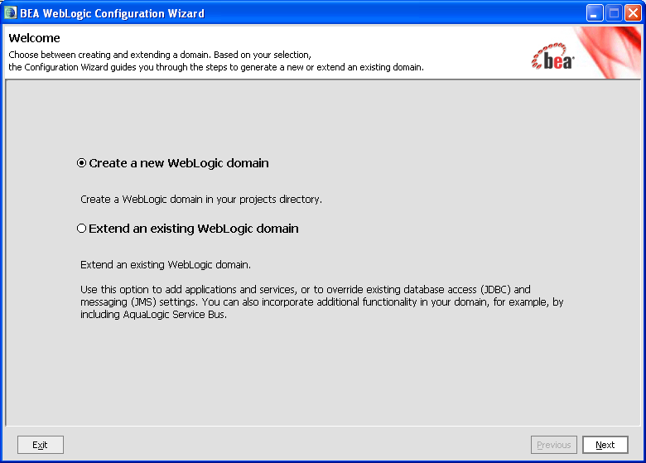

Step 2

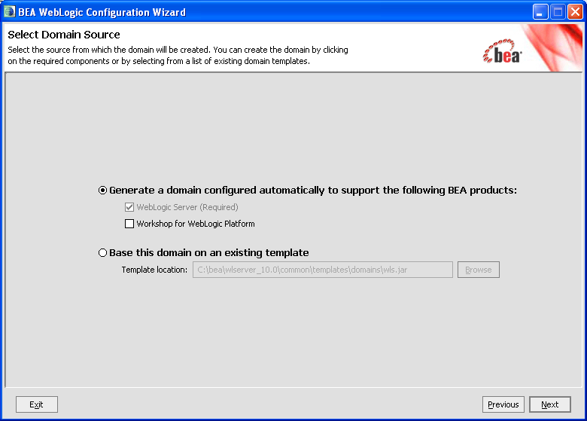

Step 3

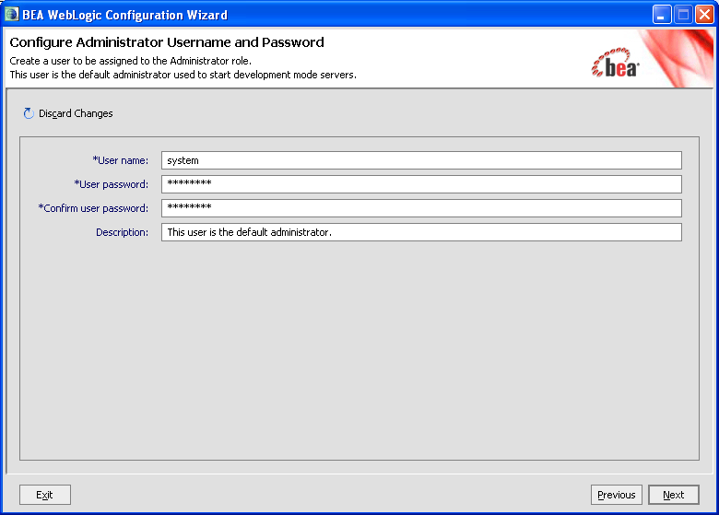

Step 4

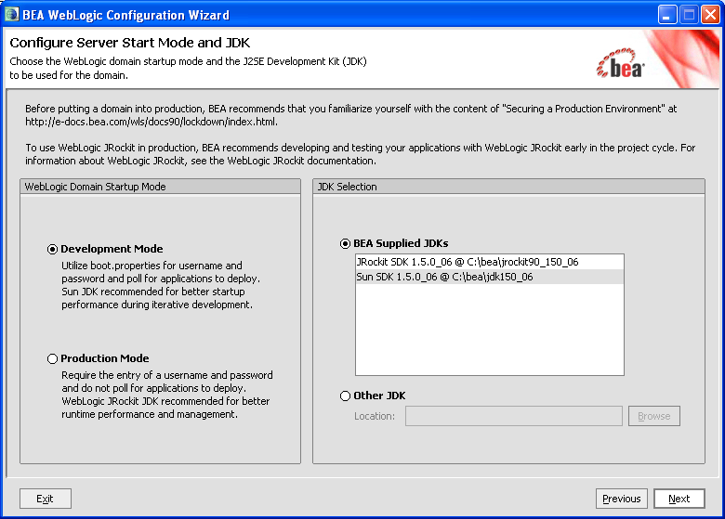

Step 5

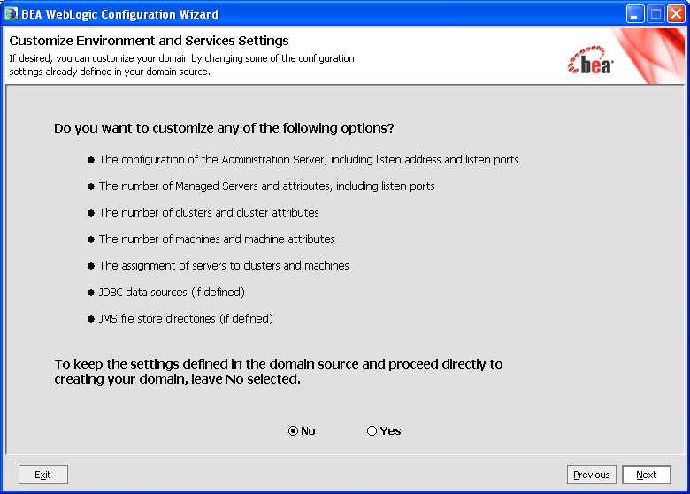

Step 6

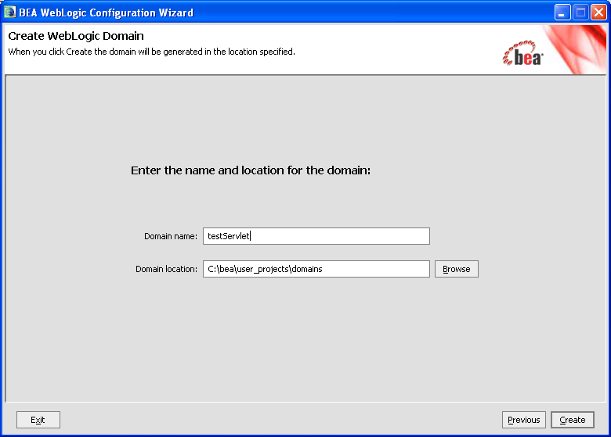

Step 7

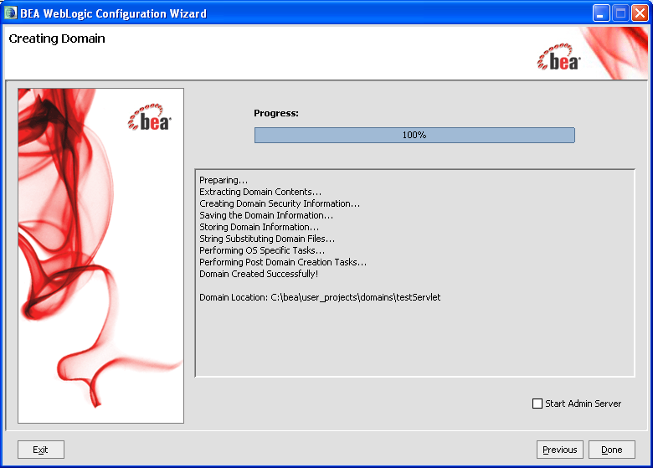

Create a Project in MyEclipse

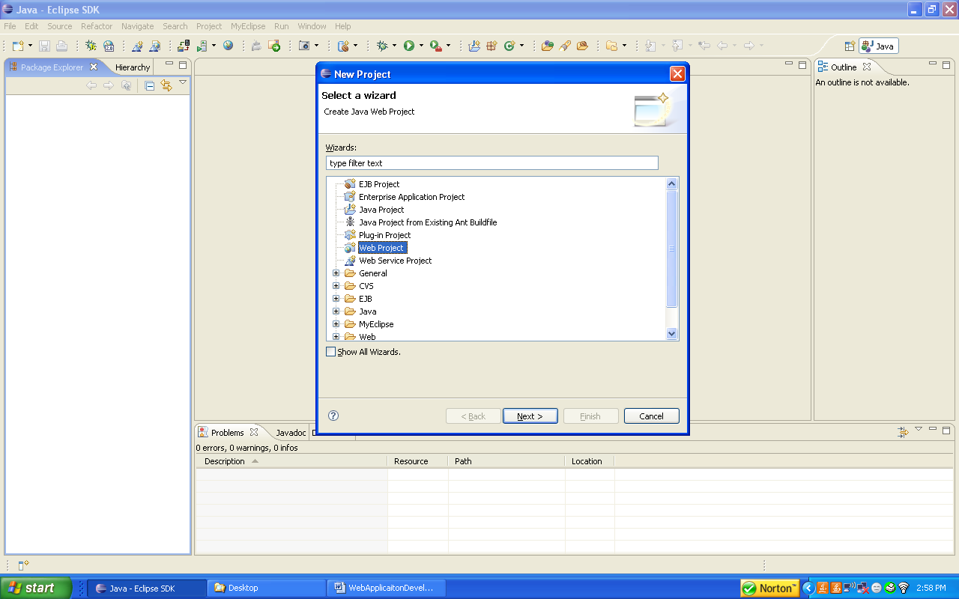

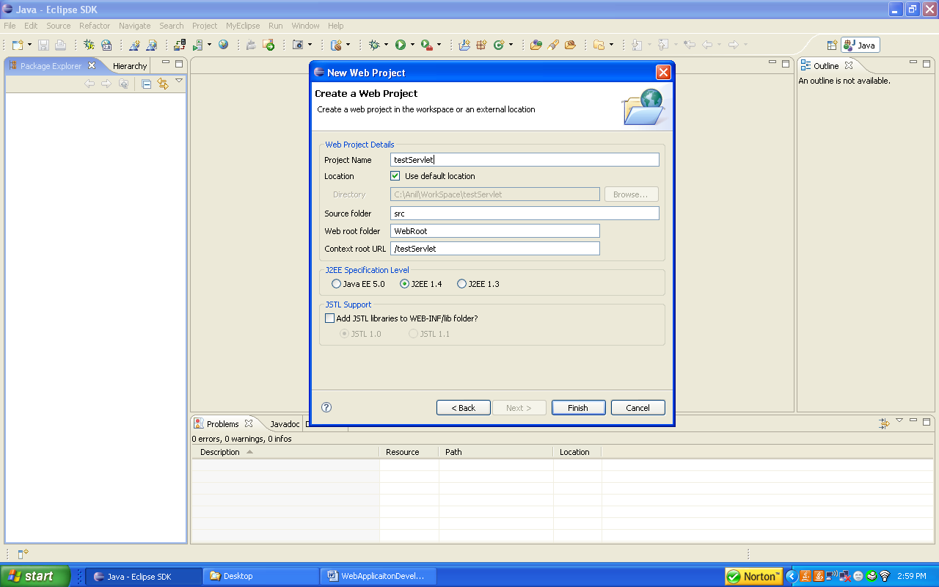

Web.xml file

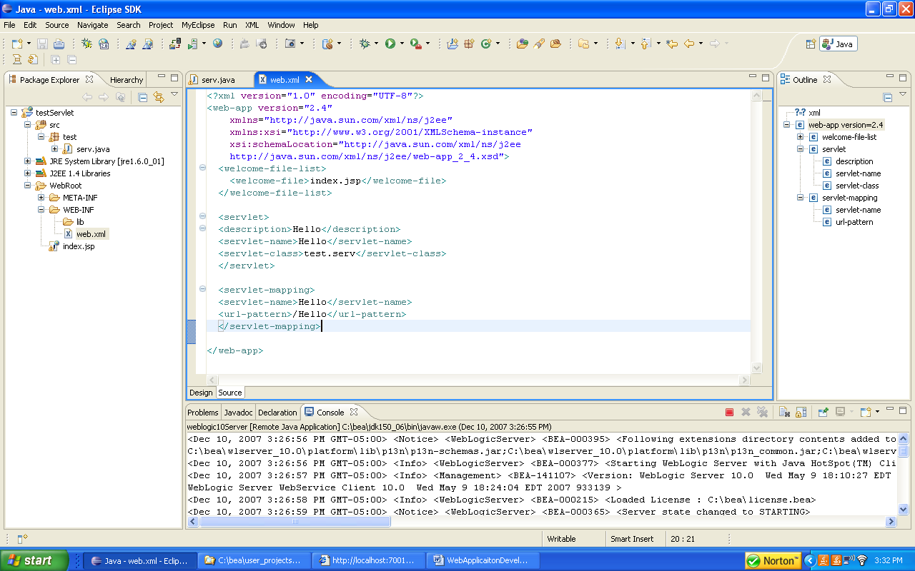

Java Source file

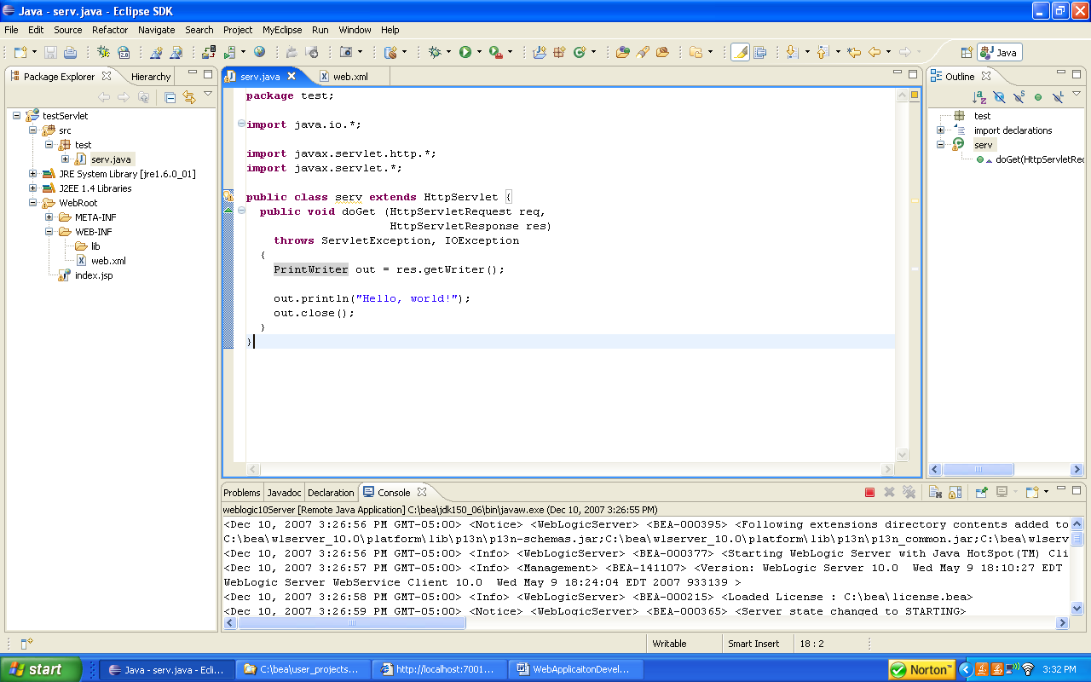

Configuring Weblogic to start from with in MyEclipse

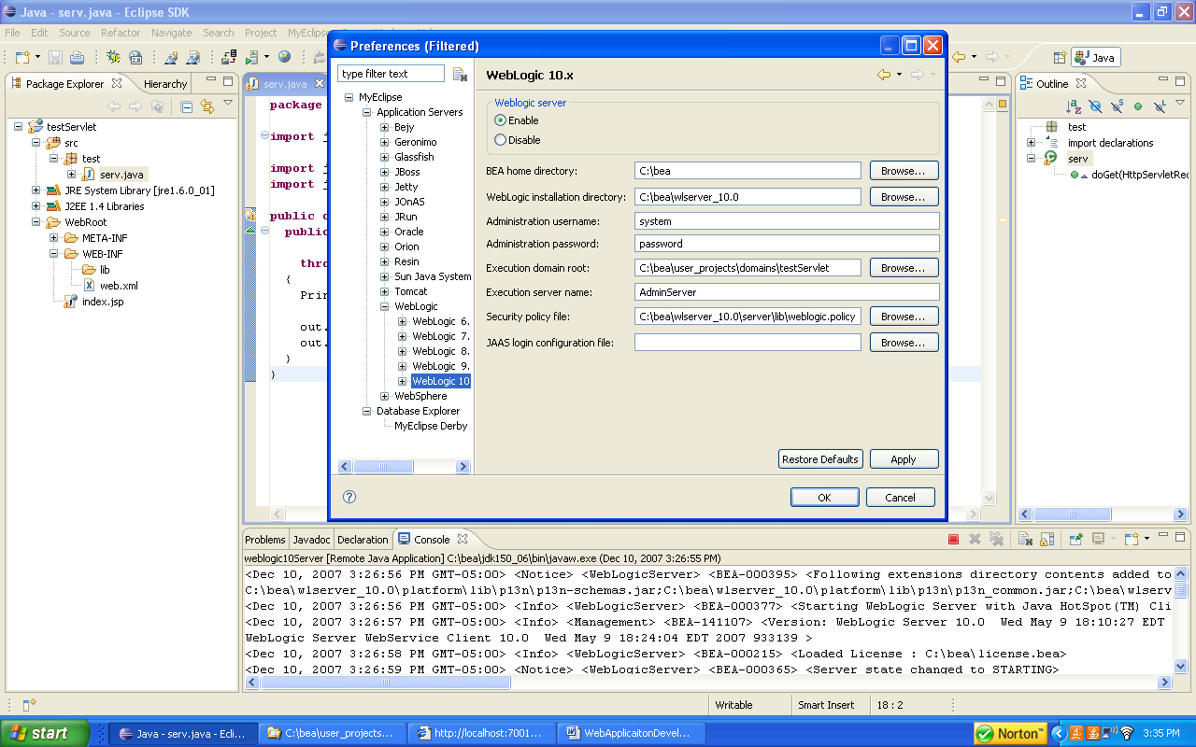

Deploy the application from within MyEclipse

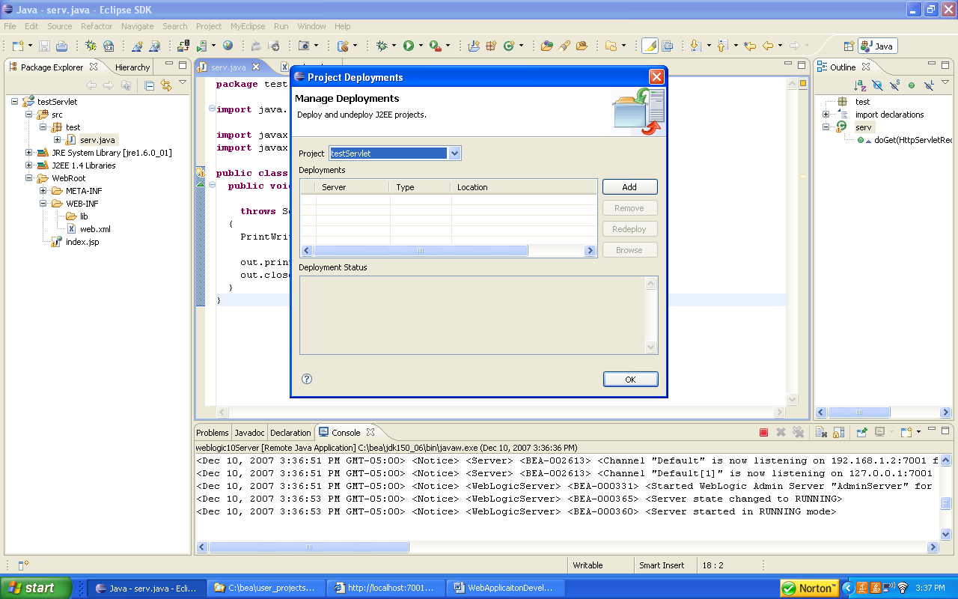

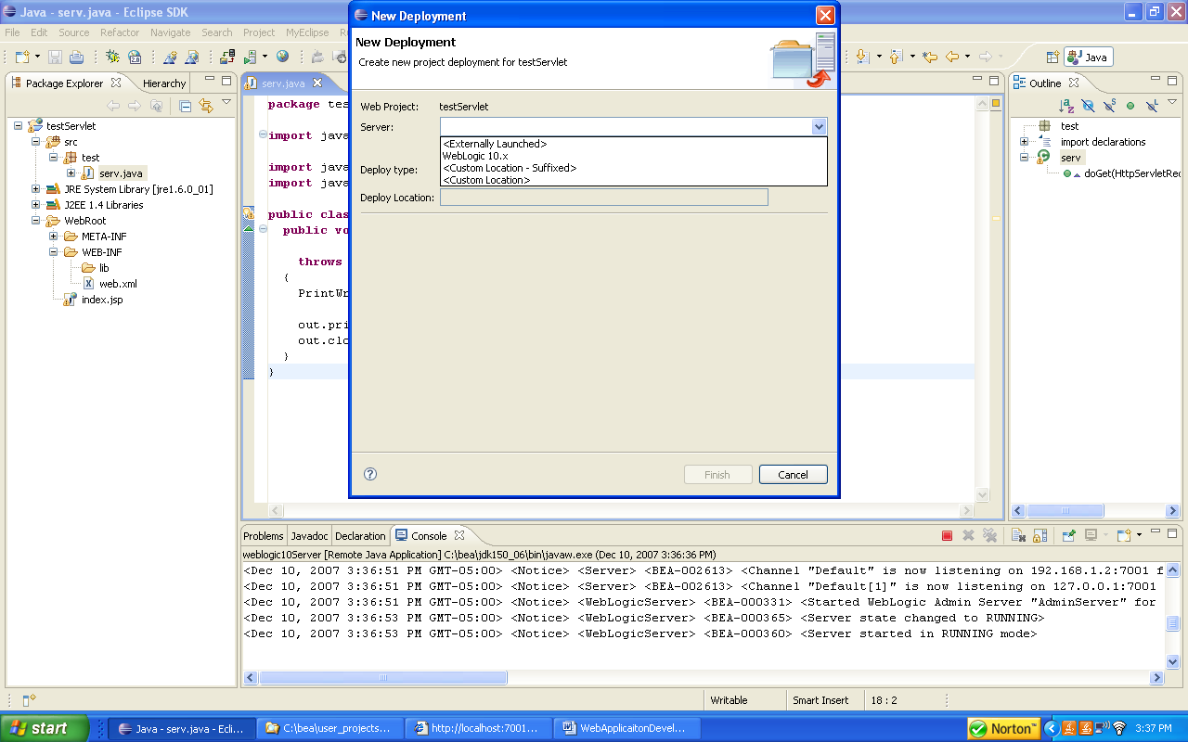

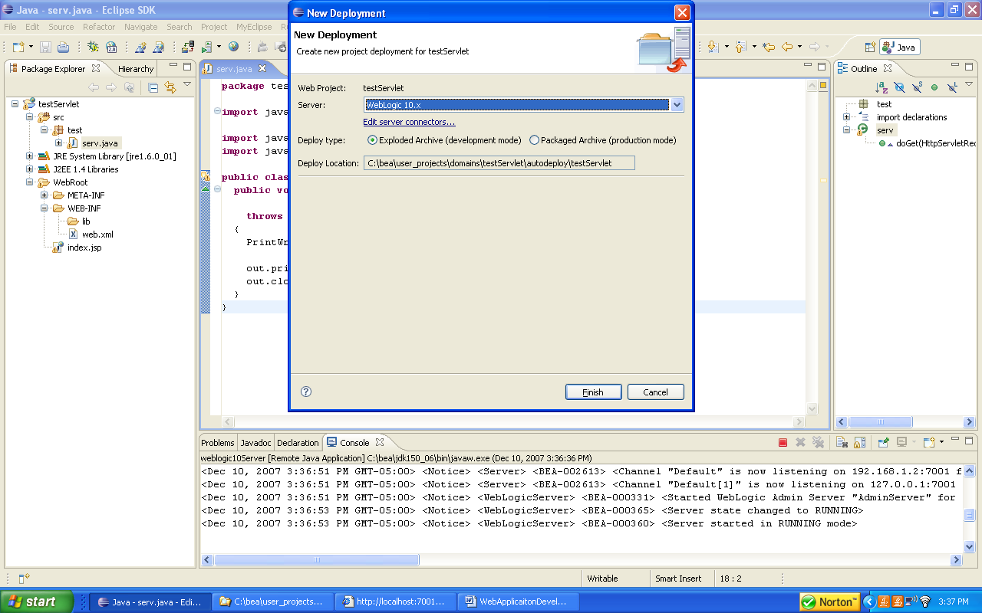

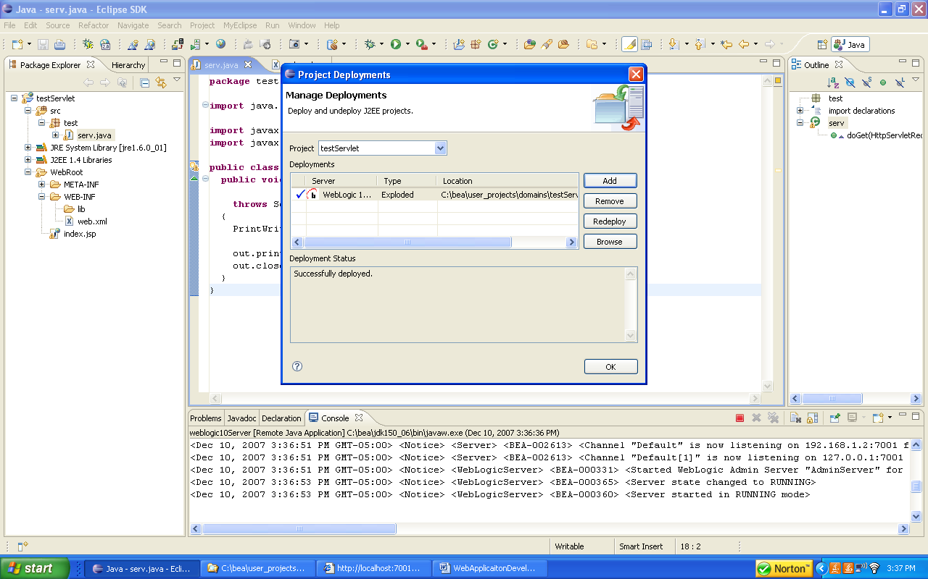

Start Weblogic from within MyEclipse

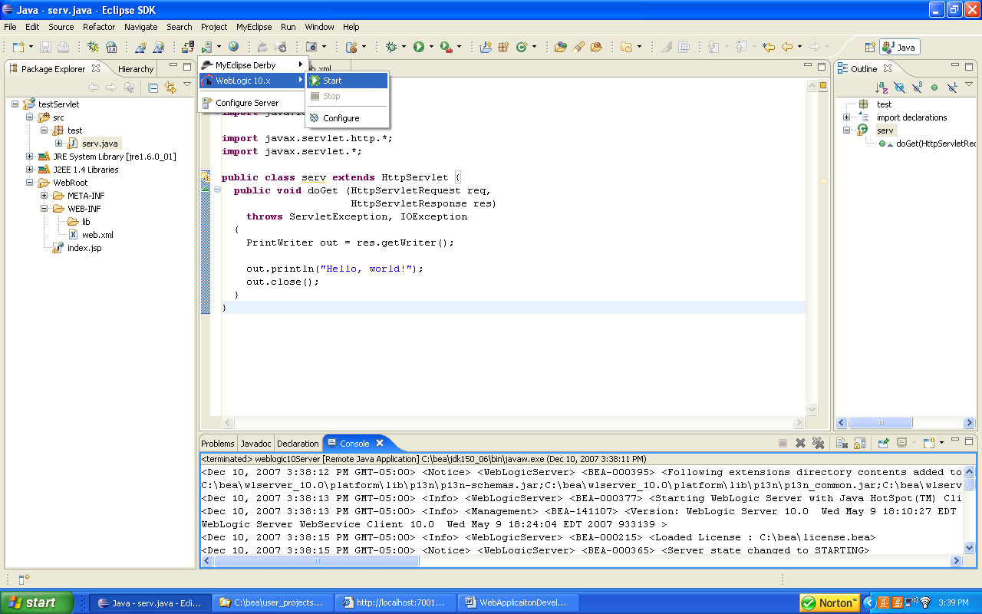

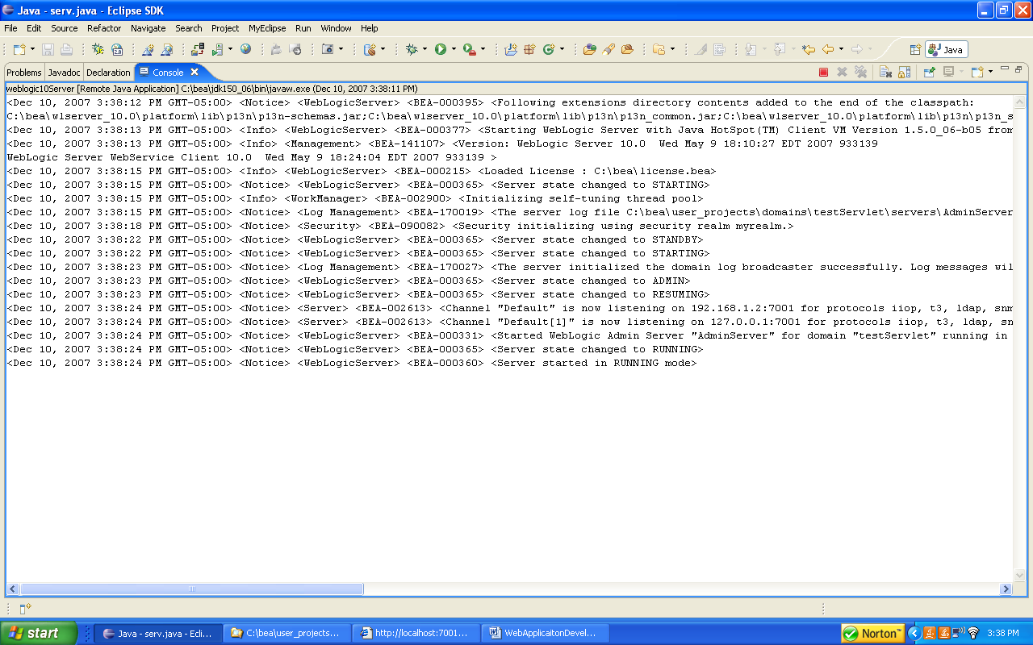

Test Application

