System in Consideration:

Operating system: Windows Vista Home premium
Processor Speed: 2.2 Ghz
Ram: 2 GB
Preferred IDE: IntelliJ
Tomcat Server Version: 6.x

- Download and install the Apache Tomcat Server

One of the site to do so is http://tomcat.apache.org/download-60.cgi

- Now start Intellij IDEA.
- Start a new project
- Choose to build from start
- Follow the steps to finish
- Now press the configuration button and click on edit configuration as shown below in the picture.

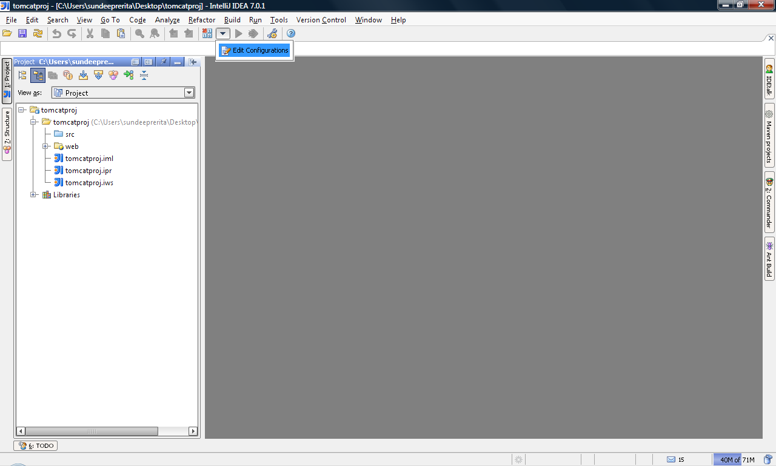

7) Now a box like below shows up.
Hit the + sign on the top and a drop down menu shows up on it choose tomcat server and choose local for local tomcat installation.
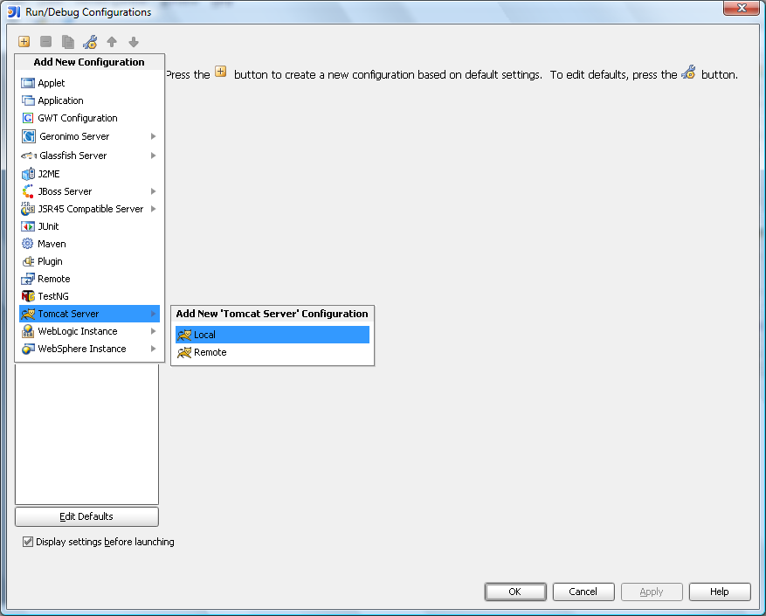

8) Now another box shows up like this
Check the appropriate checkboxes in this menu

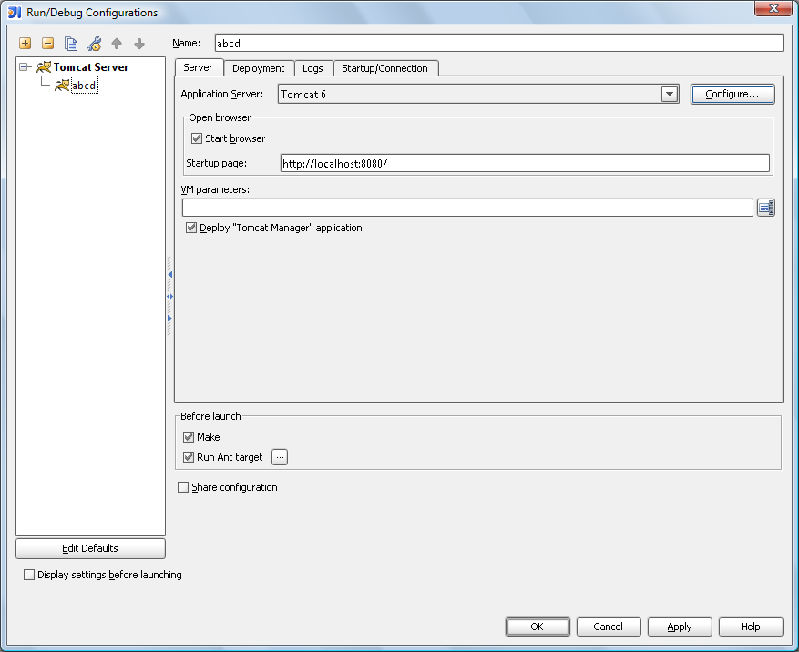

9) Now under server tab hit configure
A menu box like below shows up

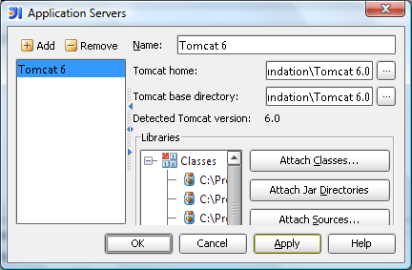

10) Click on the 3 … button and browse to the tomcat installation home directory and hit on apply and ok
Now it takes back to the menu box that it was like before.
Click on the fix button on the middle right of the menu box
Now your apache tomcat is integrated with intellij
Now add a .jsp file type to the project and write the appropriate code
Now you can run the program

