SW401 - Fall 2007
Homework #7; December 9, 2007
Don Petreycik

Tutorial: How to Write a Servlet Using IntelliJ and Apache Tomcat

Operating System:
Windows XP Professional (Service Pack 2)

Requirements:
- jdk1.6.0_02
- IntelliJ IDEA 7.0M2
- Apache Tomcat 6.0.14

Procedure:

1. Create new project and configure IntelliJ IDEA
Start IntelliJ IDEA and create a new project from scratch using the “File” menu or “Quick Start”. Click “Next”.

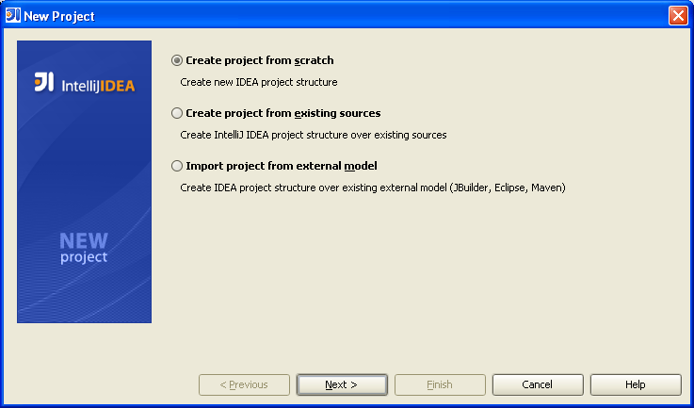

Enter a name for your new project and click “Next”.

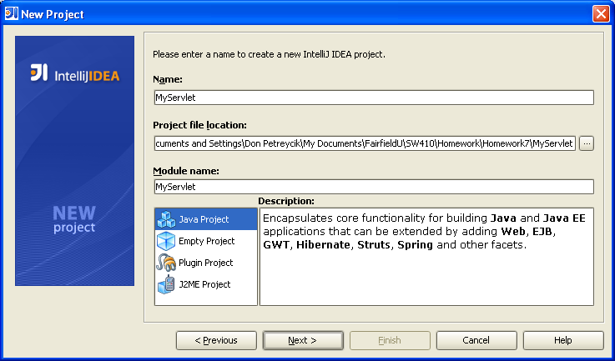

Select “Create source directory” radio button and click “Next”.

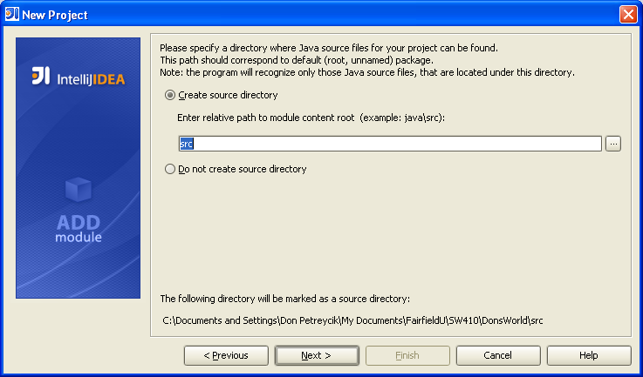

Select Web application 2.5 and click “Finish”.

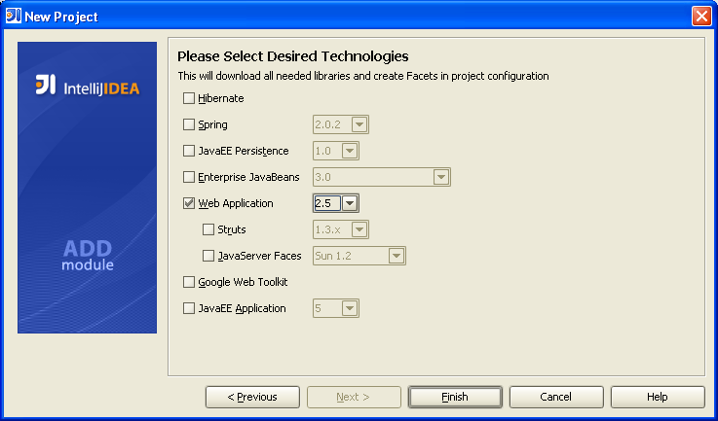

Your new project should look like this.

Select “Run”, then “Edit Configurations”.

Click the “+”button in the “Run/Debug Configurations” dialog box, then select “Tomcat Server”, “Local”.

Click “Configure” in the “Run/Debug Configurations” dialog box. Click the “+ Add” button in the “Application Servers” dialog box. Navigate to your Tomcat home directory in the “Tomcat Server” dialog box.

Click “Apply”, then “OK” in the “Tomcat Server” dialog box. Click “Apply”, then “OK” in the “Application Server” dialog box.

Enter “Application Server” name and path to your new servlet’s “Startup page” in the “Run/Debug Configuration” dialog box. Notice “Warning: There are no facets to deploy”. The next step shows how to fix it.

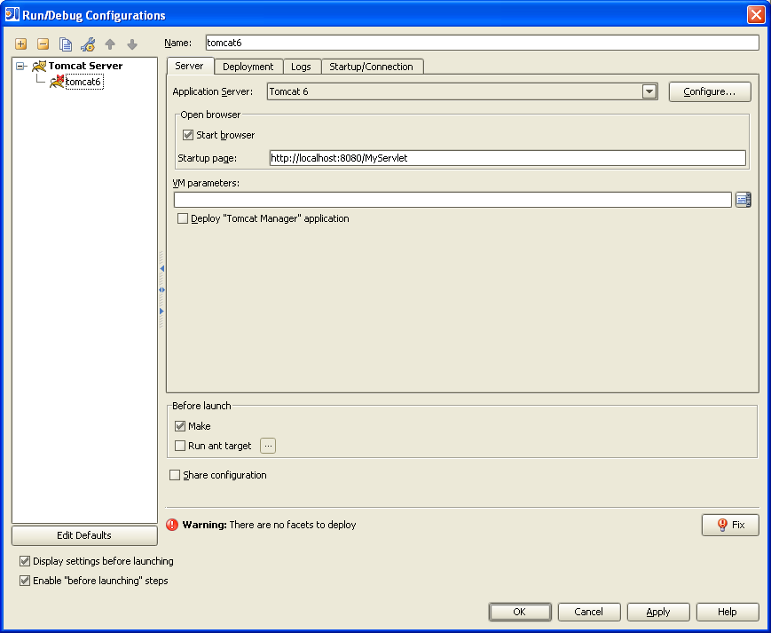

Select the “Deployment” tab on the “Run/Debug Configuration” dialog box, select “Web (In your project)” Java EE Modules to deploy at the server startup, check the “Deploy web facet ‘web’” check box. Click “Apply”, then “OK”.

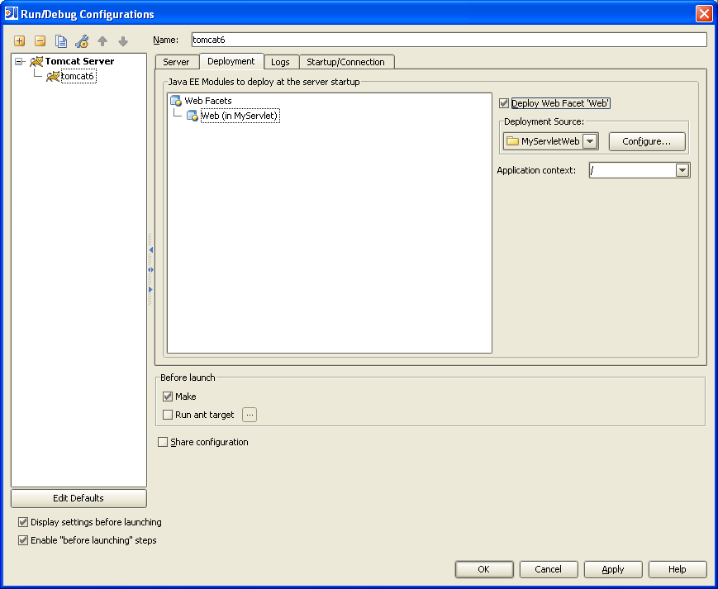

2. Create a Basic Servlet
Create a package for your servlet in the source directory and create a new class in that package as shown below and compile it:

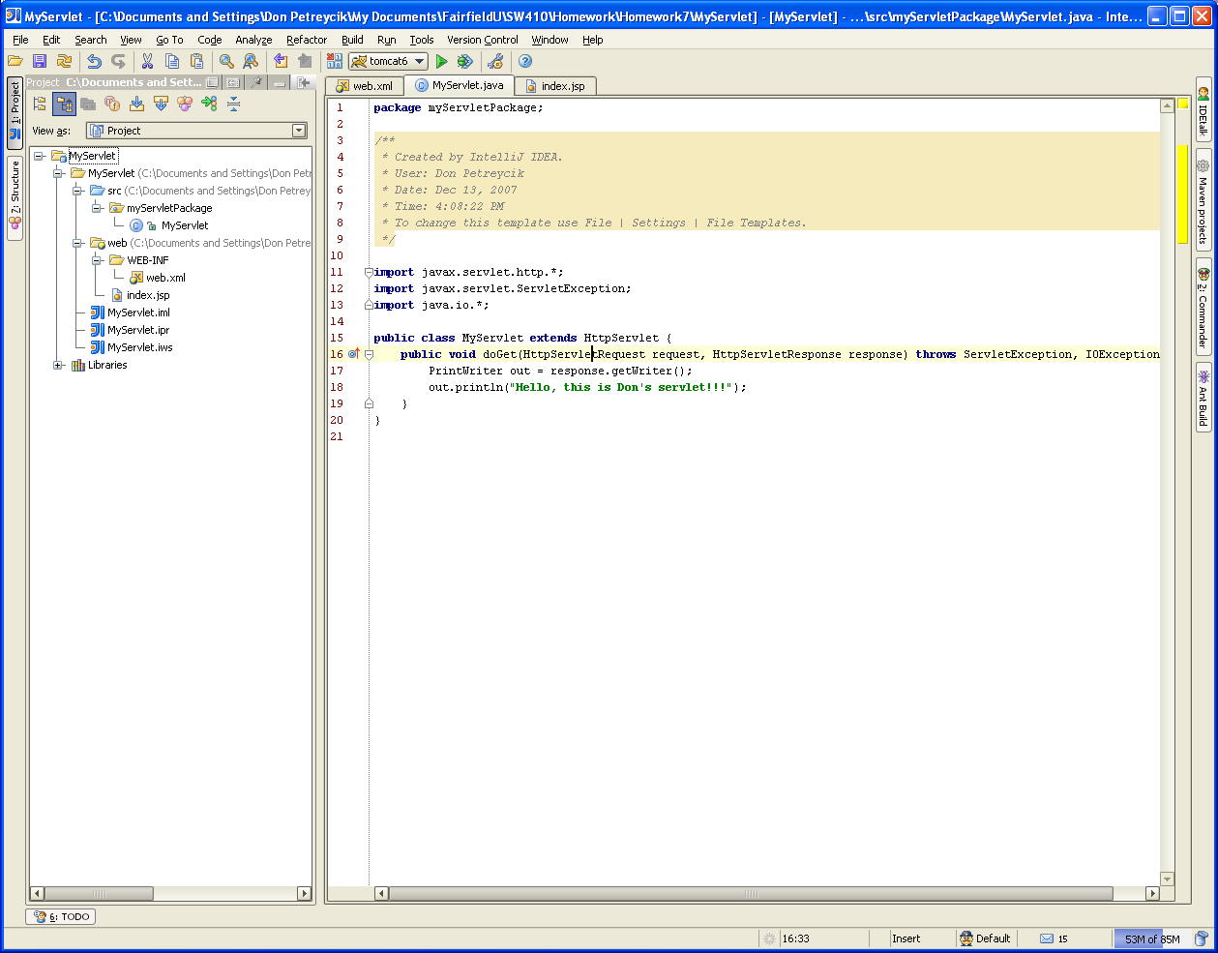

Edit ‘web.xml’ as shown in the text highlighted below:

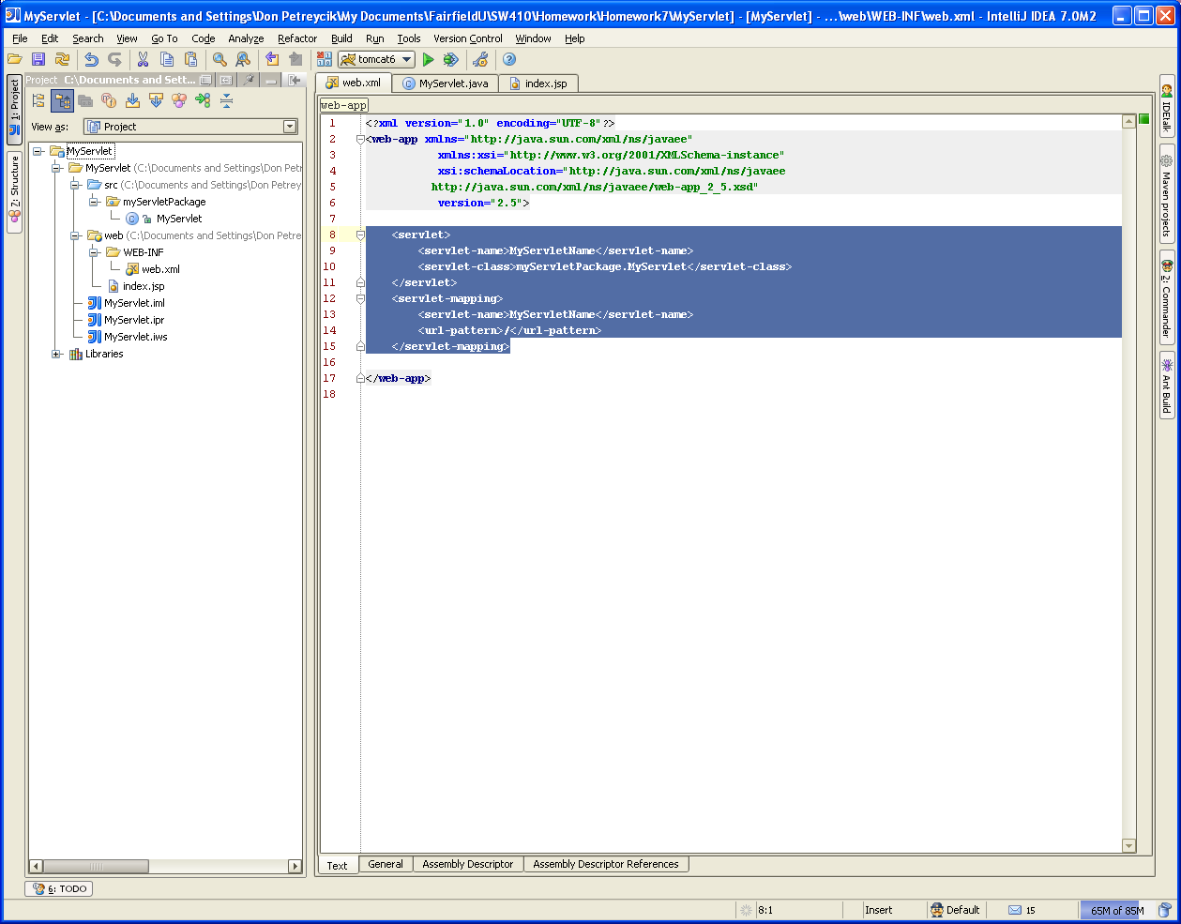

3. Run the application from IntelliJ.
If your browser does not start automatically, open it manually and type “http://localhost:8080/Myservlet” in the address field. You should see something similar to this:

