Create a new Dynamic Web Project. Create it what ever you want and hit next till it finishes.
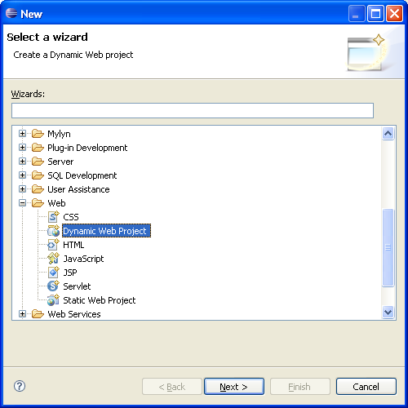

Create a new package for our Java classes
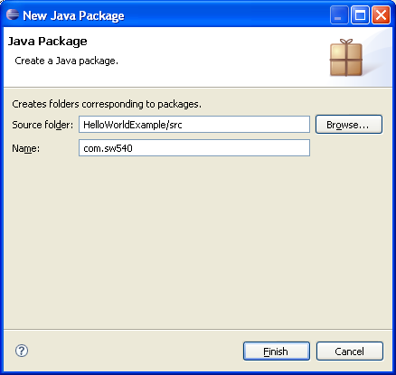

Right click on the project and go to Properties->Java Build Path. From here click on the libraries tab and add the servlet-api.jar from the apache installation directory.
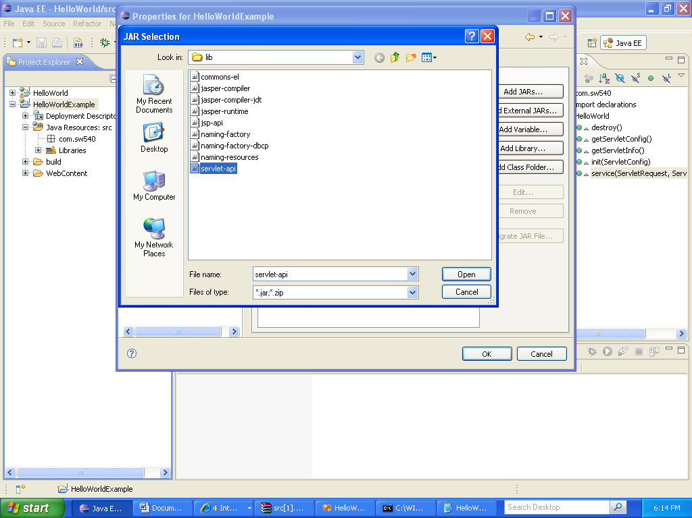

Go to our package and create a new class that implements Servlet:
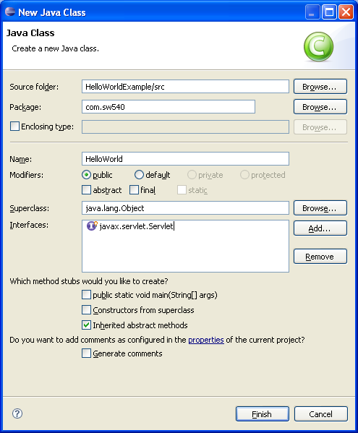

Put the following code in the service portion of our code:

PrintWriter out = new PrintWriter(arg1.getOutputStream());
out.println("<html><head>");
out.println("<title>TestServlet</title>");
out.println("\t<style>body { font-family: 'Lucida Grande', " +
"'Lucida Sans Unicode';font-size: 13px; }</style>");
out.println("</head>");
out.println("<body>");

out.println("<p>Current Date/Time: " +
new Date().toString() + "</p>");
out.println("</body></html>");

out.close();

Now it is time to modify the Web.xml. Put the following in yours
<display-name>
HelloWorld</display-name>
<servlet>
<servlet-name>HelloWorld</servlet-name>
<servlet-class><package>.<className></servlet-class>
</servlet>
<servlet-mapping>
<servlet-name>HelloWorld</servlet-name>
<url-pattern>/HelloWorld</url-pattern>
</servlet-mapping>

Create a new server in the servers tab of eclipse:
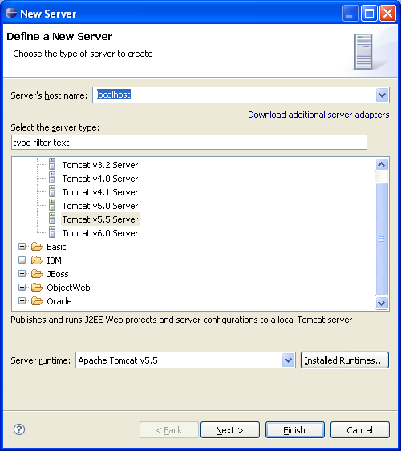

Add our project to it
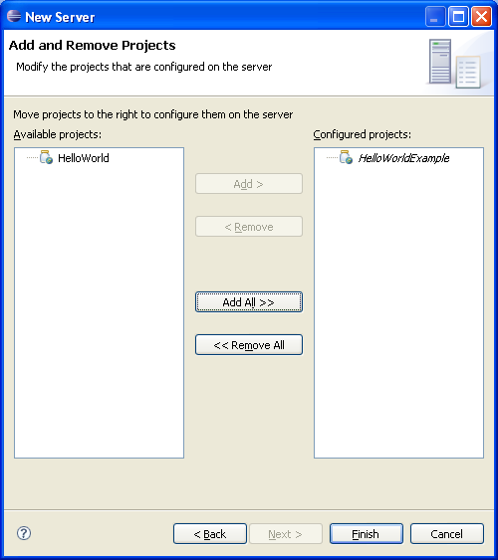

Right click on your server in the servers tab and go to properties. We now need to enable it to listen to port 8080:

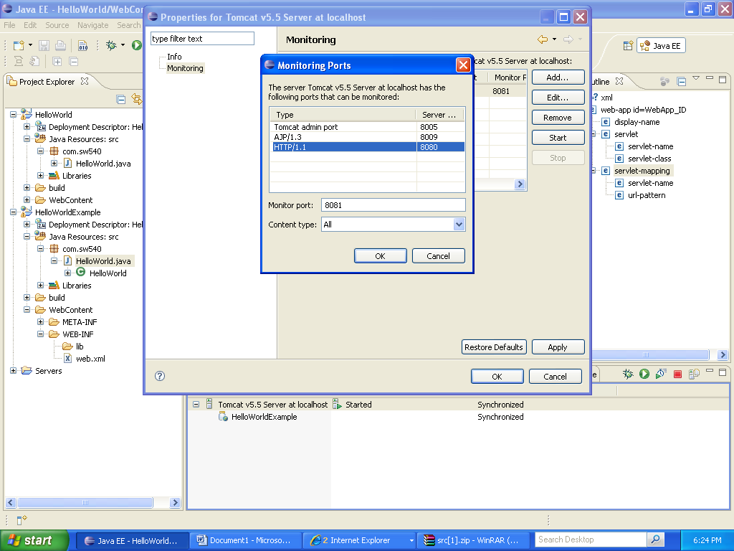

Start the server and go to http://localhost:8080/manager to make sure the server is up.

